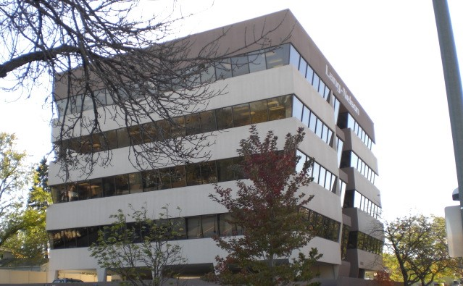

Park Boulevard Office Space

Three High Demand Suites available Soon! Location in St. Louis Park
(300sf) (900sf) and (1300sf)

Advantages/Benefits:
Customer Service: On-Site Management and Maintenance to respond to daily tenant requests.
Convenience: Close access to major freeways, shops, restaurants, pharmacy and much more.
Value: Great price for the benefit and services delivered!
Ownership: We office here as well, and take great pride in keeping costs low and value high!
Amenities: Cleaning of your suite 5 days per week, Covered and Heated Parking at an additional cost, and so much more!
Conference Room on the 6th floor Available for Larger meetings.
Off Street Client Parking!!
Amazing, cozy, and welcoming atmosphere for therapy professionals, wellness-minded businesses and client-centered services.

Contact: Tamara Richards
952-697-4607 Tamara@lanel.com

Lang Nelson Associates, Inc.
www.langnelson.com





