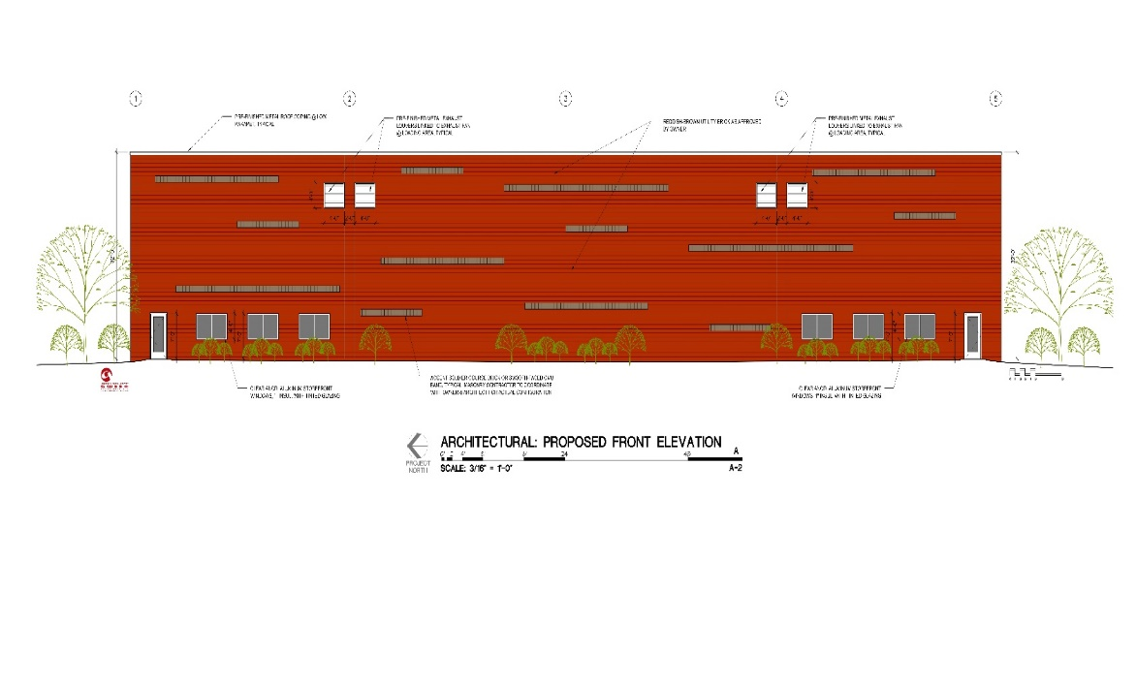
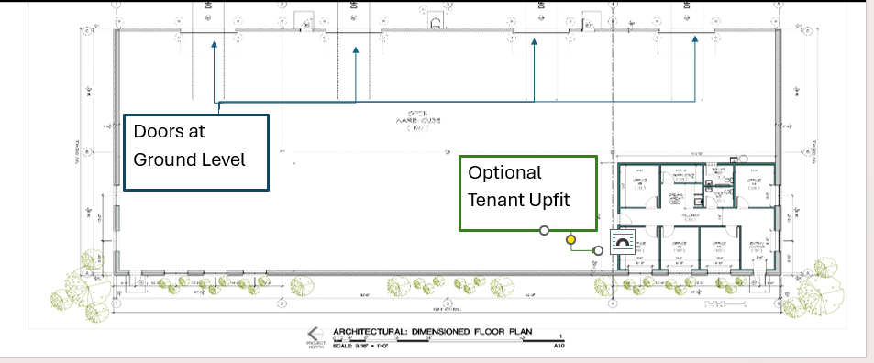
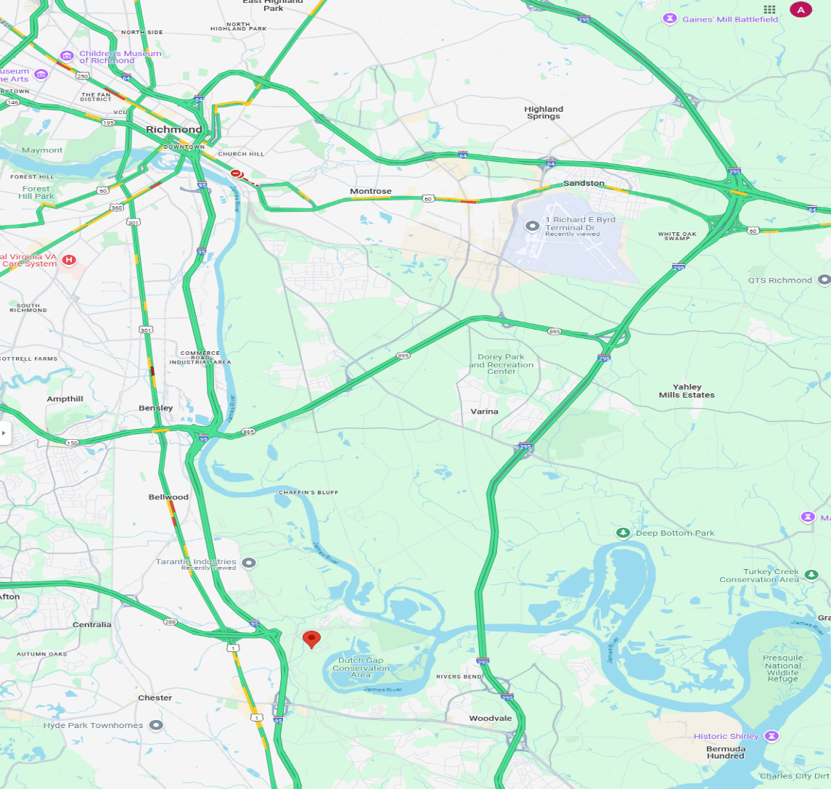
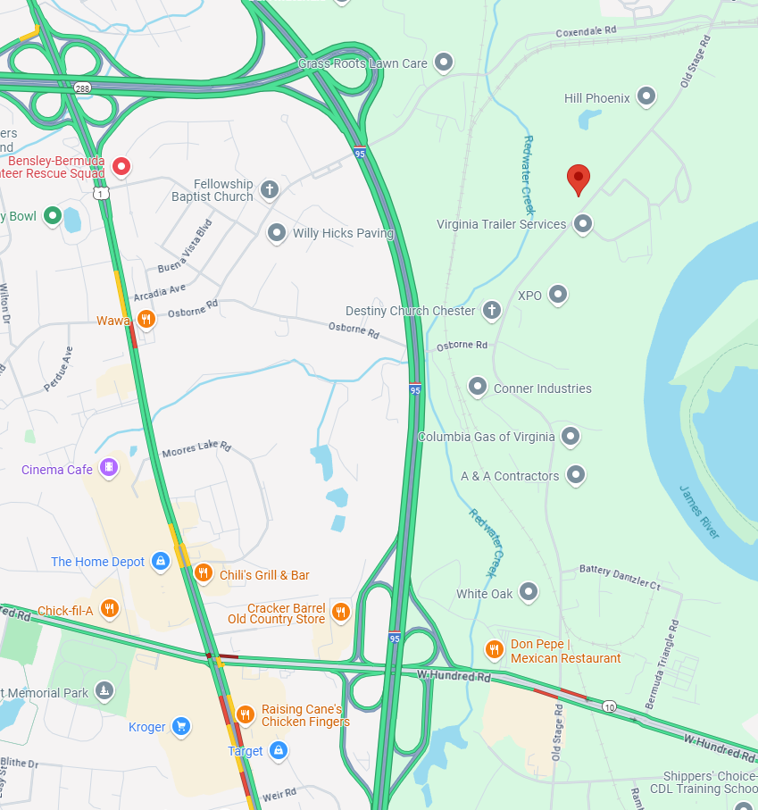
<1 Mile from I95 <5 Miles from I295 <16 Miles from Richmond <16 Miles from RIC Airport

FOR LEASE
11506 Old Stage Rd
Chester, VA 23836
Available December 2025
Parcel A
- 2.4 Acres
- 11,990 Sf Office/ Warehouse
  - Tenant Upfit Available
- Lighted, Gravel, Fenced
- 20 Space Parking Lot

- Term: Negotiable
- Price: Call
- Lease Type: NNN
- Industrial Laydown (I2)
Parcel B
- 2.5 Acres
- 11,990 Sf Office/ Warehouse
  - Tenant Upfit Available
- Lighted, Gravel, Fenced
- 20 Space Parking Lot

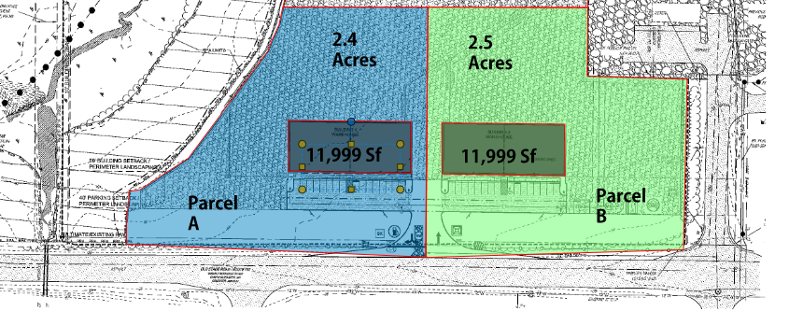
Contact:
Alexander L. Brown
Phone: (804)-694-7328
Email: alexanderb.management@gmail.com

