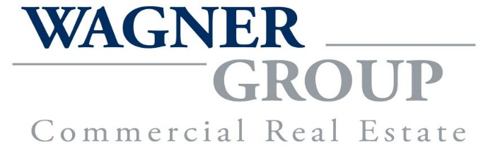

FOR SALE or LEASE

THE KEKOSKEE SALOON
30 MAIN STREET KEKOSKEE, WI

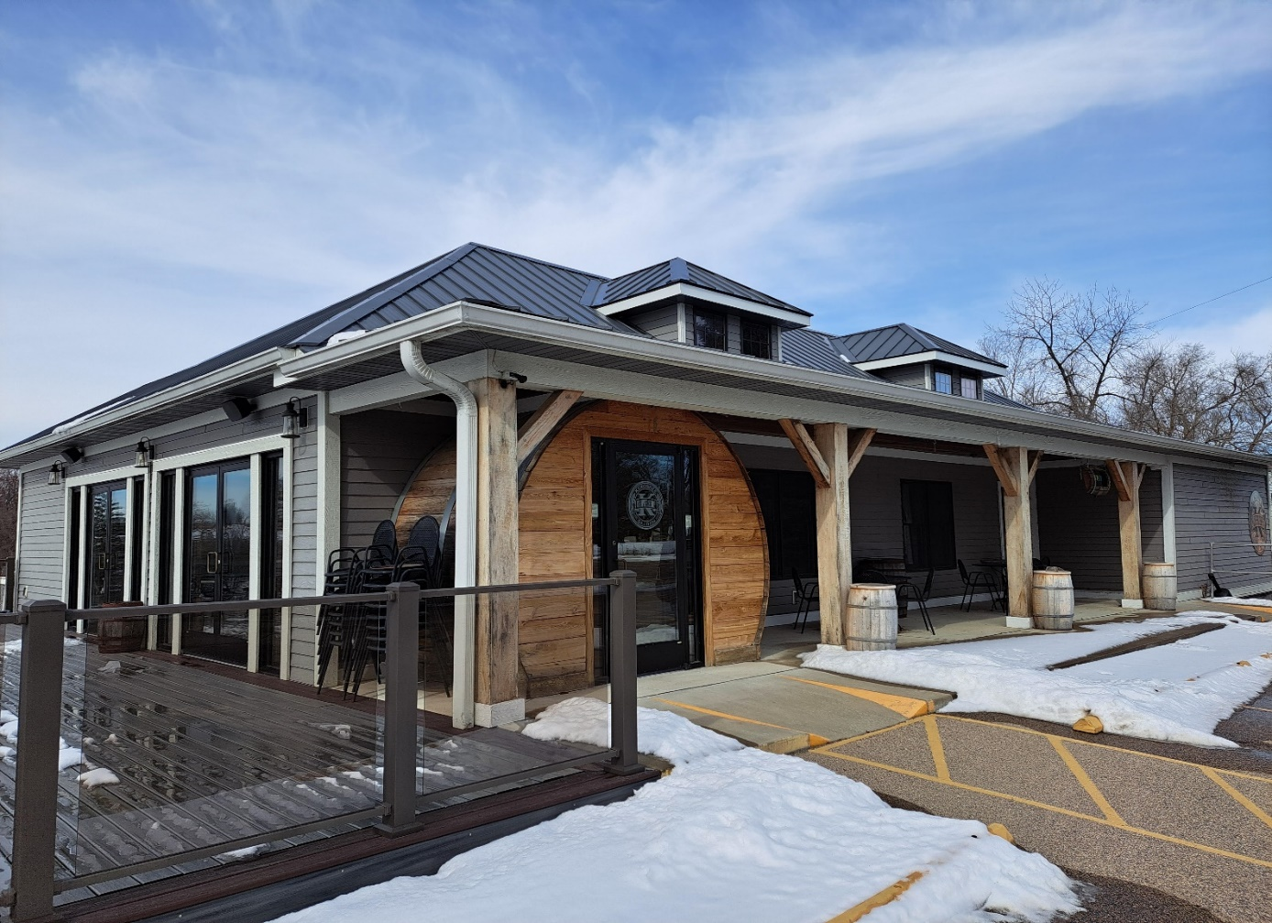

PROPERTY: Bar and Restaurant For Sale or Lease
LEASE RATE: Negotiable

EQUIPMENT INCLUDED:
Bar with all barstool’s tables and chairs, flat screen TV’s Glassware, Beer Taps
Full Kitchen with Fryers, Ovens, Stoves, Coolers, Ice Machine, Microwave Ovens. Misc. Plates,
Flatware, Linens etc.
Bar is currently leased for $2,500.00 per month until 9/01/28
Downstairs available for Hall Rental etc.

SALE PRICE: $650,000.00

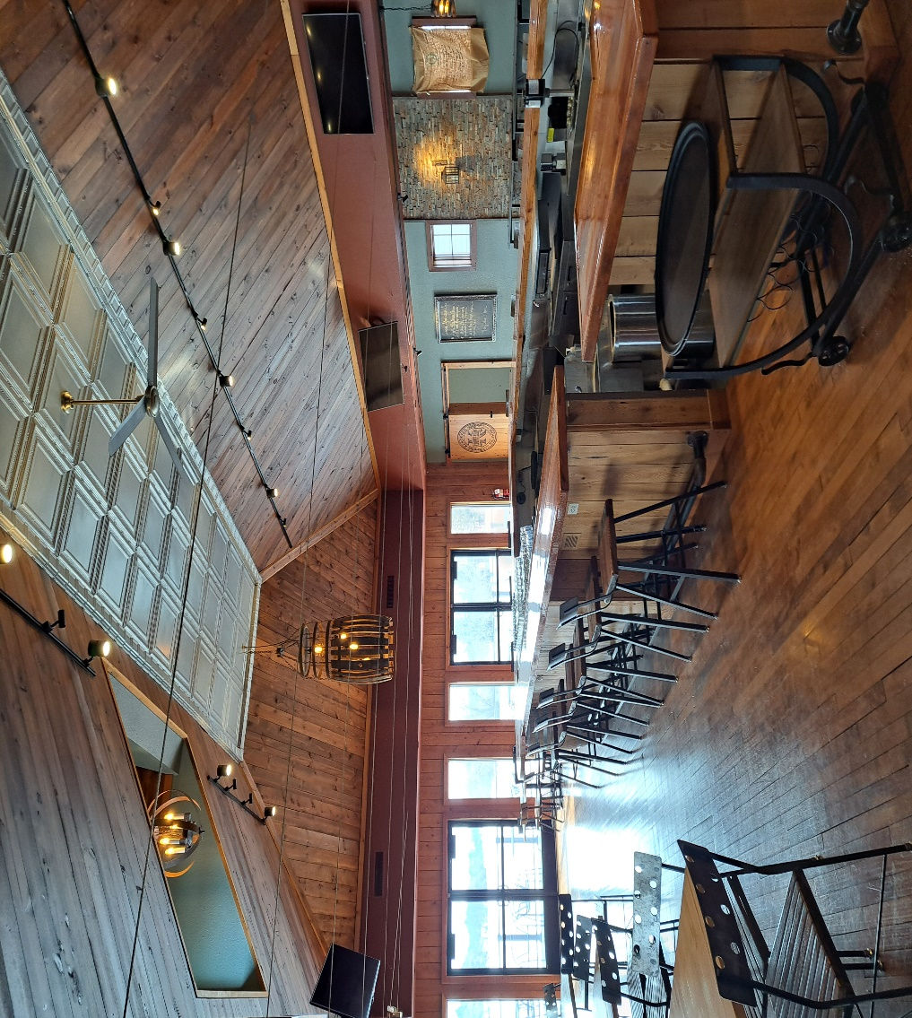

Contact: Wagner Group CRE
R. Martin Wagner
30 N Ewald St.
Mayville, WI 53050
414-788-0785
martinwagner@att.net

