COVERED OUTDOOR STORAGE FOR LEASE
3220 EAST CHERRY STREET, SPRINGFIELD, MISSOURI

Location: 3220 East Cherry Street, Springfield, MO 65802 in the Central-east part of Springfield on Cherry Street, three blocks south of Chestnut Expressway and Highway 65 interchange

BUILDINGS: 2 buildings enclosed on 3 sides and additional parking with 9,600 SF and 11,280 SF with a total of 20,880 square feet of building area. Yard lights and 3-phase heavy electrical in one of the buildings. Zoned GM, General Manufacturing

BUILDING RENTAL RATE
Per Month | $1,500 to $1,750 per building Industrial Gross
Per Square Foot | $0.156 per month or $1.87 per year

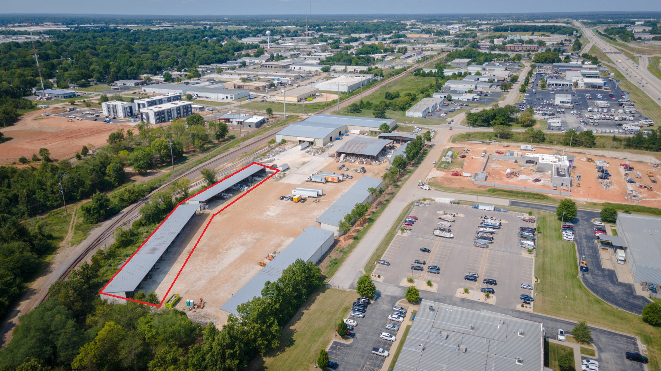

Contact:
Eric Roberts, Owner/Agent or Joe Roberts, Owner/Broker
1300 West Poplar, Suite 200, Springfield, Missouri 65802
Cell #: 417-844-5530; Phone: 417-881-1533; Fax: 417-881-1540

