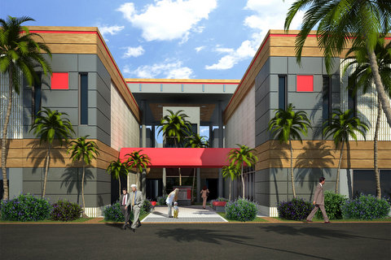
MEDPLEX
5458 Town Center Road

Boca Raton, Florida 33486

Suite | Size
1 | 1489 sq. ft.

BASE RENT: $30.00 per rentable square foot; triple net
OPERATING EXPENSES: $14.33 per rentable square foot – 2024 estimate
(includes common area maintenance, property
taxes & insurance)
Tenant electricity is separately metered and billed directly by FPL.
ANNUAL BASE
RENT ESCALATION: Four percent (4%)
CONDITION OF PREMISES: See attached floor plan.
PARKING: Surface parking and garage parking is available at no charge.
FOR LEASING INFORMATION CONTACT:
COLDWELL BANKER COMMERCIAL
Ingrid Fulmer 561-479-5970
SUBJECT TO WITHDRAWAL, CHANGE OR PRIOR RENTAL

