FOR SALE
12.56 acres
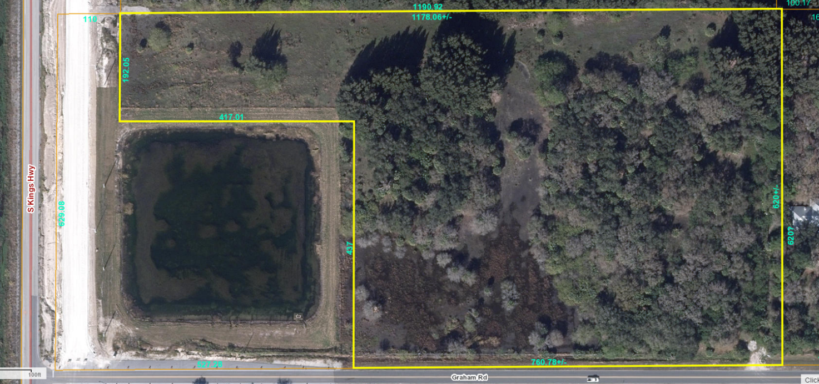
Northeast corner of Kings Highway and Graham Road, Fort Pierce, FL
Ideally located in the heart of the booming Treasure Coast Research Corridor
Next to Casino Fort Pierce
Current zoning AG-1, Potential zoning C-3, City of Fort Pierce
Over 4,000,000 SF under development within 4 miles of site
$2,499,000
Contact: Harry Zuker, Broker

(772) 465-2000 ext. 102

