Luther Road
A Retail and Office Warehouse Community
Harrah / Choctaw Area
Located: NE 23rd St. & Luther Rd

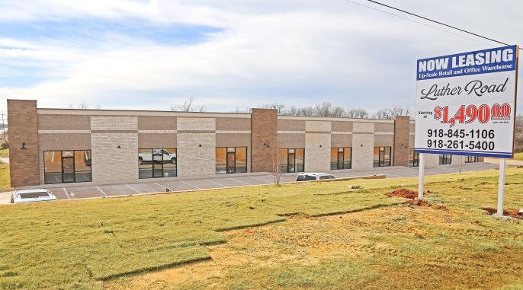
Park Place management, LLC
918-369-9300 (office)
For more information contact:
T.J. Remy 918-845-1106 & Tim L. Remy 918-261-5400
The above information is not warranted or guaranteed and is subject to change.
Retail Space
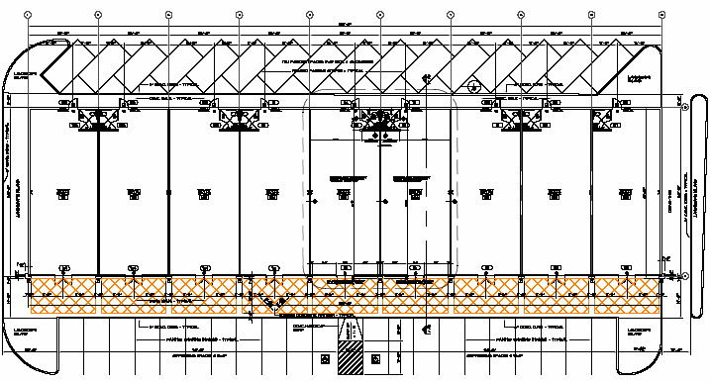

The retail center at Luther Road consists of 15,000 S.F. of prime, up-scale, retail space located at NE 23rd Street and Luther Road in the Harrah and Choctaw area. Each retail space is 1,500 S.F. Leasing begins at $14.95 P.S.F. triple net with build-out included.

Park Place management, LLC
918-369-9300 (office)

For more information contact:
T.J. Remy 918-845-1106
Tim L. Remy 918-261-5400

The above information is not warranted or guaranteed and is subject to change.
Office/Warehouse Space
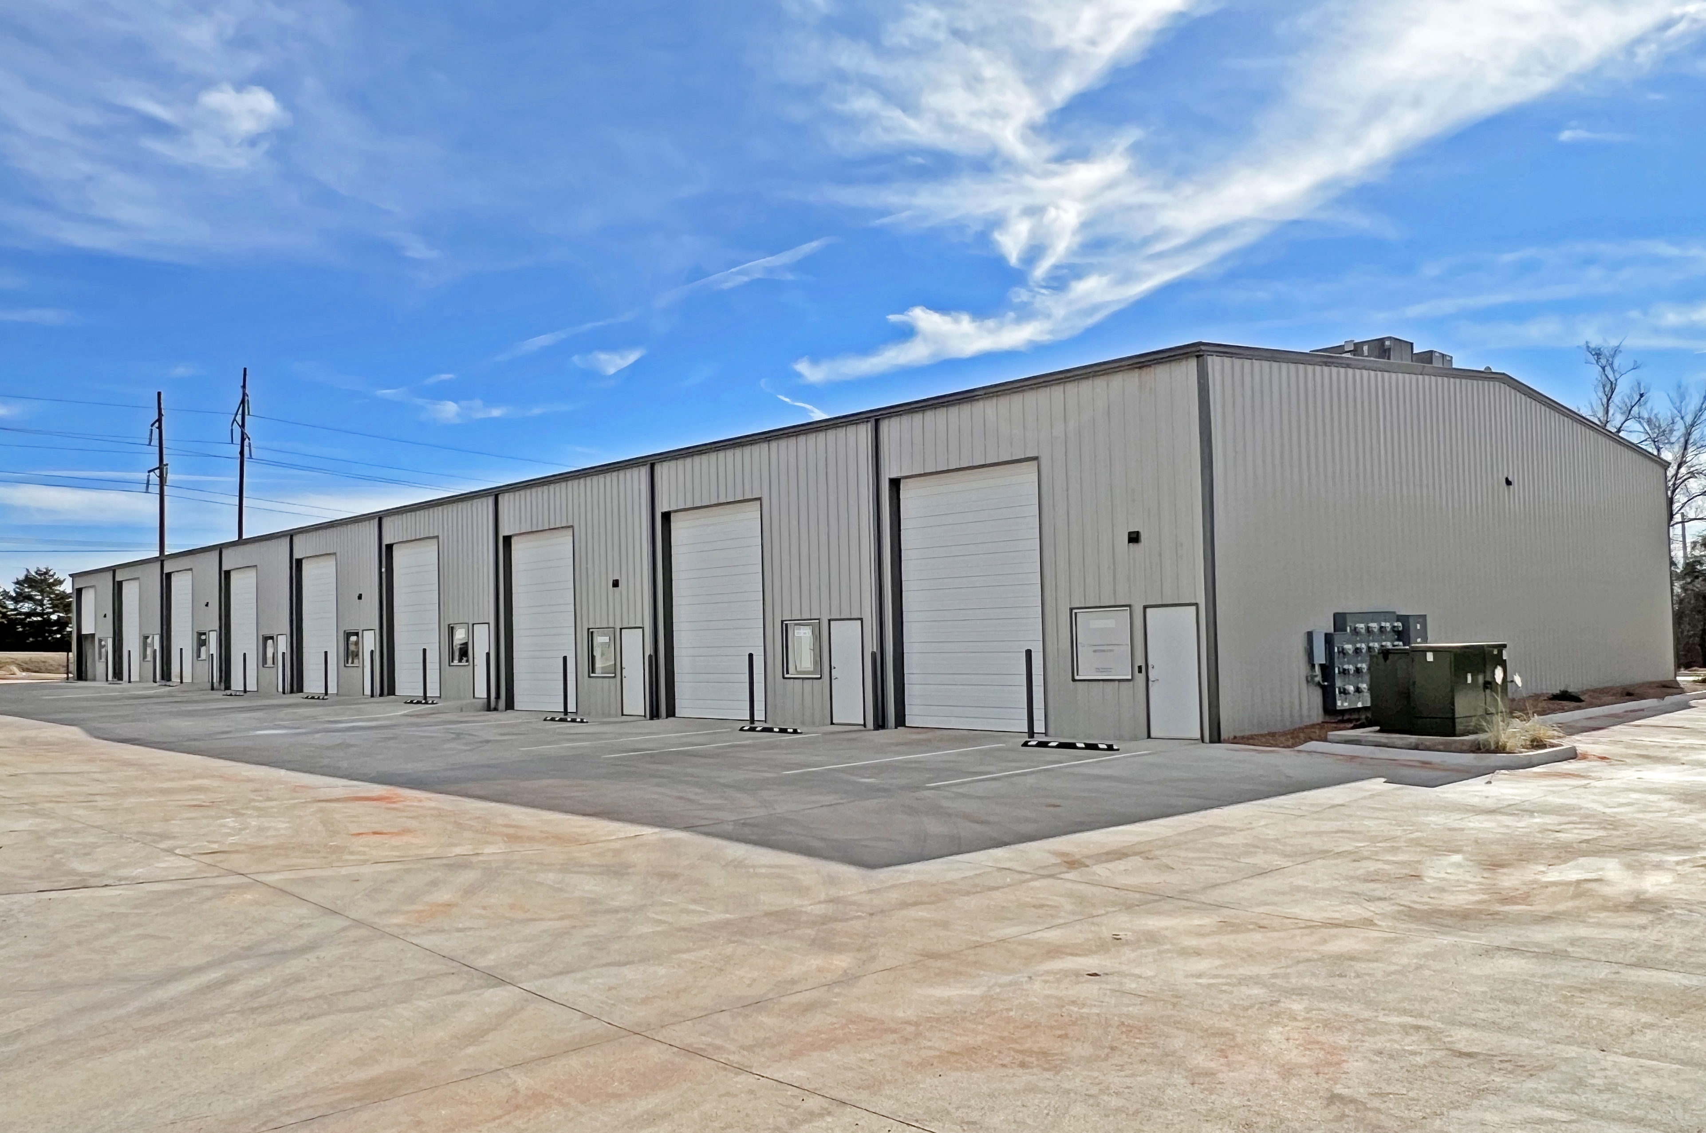

2,000 S.F. (25 ft. x 40’) of office warehouses. Each unit is self-contained with individual heat/air. There is one private office per module, one bathroom, and the remaining space is warehouse with two 12 x 14 overhead doors. All areas are under central heat and air. Tenant pays electric and gas and Landlord pays for water and trash. Leasing begins at $1490.00 per month.

Park Place management, LLC
918-369-9300 (office)

For more information contact:
T.J. Remy 918-845-1106
Tim L. Remy 918-261-5400

The above information is not warranted or guaranteed and is subject to change.

.

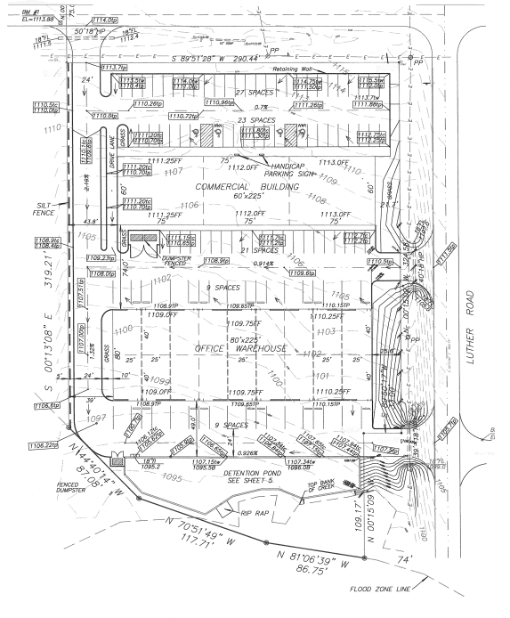

Luther Road is a retail and warehouse community located at NE 23rd Street and Luther Road in the Harrah and Choctaw area. The project consists of 15,000 S.F. of prime retail and approximately 18,000 S.F. of office/warehouse space. Office/Warehouses start at $1,490 a month and the retail start at $14.95 P.S.F.

Park Place management, LLC
918-369-9300 (office)

For more information contact:
T.J. Remy 918-845-1106
Tim L. Remy 918-261-5400

The above information is not warranted or guaranteed and is subject to change.

