RILEY ANDERS
COMMERCIAL REAL ESTATE

FOR SALE
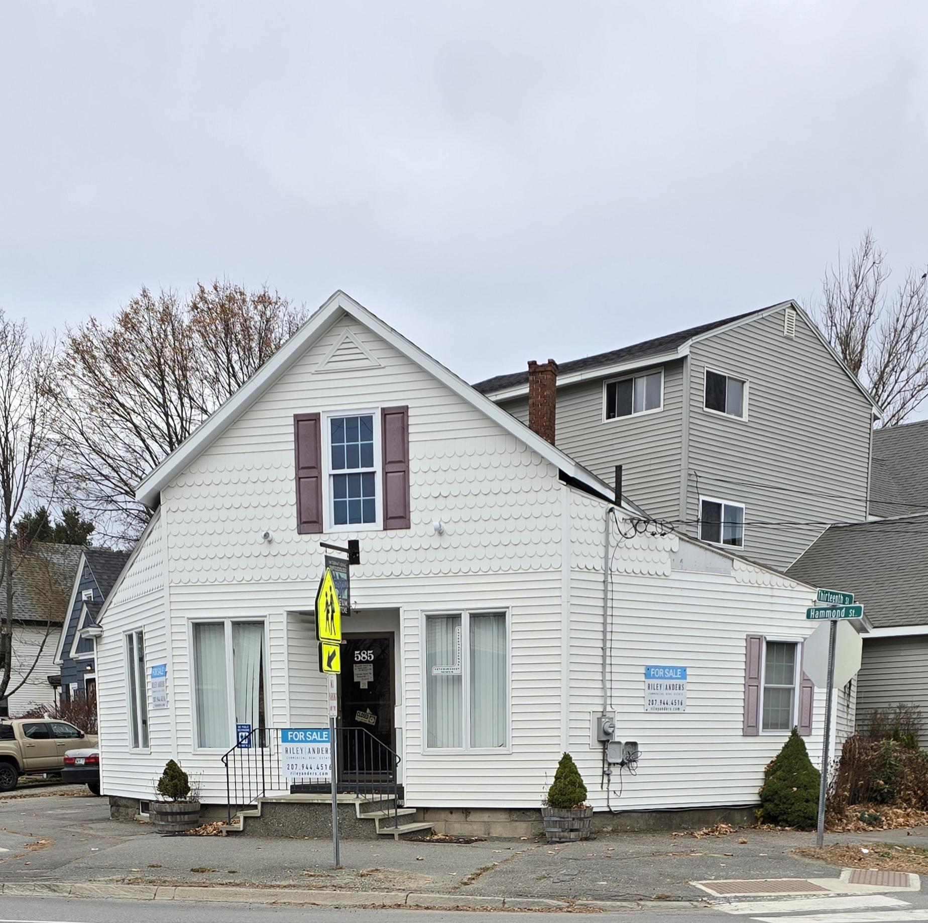
585 Hammond Street
Bangor, Maine
$325,000
Riley Anders - 175 Exchange Street, Suite 280, Bangor, Maine 04401
207-944-4516 www.rileyanders.com bill@rileyanders.com

