Brown and Associates, Ltd.
Commercial and Investment Real Estate
7686 W. 88th Ave * Arvada, CO 80005
✉ sambrown@brown-associates.com
📞303-938-9946

TOWN CENTER AT HIGHLANDS RANCH, 80129: The Highlands Ranch area has been rated by the Wall Street Journal as the fourth wealthiest areas in the Nation. The Development is located at the West entrance to Highlands Ranch at the busy SE corner of Sante Fe Drive (Highway 85) and Town Center Drive. Highway 85 is not only the west entrance to the enormous Development of Highlands Ranch, but is also the major connecting road between Metro-Denver C-470 and Castle Rock. The Development is next to the Douglas County's Football Stadium, a Kinder Care and Charter School with grades K through 12th. We have a 1,200 sf space coming available next to pizza business and former Subway 1,200 square feet space.
Base Rent $30 a SF 2021 CAM Estimate $15 per SF 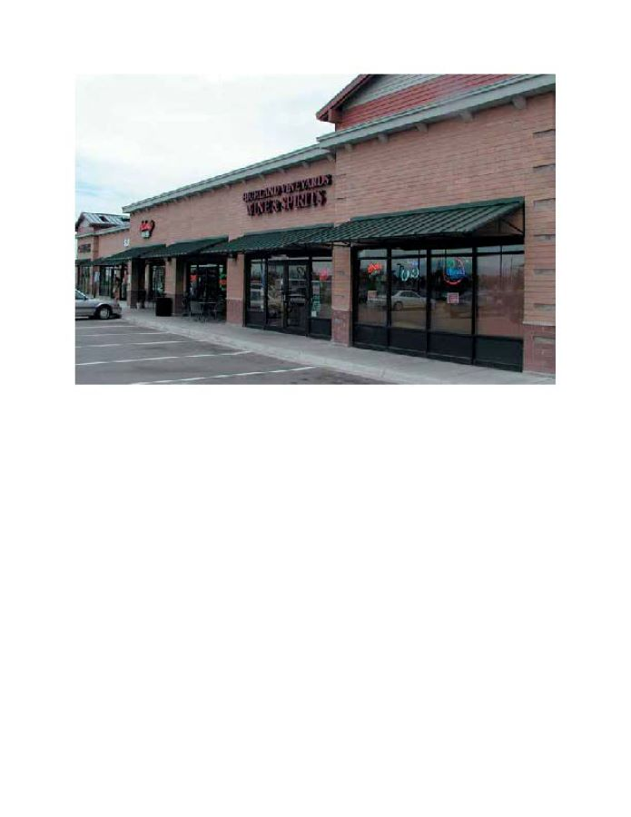
Sam Brown sambrown@brown-associares.com Phone: 303-938-9946

