22 E. 10TH ST, TRACY CA 95376
2 (1500 SqFt each) office/retail building (3000 SqFt total)
Tracy Central Business District (CBD)

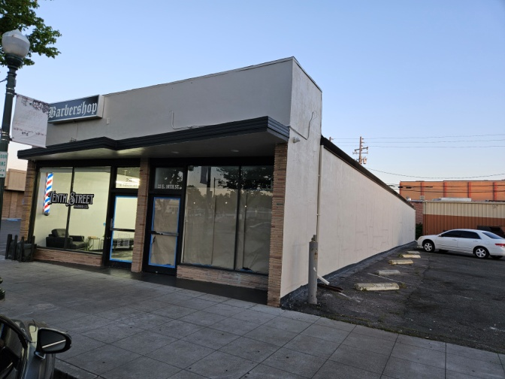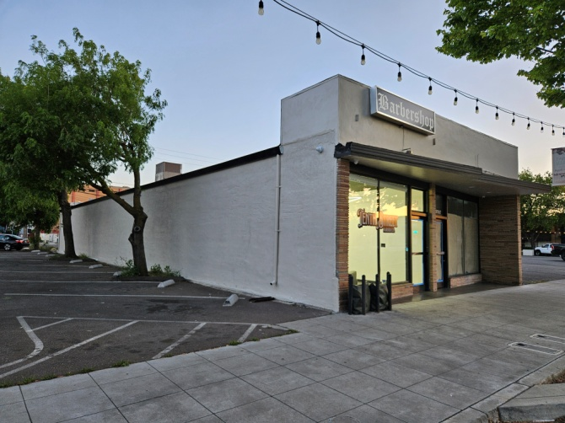
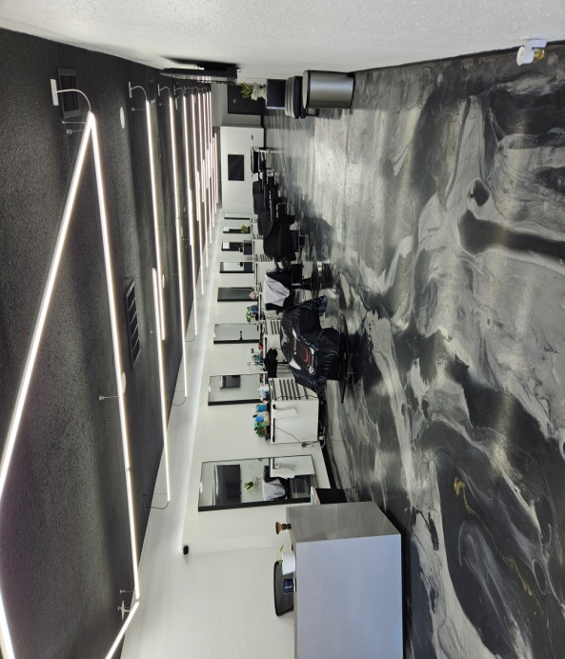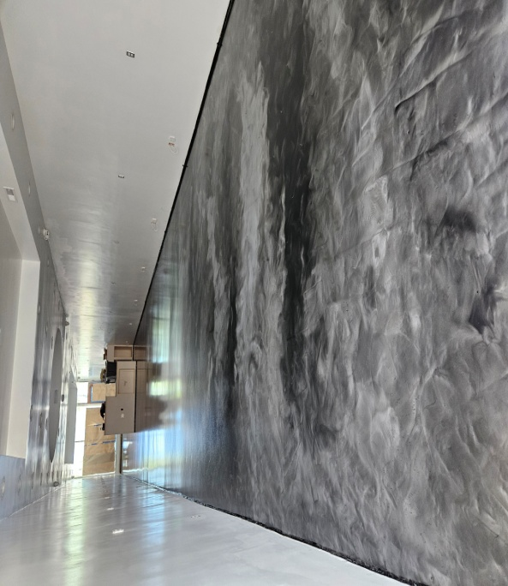
Own a Piece of the Thriving Downtown Tracy! Turn-Key Investment Opportunity and future Owner-Occupied if desired. This meticulously remodeled building offers the perfect blend of location, functionality, and investment potential. High pedestrian and traffic count. Close to city hall, banks, hospitals and shopping centers. Plenty of street and back lot parking. Asking price $1,290,000

Building consists of 2 units: 1500 SqFt each with a lot size of 4861 SqFt.
22 E. 10th st, Leased for $2,500 monthly with 5 years lease to 07/2029
24 E. 10th st Leased for $2,500 monthly with one year NNN lease to 07/ 2025
Tenants pay all utilities with each separate water and PGE meters.

Hanna Ibrahim, Broker | DRE#01356664 | NMLS#2050600 |
209-814-4445 / 415-638-9175
Century21 Real Estate Alliance, 1569 Sloat Blvd #300, San Francisco, CA 94132

