 |  | MLS#10120310
SALES, LEASES, RESIDENTIAL, COMMERCIAL, FARMS & LANDS |  | OWNER: |  |  | Sue Loftin
 | TELEPHONES:  NEWNAN - (770) 253-6990  FAX - (770) 253-6843  WEBSITE - www.LindseysRealtors.com | LOCATION: |  |  | Highway 29N, Newnan, GA 30263
  14 JACKSON STREET
  NEWNAN, GEORGIA 30263
  SINCE 1948
See Attached Survey…  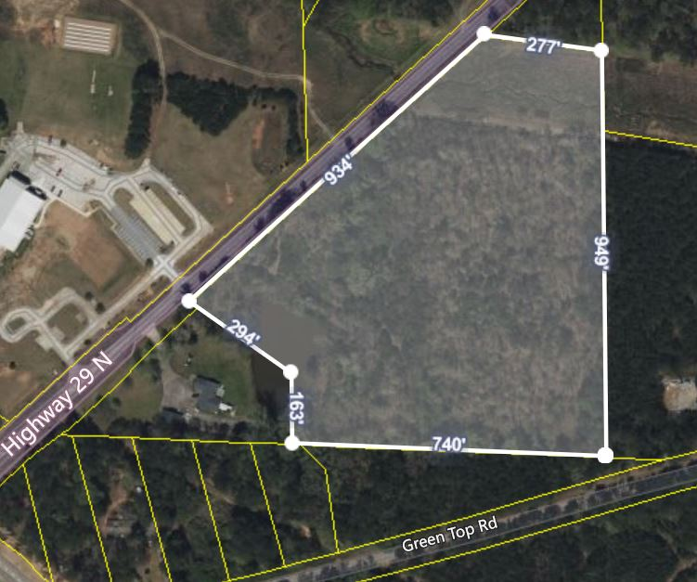 |  | SALES PRICE: |  |  | $599,900
 |  | APPROX. NO. ACRES: |  |  |  | 14.41+/- Acres
 |  | LISTED BY: |  |  |  | Frank & Chip Barron
 |  | DISTRICT: |  | 5th |  | LAND LOT: | 118
 |  | ACCESS |  | 819.25’+/- paved frontage on Hwy 29
 |  | WATER: |  | Available |  | SEWER: | None
 |  | GAS: |  | Available |  | ELEC: | EMC
 |  | ZONING: |  | RC – Rural Conservation
 |  | TAXES:  SCHOOLS: |  | 2022 - $1,251.78  Northside / Madras / Newnan
 |  | LEGAL IN FILE: |  | No |  | PLAT IN FILE: | Yes
MORTGAGES: | None
TERMS: | Cash or conventional loan
IMPROVEMENTS: | None
OTHER:  DIRECTIONS: | Small pond (dries up in dry weather), small stream on property. Georgia Power Transmission line on northernmost border.  Hwy 29N of Newnan, through the 2nd roundabout to subject property on the right.
NOTE: Although every effort has been made to provide accurate information, some of the above was supplied by others and therefore we do not guarantee or accept responsibility for the above. Price and terms subject to prior sale and change without notice.
OWNER PHONE NO. | Frank Barron – 770-231-9535  Chip Barron – 770-301-6843

