Brendan Barone
Broker/Director-Commercial Division
H3 Capital Real Estate LLC
(618) 606-3829
brendan@FrontRunnerCommercial.com
2 Butternut Ln., Glen Carbon, IL 62034
www.FrontRunnerCommercial.com

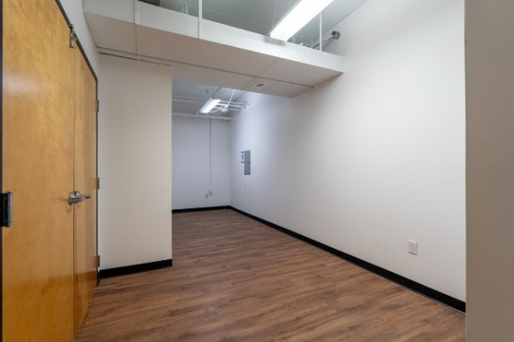
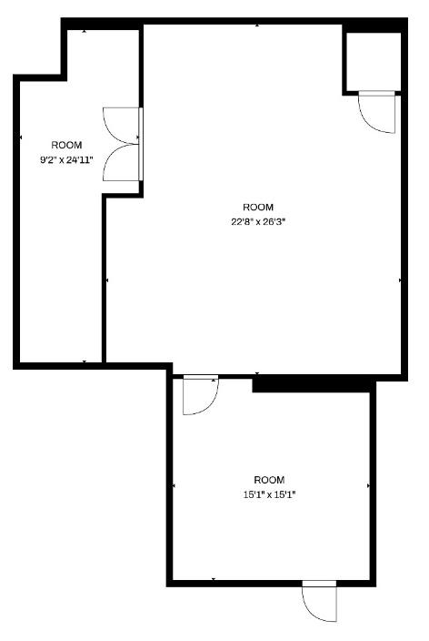
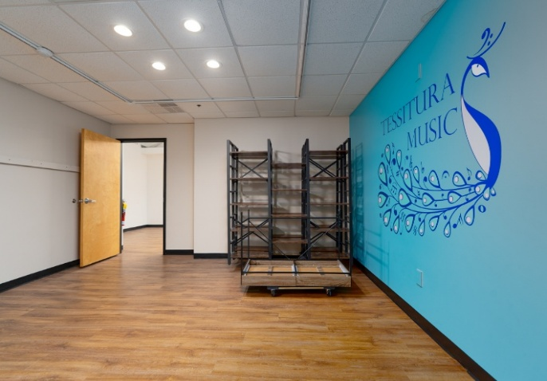
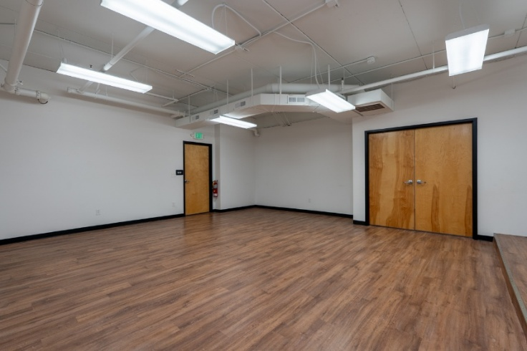

FOR LEASE

Room A
Room C
Room B
Room A
Room C
Room B
> 975 SF lower-level Space
> lease rate at $18 PSF no NNN
> Located IN The Park at Plum Creek
> Previous Use: Theatre School
> Neighboring Tenants:
- Artesian Barber
- Milan Laser Hair Removal
- Alpha As Gym
- The Goddard School
> 4.6 miles from SIUE with 14,000 Students
> Median income within:
1 Mile: 91.6k, 3 Miles: 99.2k, 5 Miles: 98.k
> There is not any natural light

975 SF Space
871 S Arbor Vitae
Edwardsville, IL
Information here in is not warranted and subject to change without notice. We assume no liability for errors on items included and quoted price. Broker makes no representation as to the environmental condition of property and recommends Purchaser’s Tenants /Independent investigation.

