PROFESSIONAL OFFICE CONDO SUITE FOR SALE
Within the Valley Office Park Old Tappan
1,325 sf

180 Old Tappan Road
Old Tappan, NJ

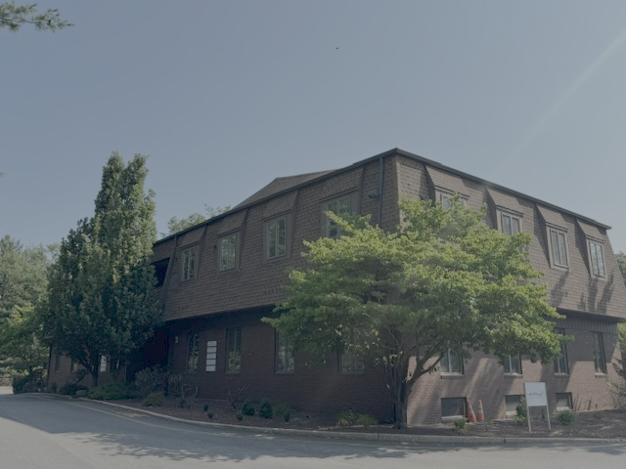

5 large Office/Counseling Rooms

Entrance Foyer with large open Reception Area
Additional Waiting area in the rear with adjacent seating

Kitchenette and Rest Room within the space

Excellent Signage outside the building and on the monument sign on Old Tappan Road

Move in condition with Separate Utilities

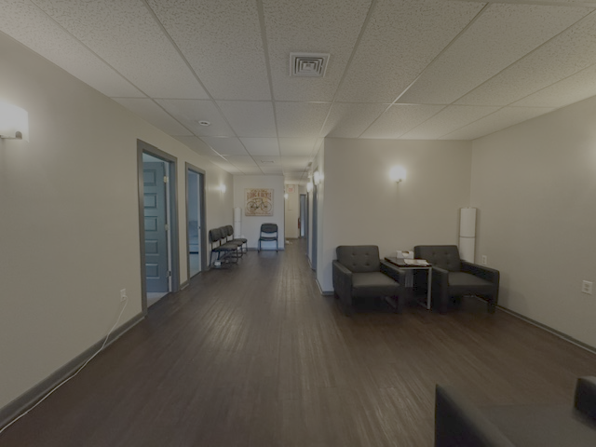

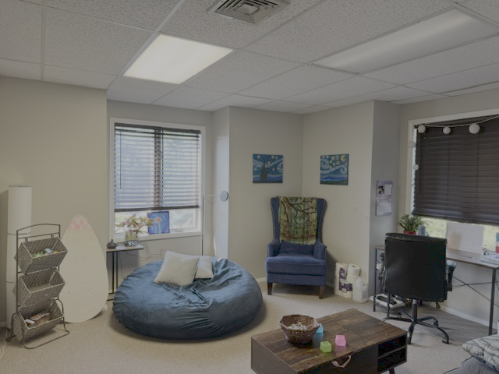

Richard Van Houten
VAN HOUTEN GROUP LLC
201-406-0611
rich@vhgre.com

The information contained herein has been obtained from sources considered to be reliable, but there is no guarantee of its accuracy by Van Houten Group LLC. Any plans are approximate and not guaranteed to be exact or to scale, and all parties should confirm measurements.

