The Abraham/Wood Place
348 Boston Post Road
Sudbury, MA 01176
Six-Tenant Commercial Property
Foe Sale: $2,900,000

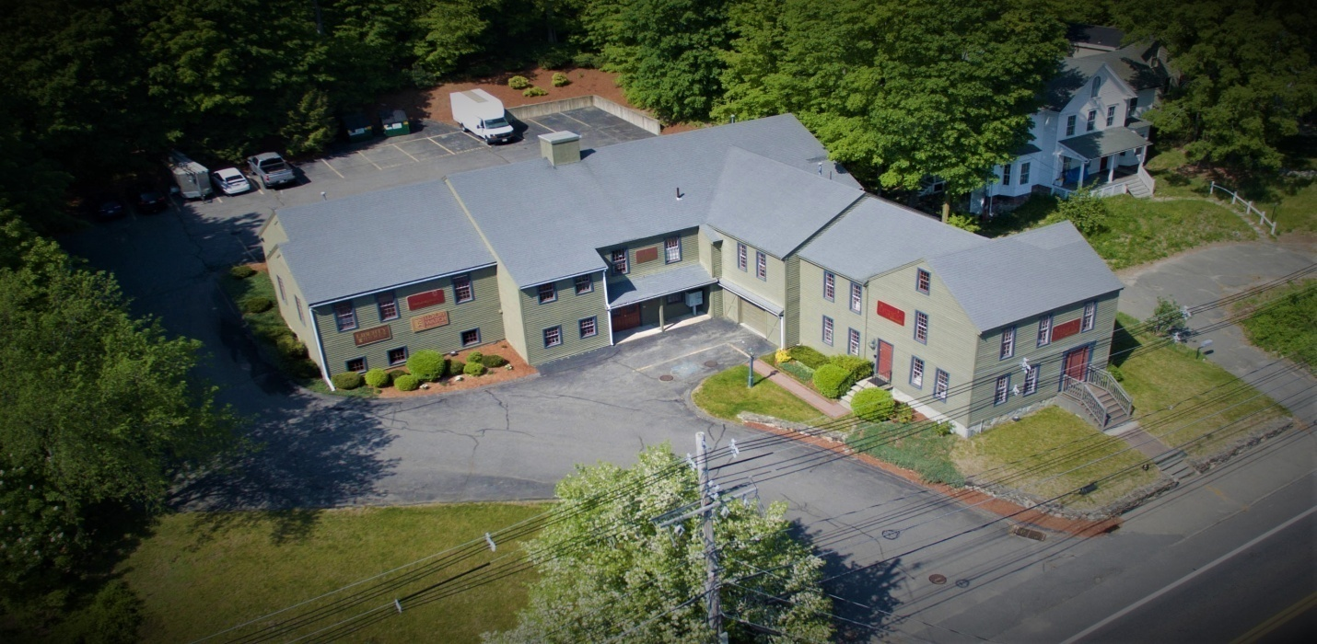

Welcome to the Abraham/Wood Place an upscale multi-tenant commercial building. This beautiful building will impress customers and tenants alike. Property has an inviting and well maintained exterior directly on route 20 with great frontage and access. It's located around other shops and businesses in the great town of Sudbury, MA with easy access to Boston. The building currently has six-units with a mix of retail and office tenants. The interior is spacious with hardwood floors and has a grand entry. There is a large warehouse area with garage door entry, which is a rare find in this area. Great opportunity for a savvy investor or for the future location of your business. There is an option to take over space for your business and have income coming in from other tenants. The building allows for a variety of business uses. Come see this beautiful property and see how this could be perfect for you. Owner financing is an option.

Edward Andrade
508-728-3406
eta7183@yahoo.com


