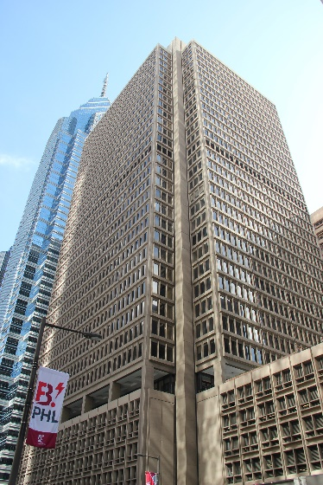
We are located in a newly renovated Class A building at 1700 Market Street. Directly across the street from Suburban Station and only 2 blocks away from Rittenhouse Square, and City Hall.
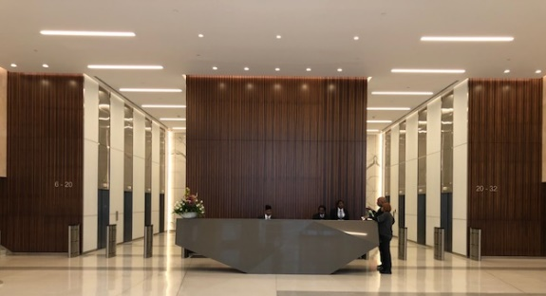

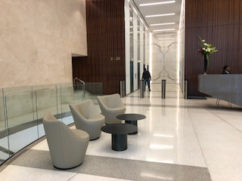

Our main lobby is also newly renovated with a sophisticated 24/7 security team. This floor includes 2 restaurants, Wells Fargo Bank with ATMS, and a pharmacy. The building also offers daycare, barber shop, and florist.

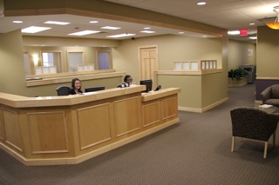
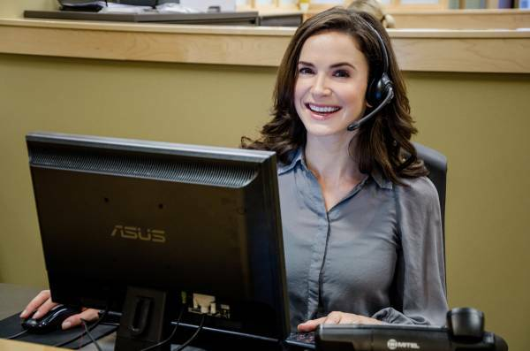
The reception area in our suite is furnished with Herman Miller Furniture. Our receptionists provide administrative services who handle office interactions with outside visitors. This includes greeting and directing guests, answering phone calls, and handling requests in a very professional manner. Our office provides high speed dedicated fiber optic internet and WIFI.
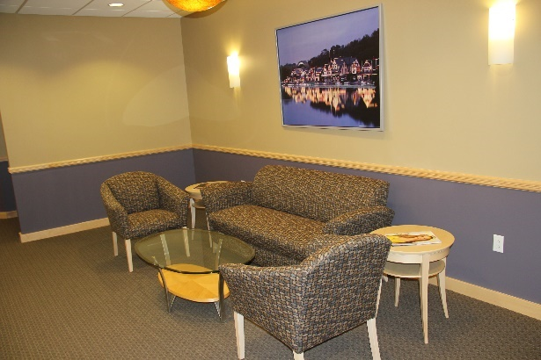

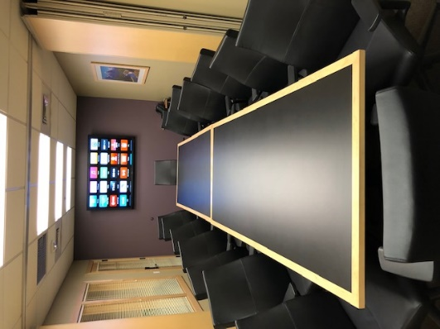
We have a large conference room that comfortably holds up to 16 people. One wall has a 70” flat screen TV and the other has a dry erase board with tear away sheets. We have conference call capability with our Mitel phone system. This room may be divided into 2 medium rooms, each holding 8 people.
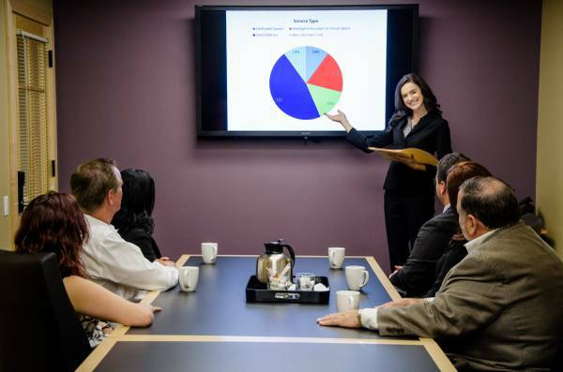

Including the same features as above, our small conference room holds 6 people and includes a 55” Flat screen TV.

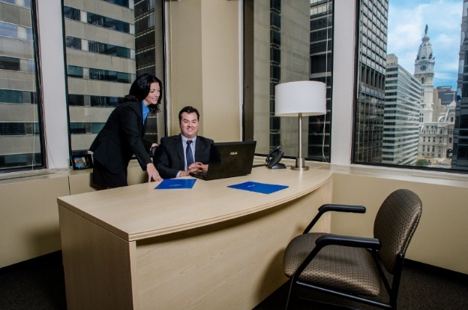

Our private window offices hold up to 4 people and have great views of Market Street and the Comcast Tower. They also include Herman Miller Furniture, and of course free WIFI. We have a kitchenette stocked with complimentary coffee, tea and water.

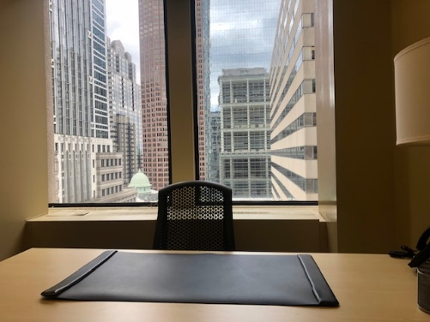
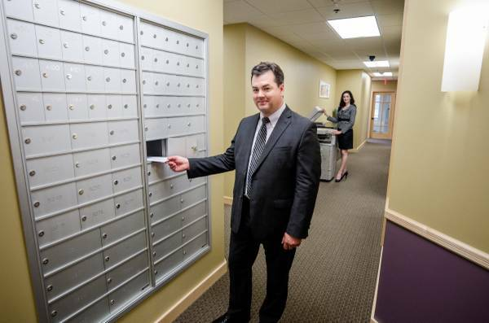

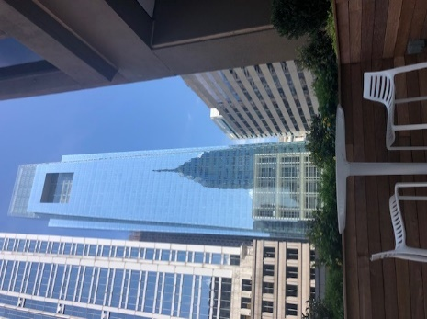
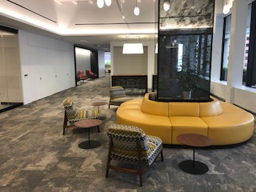
As a member of
Intelligent Office,
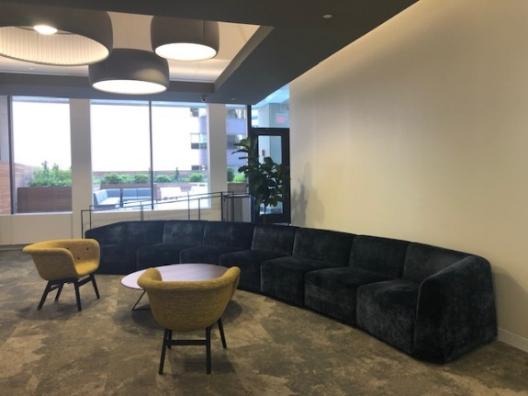
you will have access to our complimentary Indoor/Outdoor lounge on the 6th floor. The 6th floor also includes free WIFI.
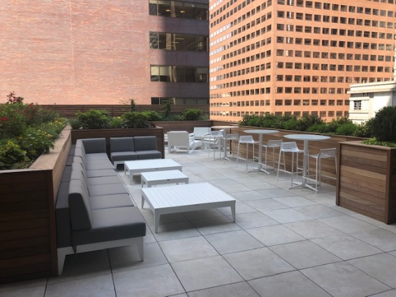

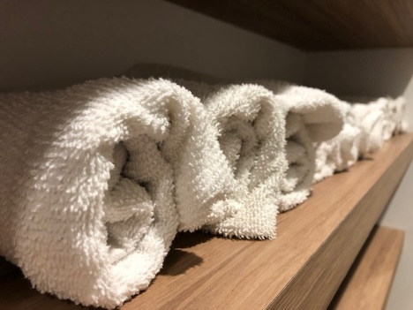
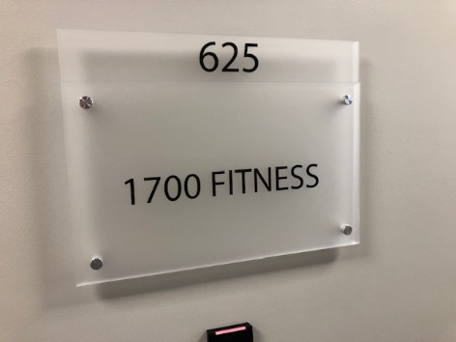
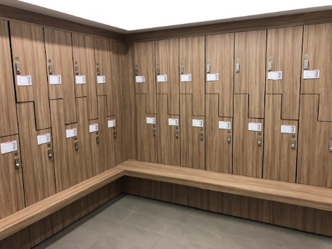

The 6th floor has been entirely re-done in the past year. We now have a brand-new gym in our building with lockers, showers, and personal trainers available.
