3330 E Hwy 10 – Moorhead, MN
Sale/Lease / Ground Lease / Build to Suit
NEW DRIVE THRU - PAD OPPORTUNITY
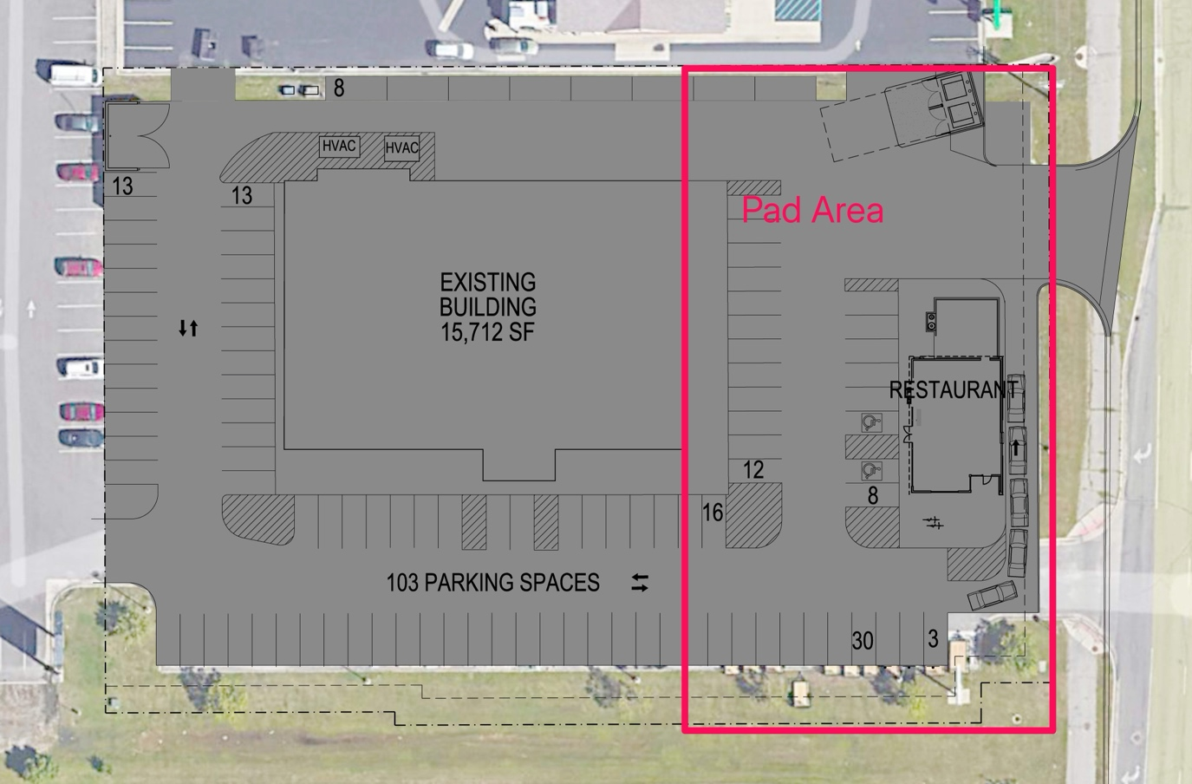-
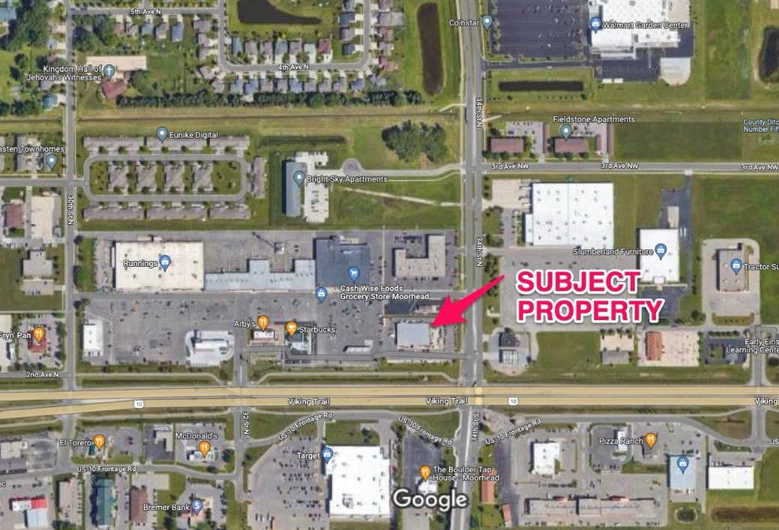

Property Highlights
- 16,000 sq ft Existing Building expandable to 22,000 sq ft
- 30k Daily Cars – FULL ACCESS
- Multiple NEW PAD options - TOTAL Site 1.98 Acres
- Grocery Anchored site – Best visibility/traffic/access in Moorhead MN.
- Anchors: Cash Wise Foods, Target, Walmart, Aldi, Running Fleet and Farm, Starbucks, Arby’s, McDonald’s, Tommy’s Express Car Wash, CVS, etc.
- Multiple single or multi-tenant buildings are possible
- Brokers Welcome

Building Rendering
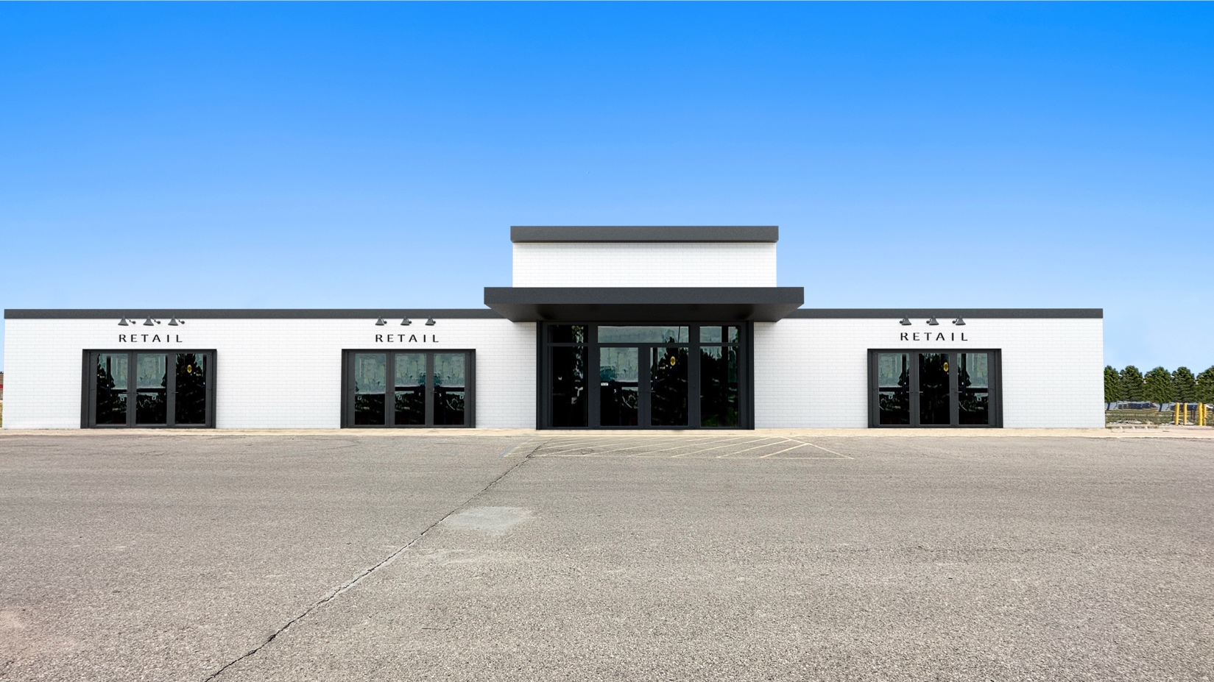

Existing Building Condition


