NEW BRUNSWICK
625 Jersey Avenue
37,000 Square Feet
Five Minutes to NJTP Exit 9
Modern, Clean, One-Story Industrial Facility
- 4 Loading Docks | - Drive-in Loading
- 16’-28’ High Ceilings | - 3,500 sf Modern Offices
- Fully Sprinklered Building | - Gas Heat

UP TO 4 ACRES OF PARKING AVAILABLE

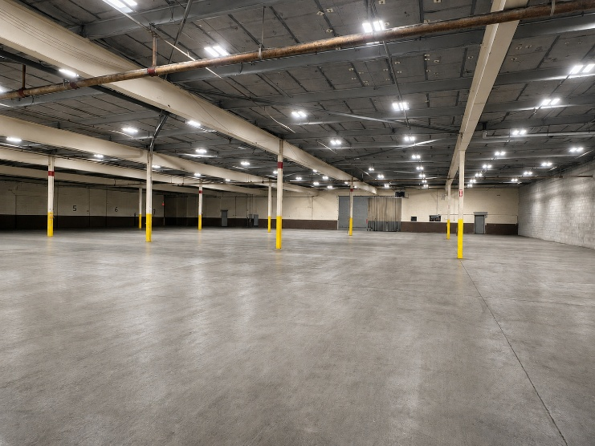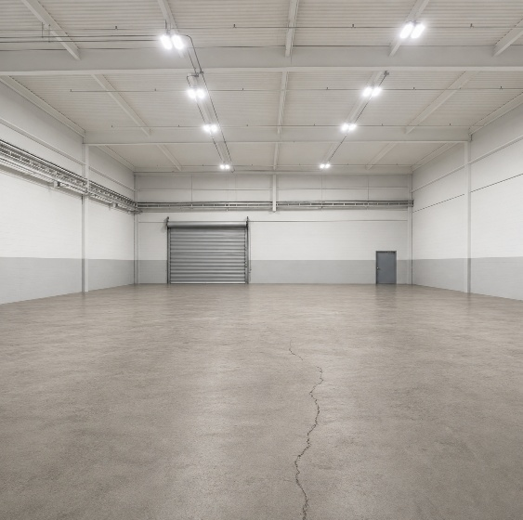

OWNER CALL KEN RUBIN
225 MILLBURN AVENUE, SUITE 202 (908) 285-1100 (Mobile)
MILLBURN, NJ 07041 KRubin@Fidelco.com

