For Lease  Pico Gateway Plaza  9430 – 9532 Whittier Blvd.,  Pico Rivera, CA 90660 | 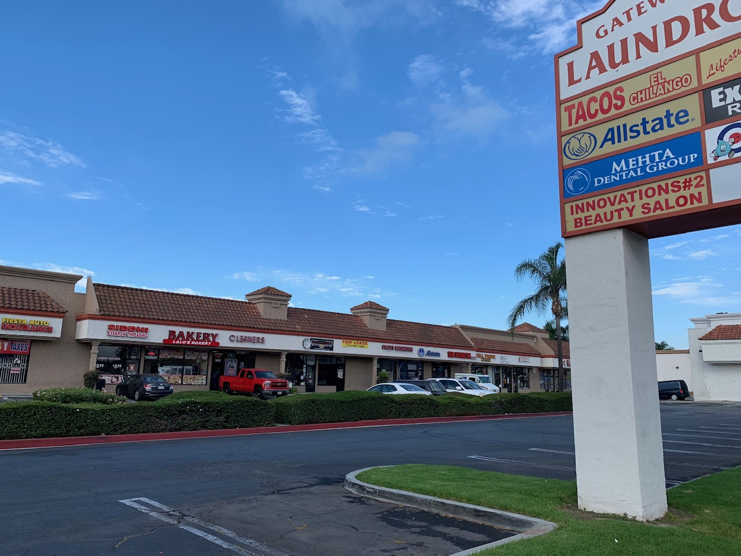
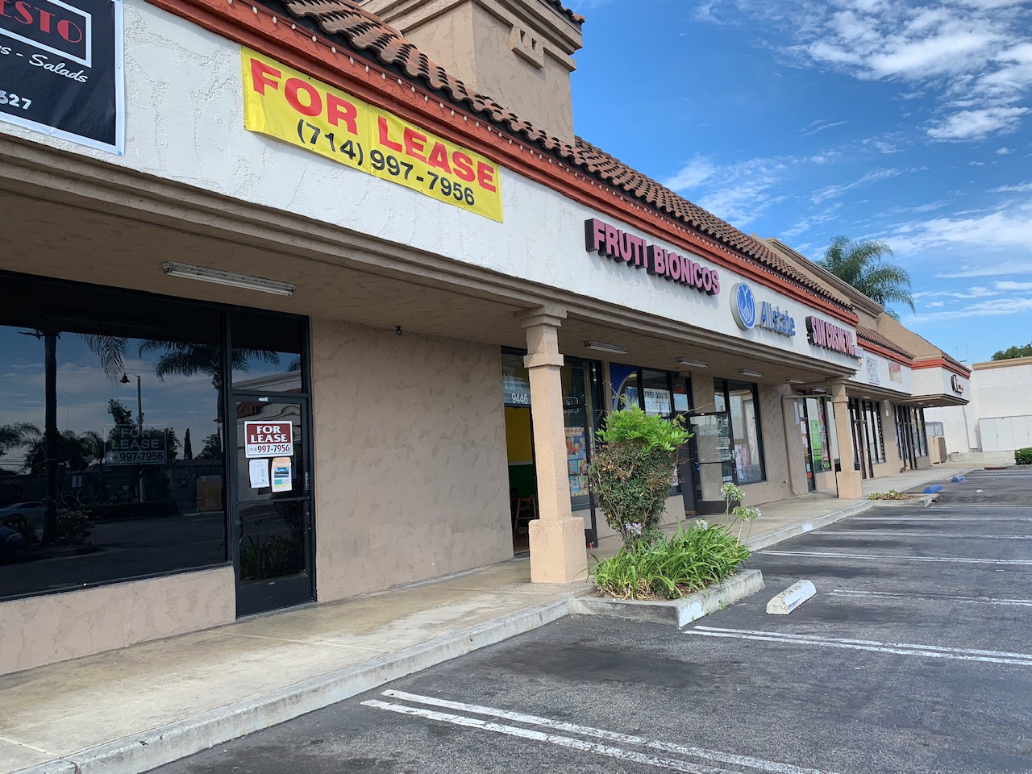 | 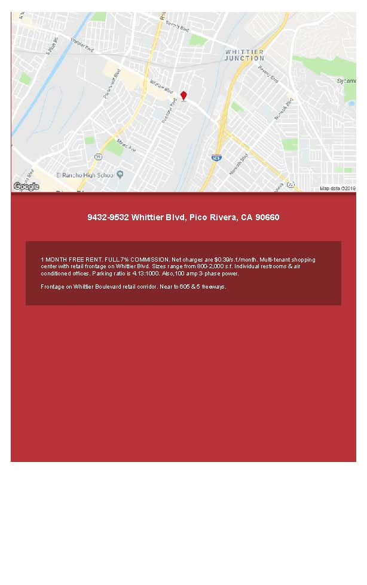

We have units available for lease!
-930 to 1032 SF UNITS
-Frontage on Whittier Blvd.
-Ample Parking
-Close to 605 Freeway
-Spacious showrooms with private restrooms
Contact our Leasing Office:
Phone: 714-997-7956 ; Email: sdassociates@sbcglobal.net
Address: 1020 N. Batavia St., Ste. B, Orange, CA 92867

