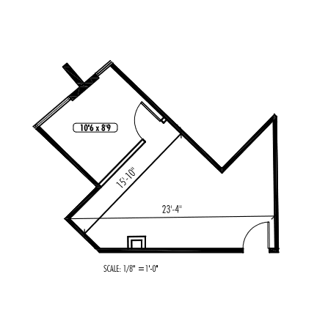
103’-8’
108’-2”
29’-1”
78’-0”
27’-9”
Base Rent: $723.52 ($15.96/ sf)
NNN: $115.15 ($2.54/ sf)
Total $838.67 ($18.50/ sf)
JB Dallas LLC • (214)854-0338
Center Point • Suite 207 • 544 SF

