Jon Day & Associates, Inc.
Commercial Realtors
jonday1@embarqmail.com
Phone (252) 756-1119 P.O. Box 507
Fax (252) 756-2427 Greenville, NC 27835-0507

58.23 Acres of Residential Land For Sale

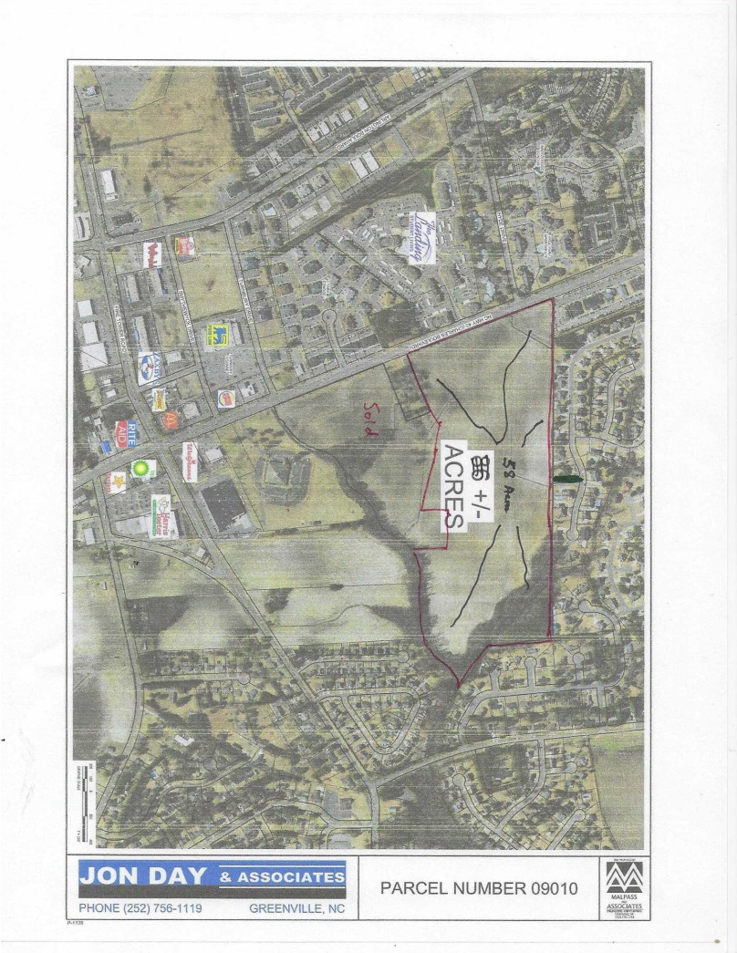
58.23 Acres for Sale, Asking Price $3,850,000.00
Prime Location on Charles Blvd near the Fire Tower Intersection
Jon Day & Associates, Inc.
Commercial Realtors
jonday1@embarqmail.com
Phone (252) 756-1119 P.O. Box 507
Fax (252) 756-2427 Greenville, NC 27835-0507

Information Sheet
Taft / Joyner Property
58.23 Acres South Charles Blvd / Tucker Estates Area

1.) Price: $3,850,000 for 58.23 Acres, $65,700 per acre

2.) Location: East side of Charles Blvd. about ¼ mile south of The Landing and Tara Condos. Site is adjacent to a 24 acre parcel that will be developed as a multifamily complex. Site is located in the south Charles Blvd area which is a highly desirable residential area about 2 miles south of ECU Campus. Major retailers located in this area include Harris Teeter, Walgreens, Walmart Neighborhood Grocery, CVS and a large number of restaurants

3.) Road Frontage: 1,200 SF of road frontage on Charles Blvd, Depth is about 2,500 feet

4.) Shape: Rectangular—See Map, sellers will consider subdividing the property.

5.) Utilities: Utilities will have to be extended to the site. They are available from an existing sewer line at the rear (East End) in the Meeting House Branch Subdivision.
An engineer will have to verify depth and adequate size. A local engineer has this information on file.

6.) Access: Future driveway on Charles Blvd, will be used to access the entire 58.23 acre tract. Additional access to be determined by local engineering and government officials.

7.) Seller approval of plans: Seller will have the right to approve buyer’s plans and approve the interconnectivity access. Seller owns the 58.23 acre parent tract and
Will consider subdividing it. Existing Restrictive Covenants on record on a 21 acre portion of the property.

8.) Zoning: O-Office possible to rezone the property to R15S, R9S, and R6S

9.) Comments: Excellent opportunity for an experienced developer to purchase a well located tract of infield development land. Buyer must present qualifications and some list of other developments at the time an offer is made.

Jon Day & Associates, Inc.
Commercial Realtors
jonday1@embarqmail.com
Phone (252) 756-1119 P.O. Box 507
Fax (252) 756-2427

- Major Retailers in This Area: Walgreens, Harris Teeter, McDonalds, Zaxby’s, Sonic
Hamburger, Bo Jangles, Jimmy Johns, Parkers BBQ, Wendy’s, Rib Eyes, CVS, Realo Drug, Burger King, Carmike Cinema, Basils, Dunkin Donuts, LIDL, Walmart Neighborhood, Bostic Sugg Furniture, Sheetz, Arby’s, O’Rileys, China 10, Boulevard Bagel, Title Boxing, Food lion, Little Caesar’s Pizza, US Cellular

- Multifamily Complexes: Tara Condominiums, The Landing, Madison Apartments,
Hype Park, Southland, Breezewood, Turtle Creek, Bellamy, Rosewood, Wimbleton, and numerous small complexes.

- Road Systems: Charles Blvd is a 5 Lane Wide Road, Fire Tower Road is a 5 Lane Wide Road.
The intersection of Charles Blvd and Fire Tower Road is being redesigned due to heavy traffic flow. Arlington Blvd is located just east of this property and is a major east/west throughfare.

- 1.8 Miles from Dowdy Ficklin Stadium and 2.5 Miles to Main Campus.

