Location Data:
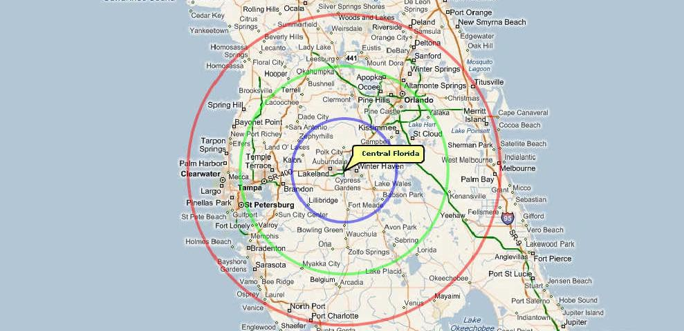
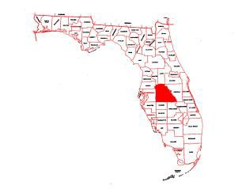
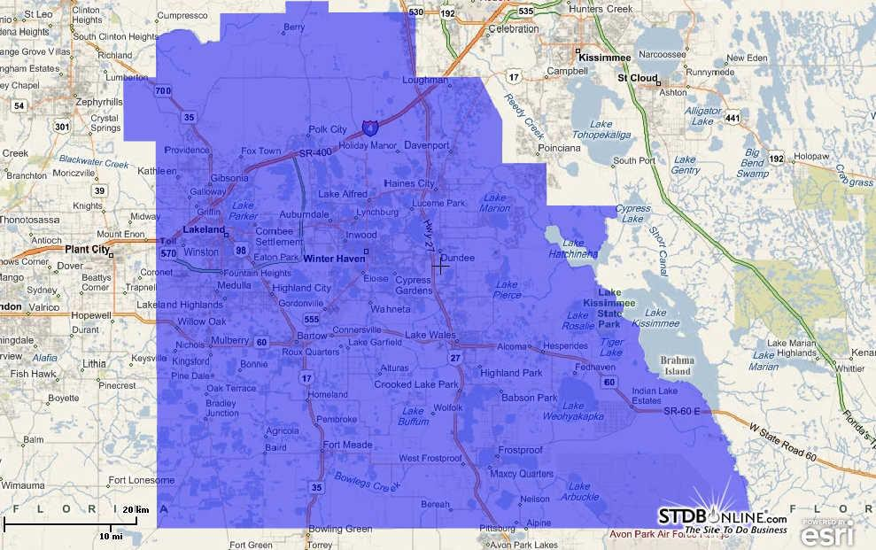
SUBJECT PROPERTY

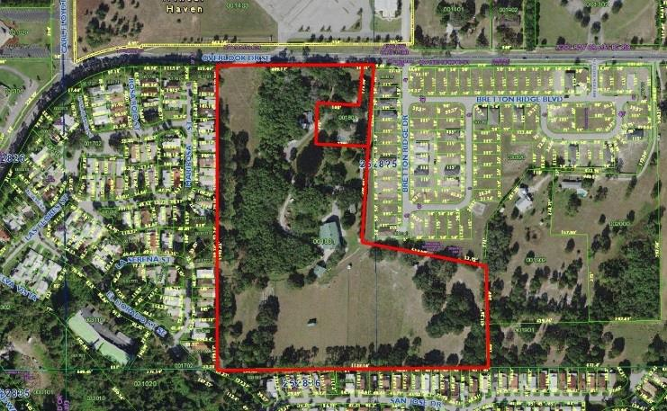 | 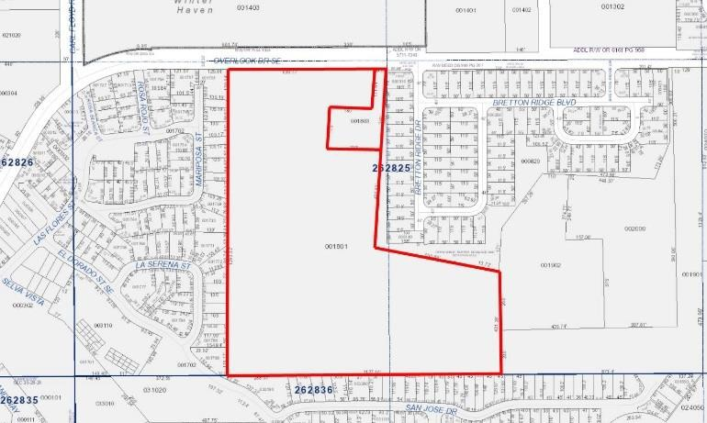
Site Data: Site #2

Location: | 1910 Overlook Dr., Winter Haven, FL. 33884
County | Polk
Access | The subject site is accessible from Overlook Drive.
Land Area | Approximately 291,852 square feet or 6.70 acres MOL.
Shape | Irregular
Zoning: | There is no zoning designation for properties located in unincorporated Polk County.
Land Use Plan | Residential Low Density - 1 (RL- 1): The purpose of the RL-1 district is to provide areas for the low-density residential needs of residents in urban areas who desire areas with larger sized lots, a minimum of 40,000 square feet.
Utilities:
Water/Sewer | Well/Septic
Telephone | Telephone service is available
Cable Television | Cable Television is available
Electricity | Electricity is available
Gas | Gas is available
Topography | Mostly level near street grade.
Easements Noted | The subject has typical utility easements', which are generally beneficial to the site. There were no apparent adverse easements or encroachments indicated upon visual inspection of the property or the county plats.
Site Improvements | The site is improved with a 1,375 square foot manufactured house constructed in 1975 and a 2,376 square foot low cost metal and wood frame barn that was constructed in 1963.  There is no deferred maintenance evidenced in the inspection of the manufactured house. The barn would benefit from some upgrading, but has been maintained over the years and is still useable. Nevertheless, these buildings would need to be removed because they are positioned on the site in areas that would impede development potential and are not likely to conform with a newly proposed development. However, both buildings could provide use as an interim use because the manufactured house is currently providing rental income and the barn could be used for storage of equipment while the property is undergoing development. Consequently, the value contribution of the improvements is sufficient to  cover the cost of removal, and the value of subject site #2 is in the land as a speculative investment for residential development.

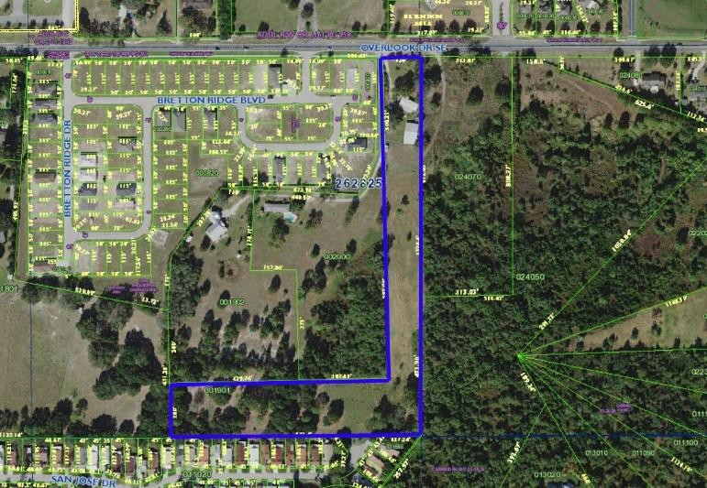 | 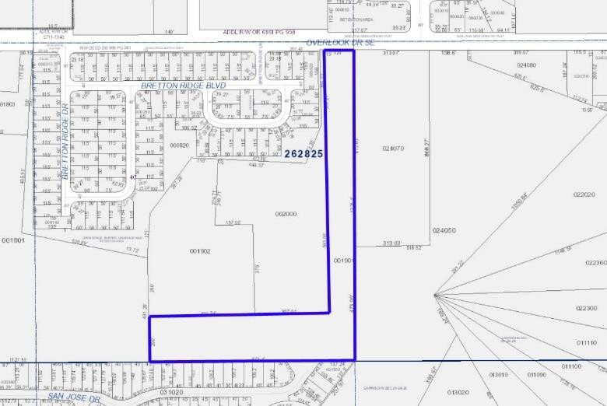

Flood Map
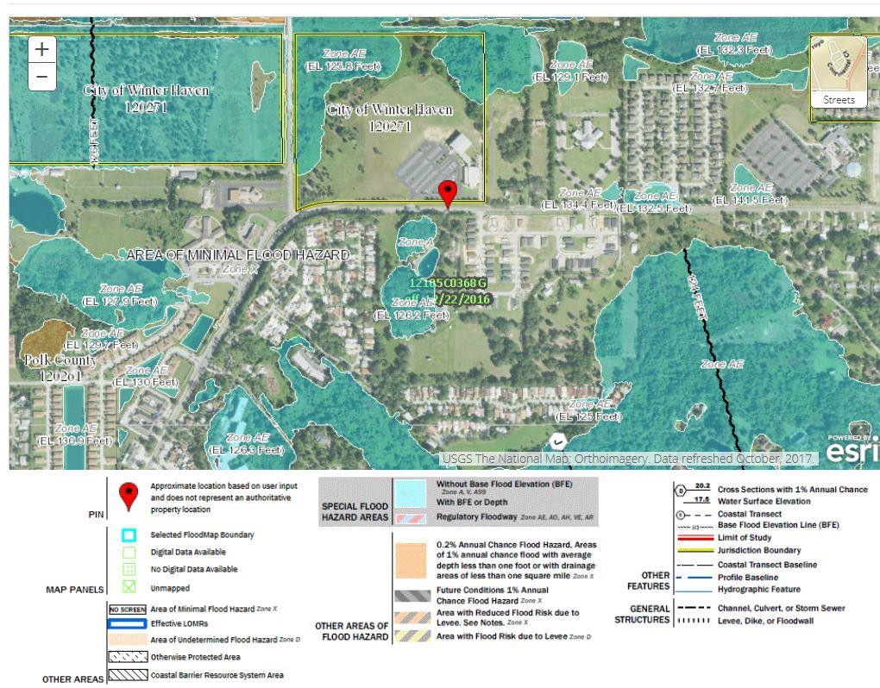


Overall Building Size Calculations (Site #1)

Building | Current Use | Enc. Area SF
Building #1 | Single Family House | 2,205
Building #2 | Manufactured House | 1,288
Building #3 | Warehouse | 7,622
Building #4 | Barn | 1,260
Totals |  | 12,375

Layout of Buildings on Site #1
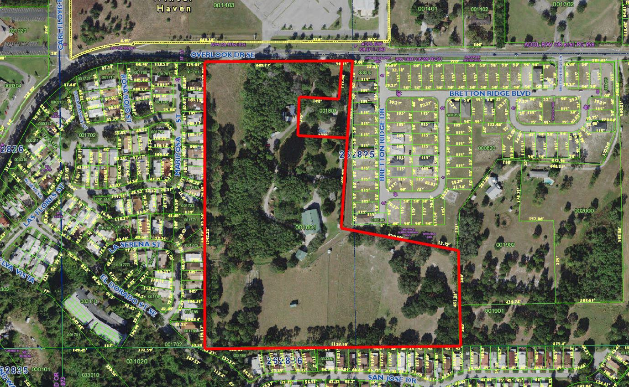

Bld. 1

Bld. 2

Bld. 3
Bld. 4

Building Number One – Single Family Home

Improvements: | Structure:
Building Type | Single Family Home
Number of Floors | One Floor
Eave Height | 10’
Building Quality | Good
Finished Area | 2,205 Square Feet
Total Building Area | 4,064 Square Feet (2,205 square foot living + 600 square foot garage + 61 square foot open porch + 1,198 square foot screen porch)
Foundation | Monolithic Slab on Grade
Exterior Walls | Stucco over Concrete Block
Roof Structure | Prefabricated Wood Trusses
Roof Covering | Architectural Shingle
Window Type | Aluminum Single Hung & Plate Glass
Door Type | Wood
Fenestration | Average
Floor Structure | Concrete Slab
Floor Coverings | A Variety of Pergo, Ceramic Tile, and Polished Concrete.
Interior Walls | Drywall Over Wood Framing.
Wall Finish | Paint
Ceiling Type | Drywall over Wood Framing
Lighting | Average Quality Lighting
Plumbing | Average Quality Plumbing Service and Fixtures.
Heating/AC | Multiple Package HVAC
Quality of Interior Finish | Average
Condition of Interior | Average
Quality of Exterior Finish | Average
Condition of Exterior | Average
Date of Construction | 2004
Actual Age | 15 Years
Estimated. Effective Age | 10 Years

Summary of Improvements:

The subject consists of a masonry single family house that was constructed in 2004. It features 2,205 square feet of living area, a 600 square foot garage, a 61 square foot open porch, and a 1,198 square foot screen porch that encloses a pool. 1 of 2 A/C units were replaced approximately 3 years ago, the house was painted inside and out in the last 2 years, pergo and polished concrete floors were installed in 2012, and the kitchen was extensively upgraded in the last 5 years with new counter tops, cabinetry, and stainless steel appliances. Consequently, there is no evidence of significant deferred maintenance, and the estimated effective age of 10 years is lower than the subject’s actual age of 15 years.

Improvements: | Structure:
Building Type | Manufactured house
Number of Floors | One floor
Eave Height | 8’ Feet
Building Quality | Good
Finished Area | 1,288 square feet
Total Building Area | 1,480 square feet (1,288 square feet living + 132 square feet screen porch + 60 square foot raised open porch/patio)
Foundation | Concrete piers
Exterior Walls | Vinyl Siding
Roof Structure | Wood Trusses
Roof Covering | Architectural Shingle
Window Type | Aluminum single hung
Door Type | Variety
Fenestration | Average
Floor Structure | Wood
Floor Coverings | Carpet, Wood, Ceramic Tile.
Interior Walls | Drywall over Wood Framing
Wall Finish | Paint
Ceiling Type | Drywall
Lighting | Average Quality
Plumbing | Average Quality Plumbing Service and Fixtures
Heating/AC | Package HVAC
Quality of Interior Finish | Average
Condition of Interior | Average
Quality of Exterior Finish | Average
Condition of Exterior | Average
Date of Construction | 2005
Actual Age | 19 Years
Estimated. Effective Age | 15 Years

SUMMARY OF IMPROVEMENTS:
The subject consists of a good quality manufactured house (Palm Harbor Home) that was constructed in 2005. It features 1,288 square feet of living area, a 132 square foot screen enclosed porch, and a 60 square foot raised open porch/patio. In 2010 the floors were replaced throughout the entire house and the kitchen was updated with new cabinets and countertops. In 2008 the bathrooms received new fixtures and in 2007 the 132 attached screen porch was added. Consequently, there is no evidence of significant deferred maintenance

Improvements: | Structure:
Building Type | Office/Warehouse
Number of Floors | One Floor
Eave Height | 20’ Average
Building Quality | Average
Finished Area | 1,068 Square Feet of Finished Office/Apartment
Total Building Area | 7,622 Square Feet. (1,068 square feet office/apartment and 6,554 square feet of unfinished warehousing).
Foundation | Monolithic Slab on Grade
Exterior Walls | Metal over Wood Frame
Roof Structure | Prefabricated Wood Trusses
Roof Covering | Metal
Window Type | Single Hung in an Aluminum Frame
Door Type | Wood, Multiple Steel Roll Doors (2 Electric Motor Powered), and a Steel Industrial Sliding Door
Fenestration | Average
Floor Structure | Concrete Slab
Floor Coverings | Carpet and Ceramic Tile in the Office/Apartment Area, and Exposed Concrete in the Warehouse
Interior Walls | Drywall Over a Wood Frame in the Office Area with Exposed Metal in the  Warehouse Area
Wall Finish | Painted in the Office
Ceiling Type | Painted Drywall in the Office with Exposed Metal in the Garage
Lighting | Average Quality Florescent Lighting in the Office/Apt. and High Intensity Lighting in the Warehouse
Plumbing | Average Quality Plumbing Service and Fixtures.
Heating/AC | Package HVAC in the Office and no air condition in the Warehouse
Quality of Interior Finish | Average
Condition of Interior | Average
Quality of Exterior Finish | Average
Condition of Exterior | Average
Date of Construction | 2005

The subject consists of a metal over wood frame office/warehouse building that was constructed in 2005. It features 1,068 square feet of living area on 2 floors that is set for use as an apartment, and 6,554 square foot of unfinished warehousing. The apartment features a living area, small kitchen and restroom. The warehouse is large an open featuring exposed concrete floors, and exposed metal walls. There is no evidence of significant deferred maintenance,

Improvements: | Structure:
Building Type | General Barn
Number of Floors | One Floor
Eave Height | 14’ Average
Building Quality | Average
Finished Area | None
Total Building Area | 1,260 Square Feet
Foundation | Monolithic Slab on Grade
Exterior Walls | Metal over Wood Frame
Roof Structure | Prefabricated Wood Trusses
Roof Covering | Metal
Window Type | None
Door Type | Wood, Multiple Steel Industrial Sliding Doors
Fenestration | Typical for Use
Floor Structure | Concrete Slab
Floor Coverings | Exposed Concrete
Interior Walls | Exposed Metal
Wall Finish | None
Ceiling Type | Exposed Metal
Lighting | Average Quality Florescent Lighting
Plumbing | None
Heating/AC | None
Quality of Interior Finish | Average
Condition of Interior | Average
Quality of Exterior Finish | Average
Condition of Exterior | Average
Date of Construction | 2006

The subject consists of a metal over wood frame general barn that was constructed in 2006. It consists entirely of unfinished area and features multiple holding stalls. There is no evidence of significant deferred maintenance,

Additional site improvements on site #1 include: approximately 31,685 square feet of asphalt paving, 3,305 square feet of concrete paving, a 144 square foot low cost wood frame shed, a 500 square foot open pole barn, approximately 620 lineal feet of 4 foot high chain link fencing, 180 lineal feet of 4 foot high vinyl 3 rail fencing, 1,735 lineal feet of 6 foot high electric wire mesh fencing, and an electric entry gate.

