
EVERGREEN LOCATION SERVICES LLC
337 Changebridge Rd , PO Box 180,Pine Brook, NJ 07058

For LEASE or SALE
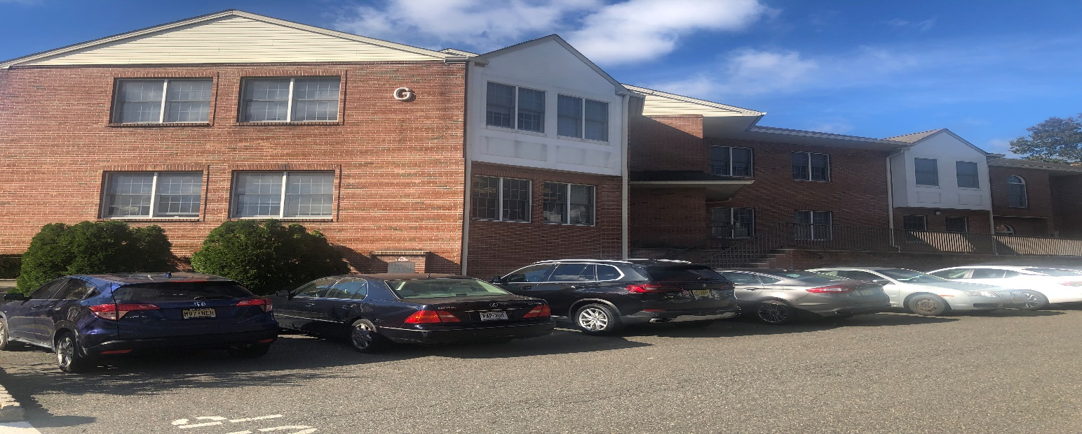
271 Rte 46 West, Fairfield (Essex County) Office Condo
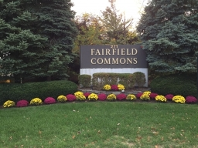 highway location

Unit(s) G201/202/203

2159+/-sft

2nd floor

Asking Sales Price $305,000 (property taxes $4900)
OR
Lease Rate $18sft + utilities

Current layout: 2 open areas, 8 offices, 2 restrooms, kitchenette, separate entrances

EZ access to Rte 80/287/23

For more information please contact Sal Bellafiore 201-400-8847 salb@evergreencommercial.com
or Cathie Salamone cathies@evergreencommericial.com 201-400-0660

*all information deemed reliable but not guaranteed*

