DiVosta gets green light to build high-end development west of Lake Worth Beach
Gannett
Mike Diamond, Palm Beach Post
February 29, 2024 at 5:13 AM
DiVosta Homes, part of Atlanta-based homebuilder PulteGroup, will soon build a 145 single-family home development on 96 acres off State Road 7 west of Lake Worth Beach.
Palm Beach County commissioners approved needed zoning changes during a public hearing on Feb. 22 to allow the development plans to move forward. About half the site is a farm and the other half a polo field.
The development is within Heritage Farms, but the vacant land is to the south of the rural equestrian development whose residents successfully fought to remove landscape companies that were affecting their lifestyle.
Homeowners in the 1,300-acre Heritage Farms neighborhood reluctantly supported the DiVosta plan, concerned that an even more dense development might be proposed.
DiVosta will limit the number of homes to 145. The development will have its own entrance and exit off State Road 7, which should help to minimize the impact on Heritage Farms' residents.
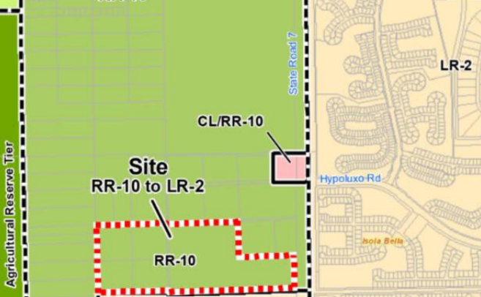
The site outlined in red is where DiVosta Homes, a Pulte Homes' affiliate, will be building a high-end development of 145 single-family homes west of State Road 7 near the intersection of Hypoluxo Road. County commissioners recently approved the development plan.
DiVosta Homes sought the zoning change, as most developers do, to increase the density of its project. Under the current code, it could have only built one home per 10 acres or about 10 homes. With the change approved by county commissioners, it can now build as many as 192 homes, but the homebuilder agreed to a staff recommendation to build no more than 145 zero-lot line homes.

Another development will go up on former site of trotting facility

Horses resumed training Palm Beach Trotting Center on Thursday, March 17, 2016 in unincorporated Palm Beach County.
The DiVosta parcel is adjacent to and just north of the Trotting Center site that has already received county approval for a 166-home development to be built by Lennar. The center received a devastating blow when Pompano Park, Florida's only trotting track, stopped racing in March 2022. The property was bought just three months later.
Many of the trotters that raced at Pompano boarded and trained at the Trotting Center. At its height, the facility featured 14 barns totaling 399 stalls, 50 groom quarters, a veterinarian lab building, an equipment maintenance building and a restaurant. The property had two equine exercise pools, 30 turn-out corrals, a 11/16-mile trotter track, a 6/10-mile deep sand track and a 1/2-mile straight training strip.
County planners concluded that the DiVosta proposal should be approved "considering the pattern established by the Trotting Center development." It also said the parcel was large enough to sustain a master-planned residential community. The DiVosta development will have expanded buffers with native vegetation and limited site access from State Road 7 only, staff noted.
DiVosta said its project “recognizes the unique nature of the Heritage Farms community" and the need for a planning mechanism that will aid in protecting the rural character of the neighborhood without restricting the rights of property owners. It plans on locating smaller lots closer to State Road 7 and placing larger lots further away from the major highway.
The site is comprised of five parcels. The four westernmost parcels, totaling about 40 acres, are owned by Cypress Polo Club LLC. The site is currently used as a polo field. The approximately 56-acre eastern parcel, fronting State Road 7, is known as the Yee Property. It has been used a farm for the past 40 years.
MORE: Closer look at new residential developments Hunter's Crossing and The Trotting Center
An issue, as is with most development in Palm Beach County, is increased traffic. According to the developer’s traffic study, the DiVosta project would generate 1,840 daily vehicle trips onto State Road 7, a heavily congested roadway.
There will also be an impact on Palm Beach County Fire Rescue. The agency estimates that its response time will be eight minutes, higher than its current average of 7 minutes, 16 seconds for the station that would serve the development.
The Treasure Coast Planning Council noted that the zoning change allows for a 20-fold increase in development. It said it is concerned about the impact on what is a rural area. The council recommended that the county wait for the adoption of the Heritage Farms neighborhood plan before approving the DiVosta development.
Mike Diamond is a journalist ar The Palm Beach Post, part of the USA TODAY Florida Network. He covers Palm Beach County government and transportation. You can reach him at mdiamond@pbpost.com. Help support local journalism. Subscribe today.
This article originally appeared on Palm Beach Post: West of Lake Worth Beach farm, polo parcels to be replaced with 145 homes

