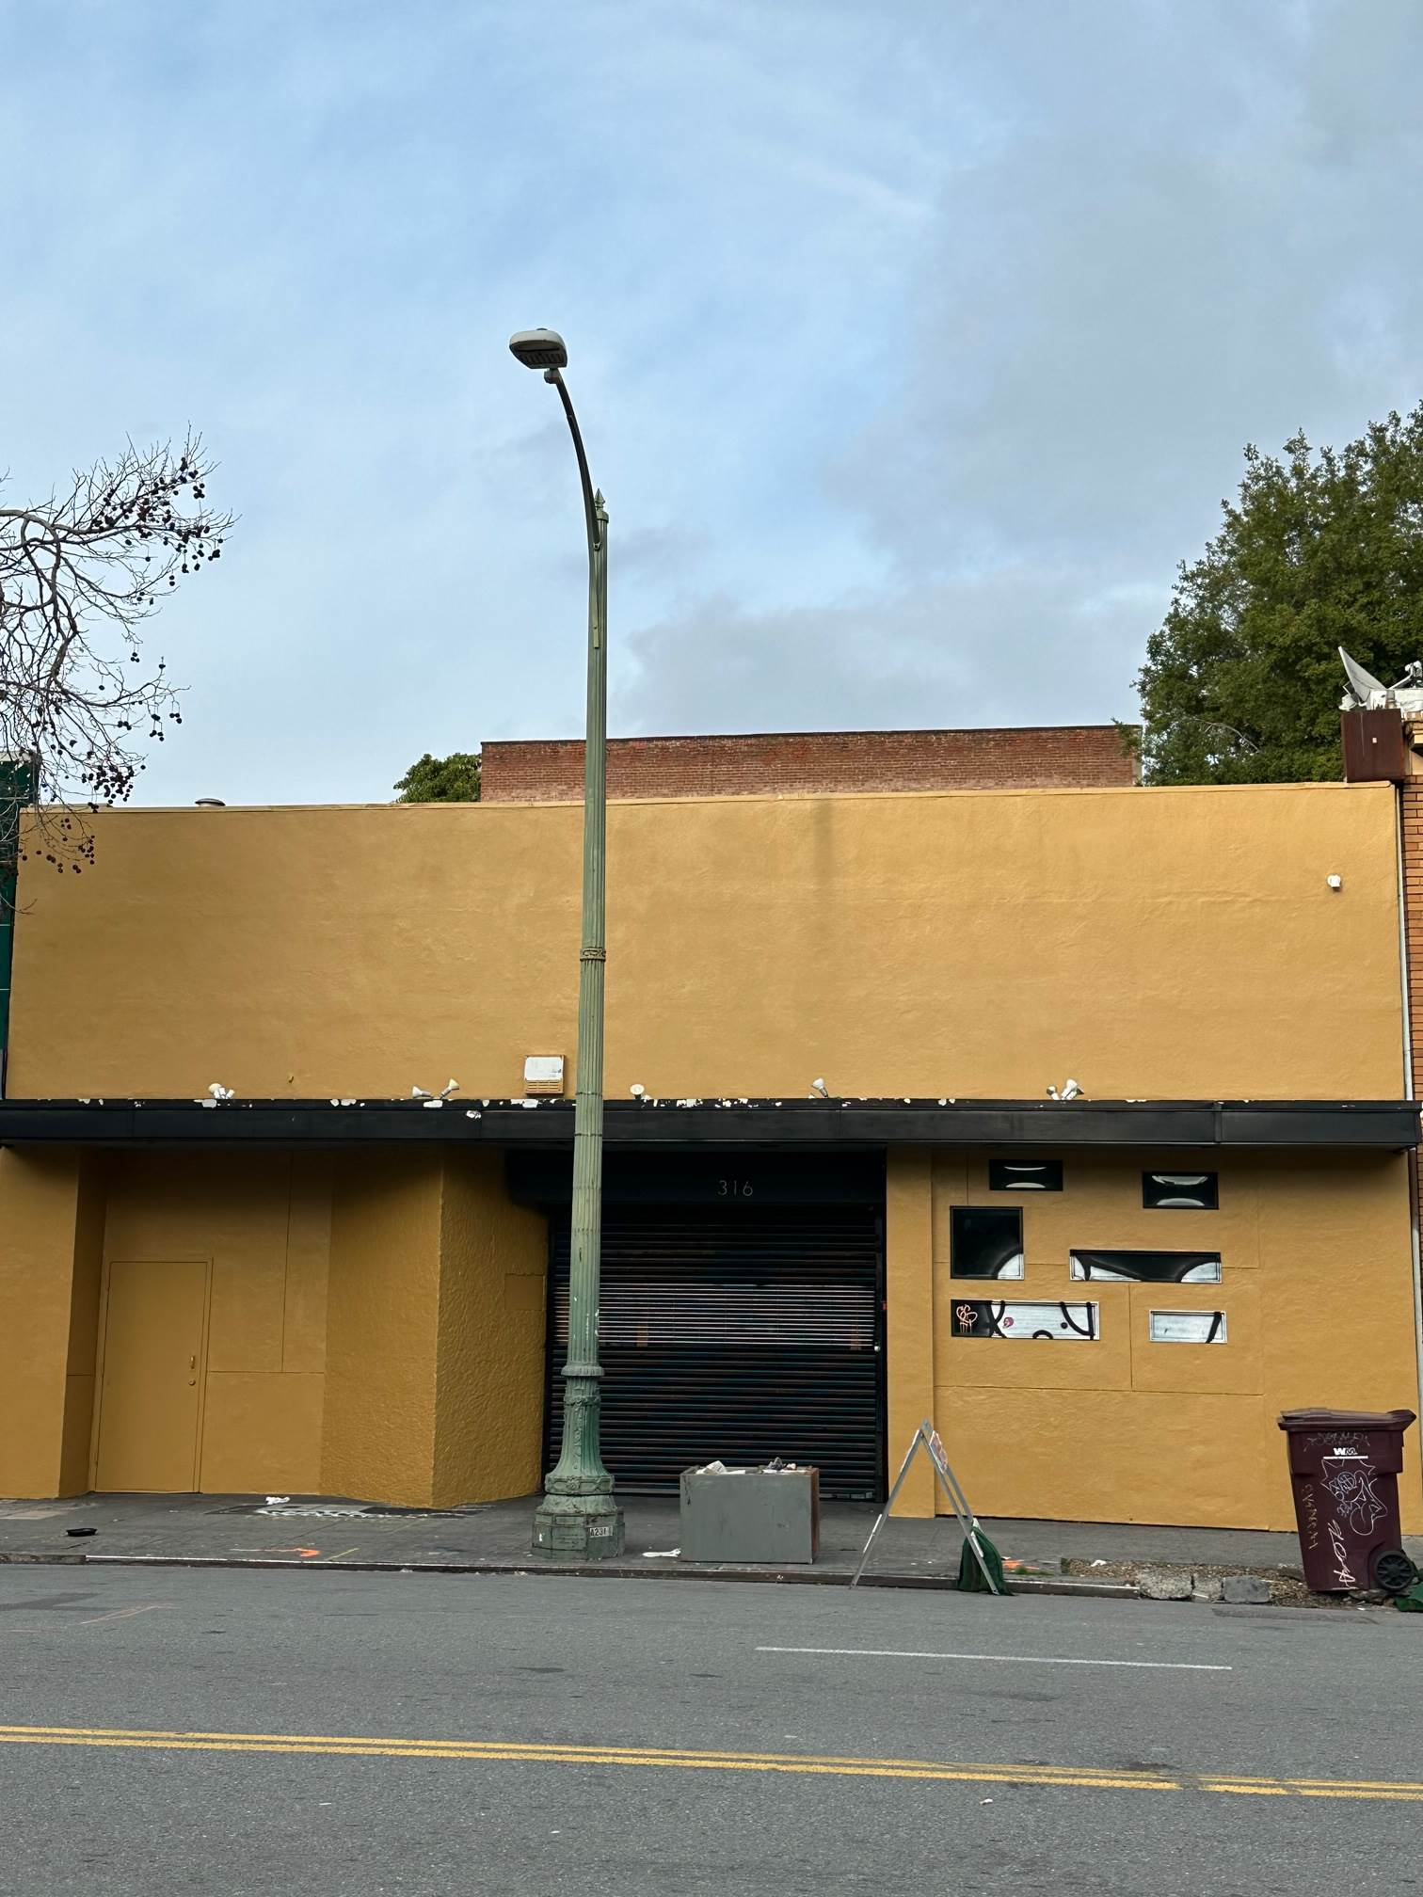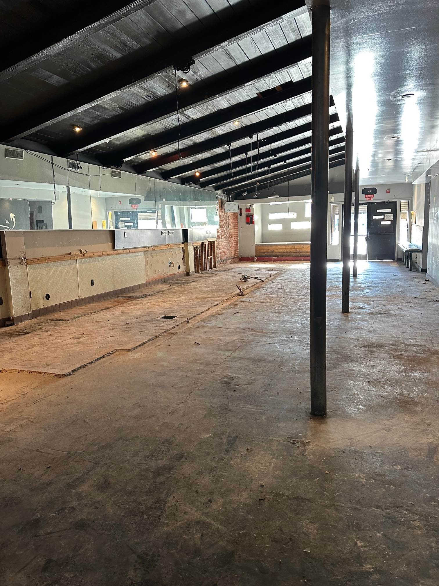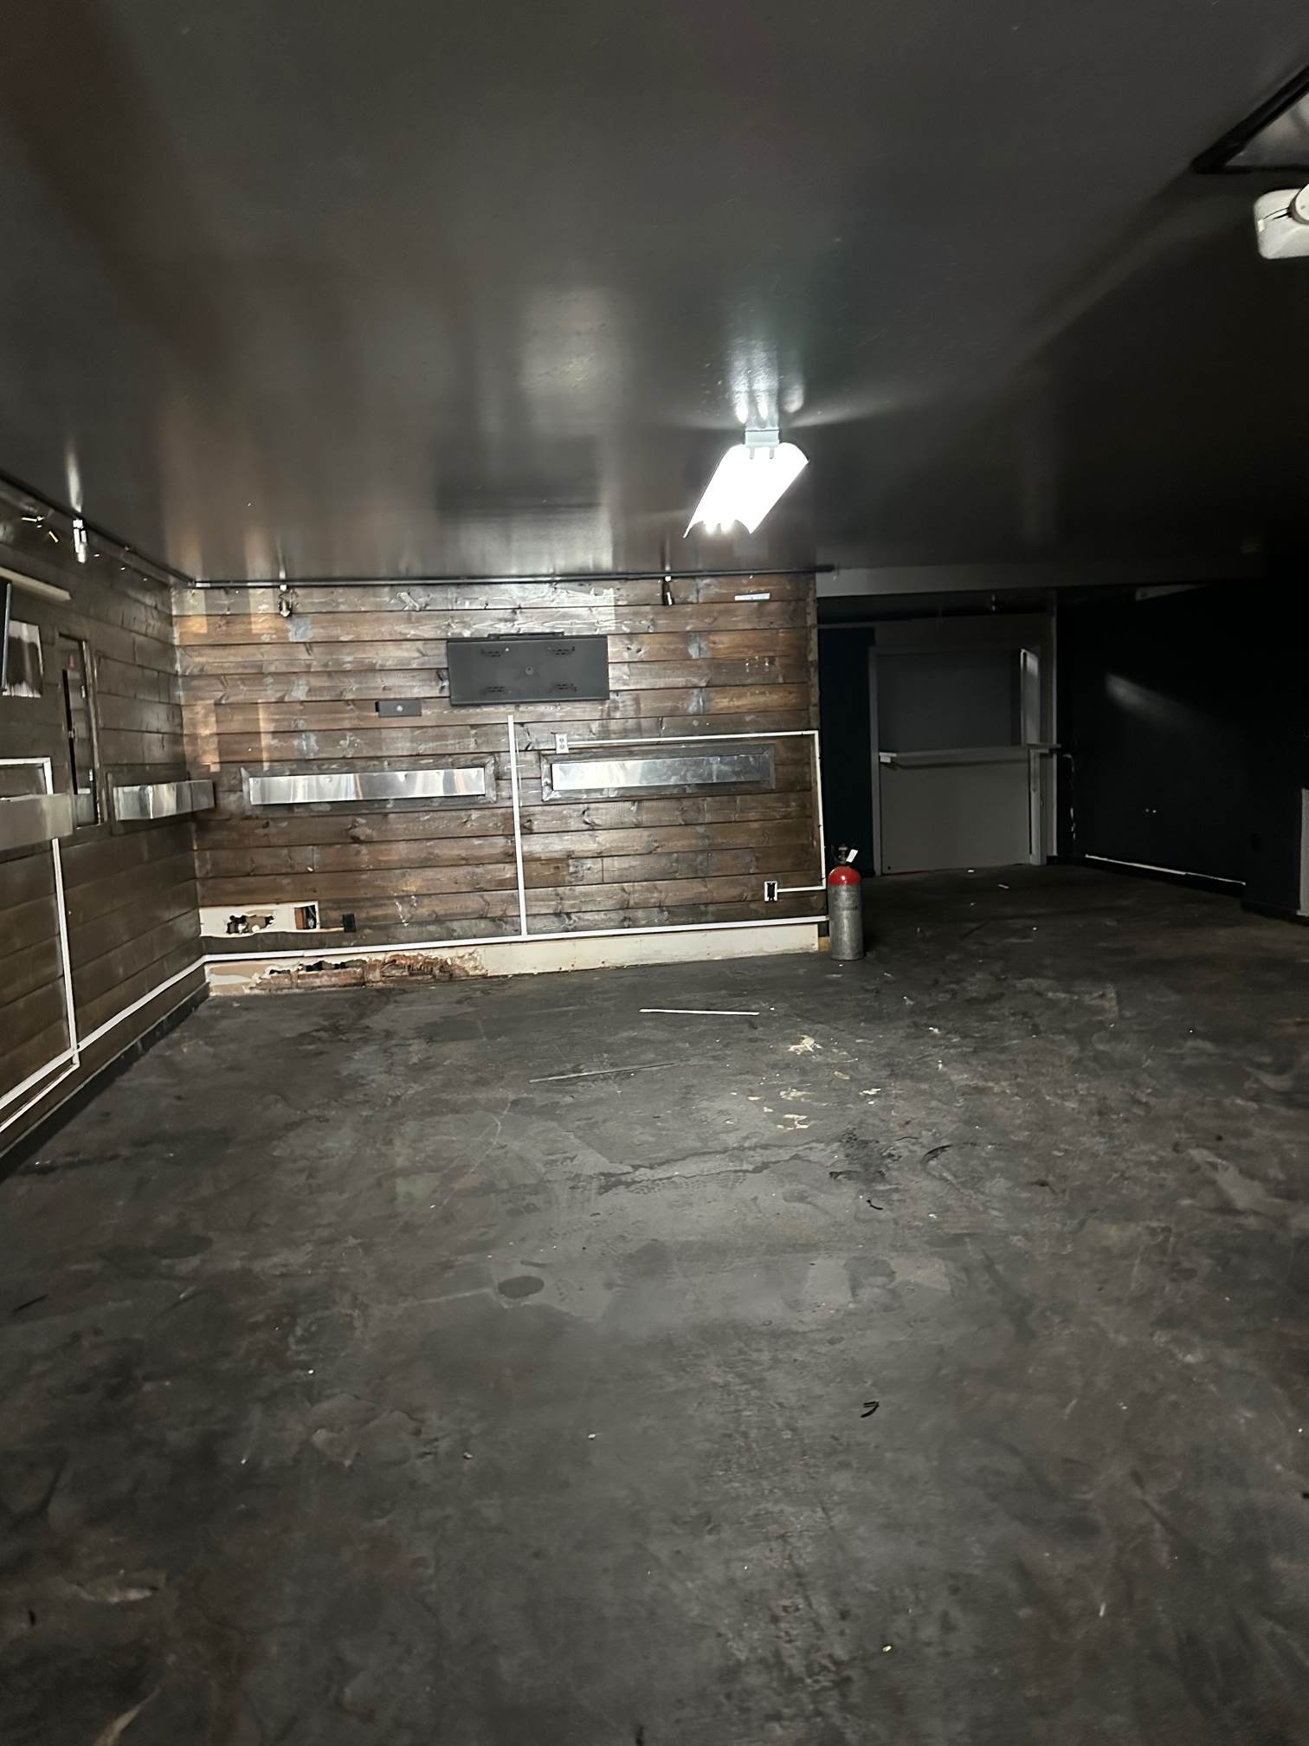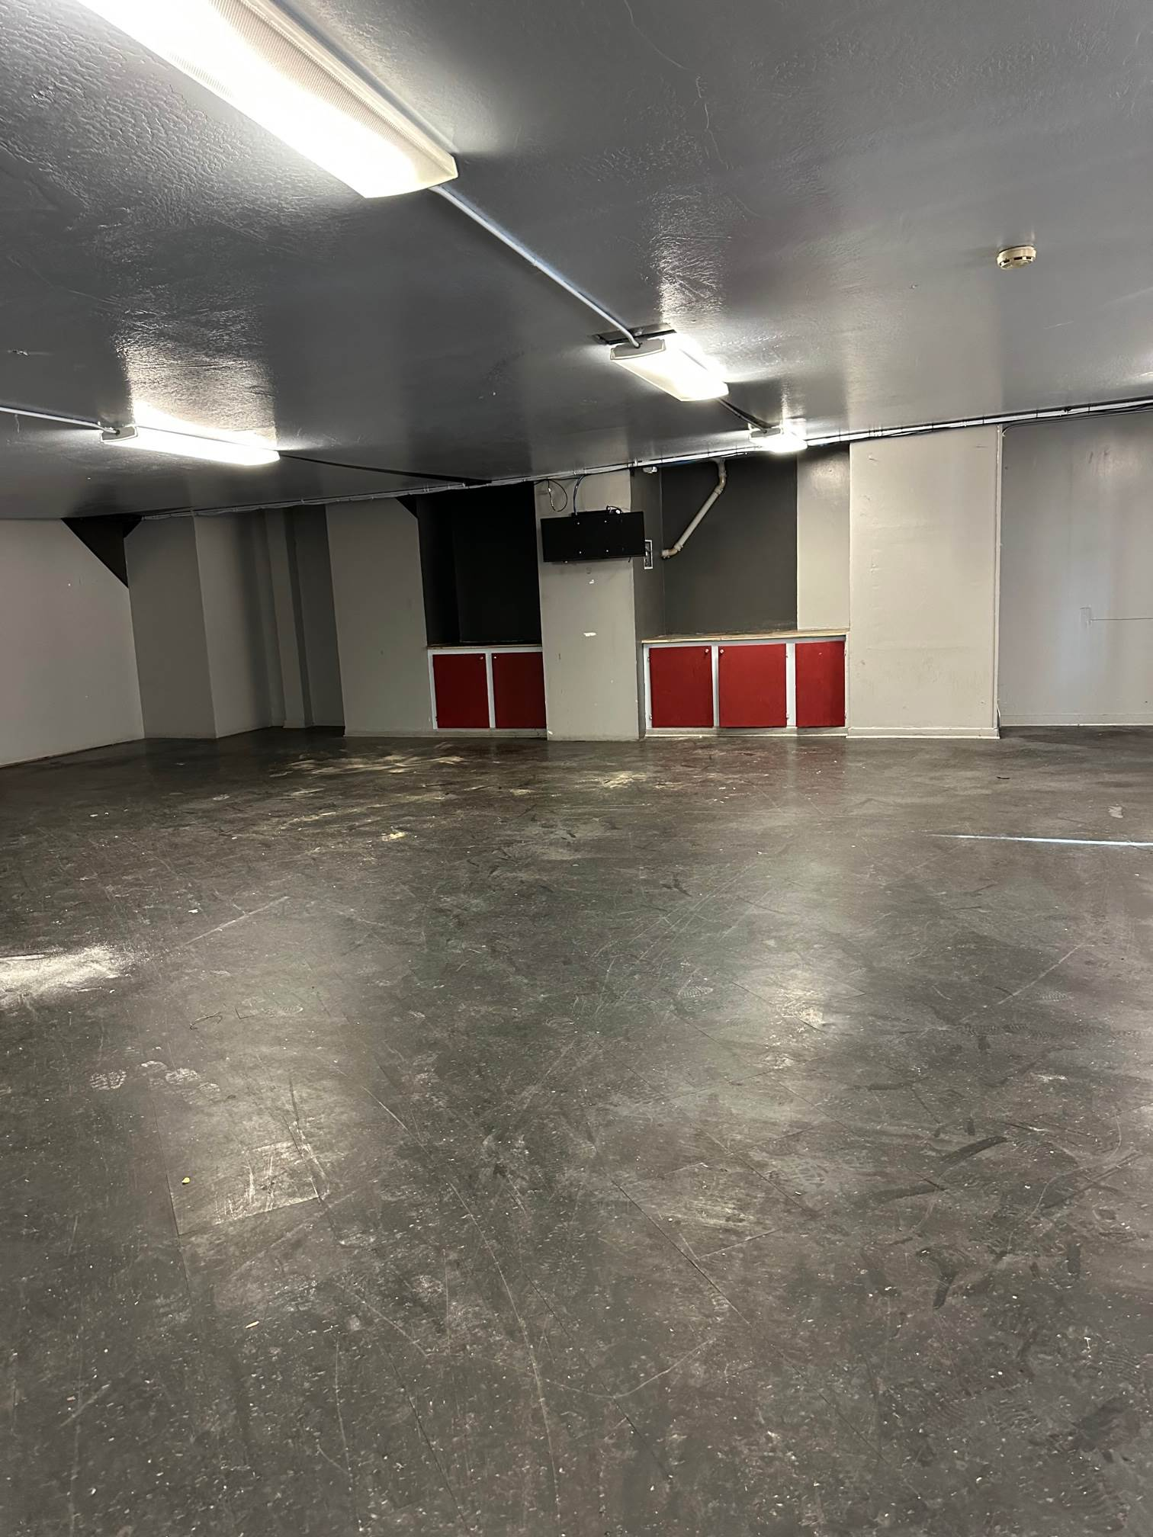

FOR SALE/LEASE

Retail/Restaurant/Bar
316 14th Street, Oakland, CA 94612

Great downtown location walking distance to financial district, Bart, convenience to all.
Former Restaurant and Bar at this location for a long time.

The building consists of an approximately 5636. sq. ft. Great for an owner/user or investment.
First floor 3880 sq. ft. per assessor
Second floor 1756 sq. ft. unverified

Lot Size: 4120 sq. ft. per assessor
Building Size: 5636 sq. ft. unverified

Asking: Upon Requested Proforma NOI $118,356. @ 7% CAP

Contact: Bonnie Chui, DRE #00894884
B.C. Realty (510) 835-8888
Email: bcleader2015@gmail.com
Website: www.bcrealtyleader.com

Information deemed reliable but not guaranteed. Buyer to verify prior to entering into contract

