PRIME COMMERCIAL DEVELOPMENT OPPORTUNITY

12 Acres on North Carolina's Gateway to the Mountains
US 321 Hickory Blvd., Lenoir NC – Caldwell County PRICE: $1,400,000

EXCEPTIONAL HIGHWAY FRONTAGE

MOUNTAIN DESTINATION TRAFFIC
12 ready-for-development acres strategically positioned on North Carolina's busiest thoroughfare - the main artery to the Blue Ridge Mountains. This premium commercial site captures the daily flow of 25,000+ vehicles traveling to North Carolina's most celebrated mountain destinations including Blowing Rock, Banner Elk, Boone, Appalachian State University and the High Country.

LOCATION ADVANTAGES
- 610 feet of frontage on Highway 321 (4-lane divided highway)
- Located in Lenoir - Caldwell County seat (population 18,000)
- 2.5 miles south of US 321 and US 18 intersection, one of NC's busiest intersections
- Adjacent to J.E. Broyhill Civic Center
- Gateway position to the Blue Ridge Mountains and popular resort towns

DEVELOPMENT READY
- Zoned: B-7, Business/Commercial
- Utilities: Water, sewer, natural gas, and electricity
- Topography: Ready for development terrain
- Size: 12 acres providing maximum flexibility

IDEAL FOR:
- Multifamily Development - Capitalize on mountain tourism and university traffic
- Commercial Retail - Serve 25,000+ daily travelers plus local population
- Mixed-Use Development - Combine residential and commercial opportunities
- Hospitality/Tourism - Perfect for travelers heading to mountain destinations

MARKET POSITION
Positioned in the heart of the North Carolina Foothills, this property benefits from:
- Consistent daily traffic flow to Blowing Rock, Banner Elk, Linville, Boone and Blue Ridge Mountain communities
- Proximity to Appalachian State University
- Growing Caldwell County economy
- Year-round tourism to mountain destinations

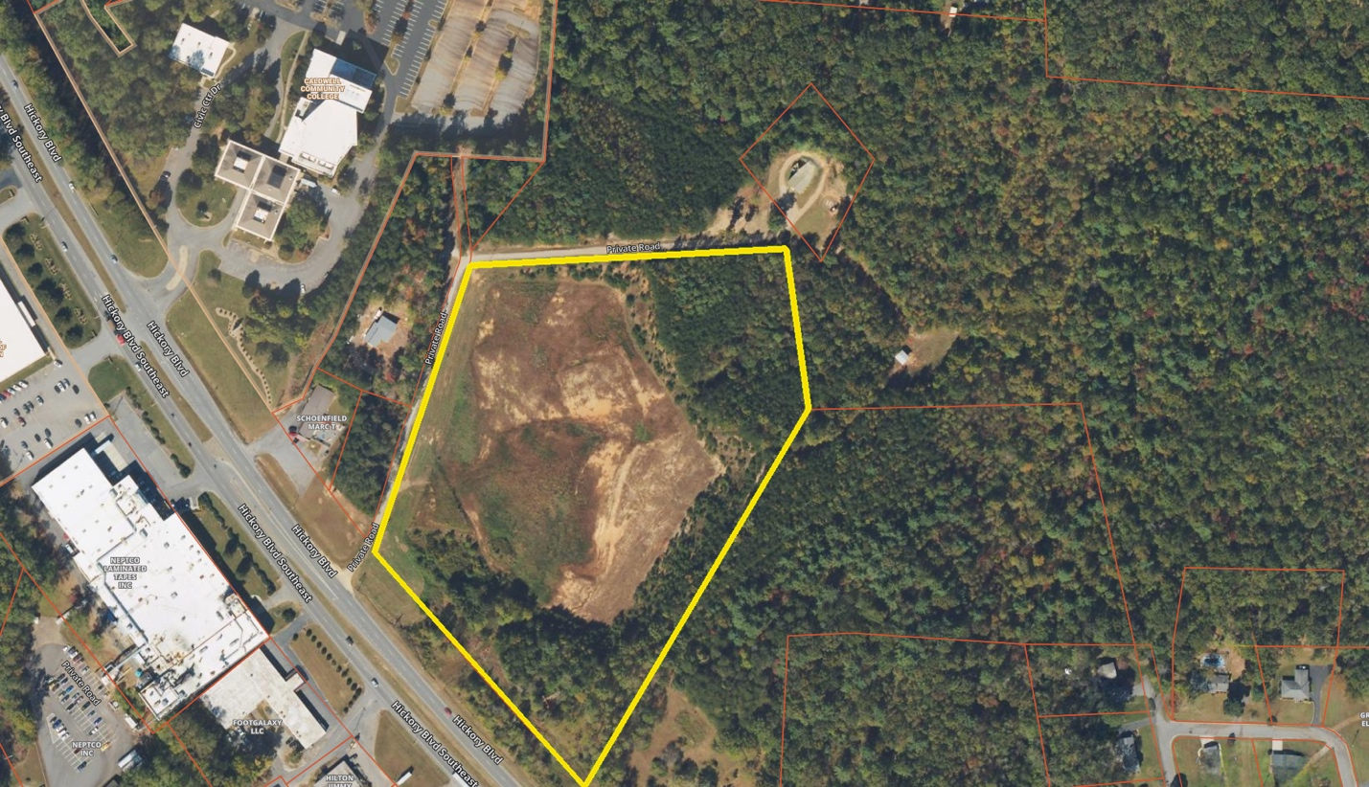
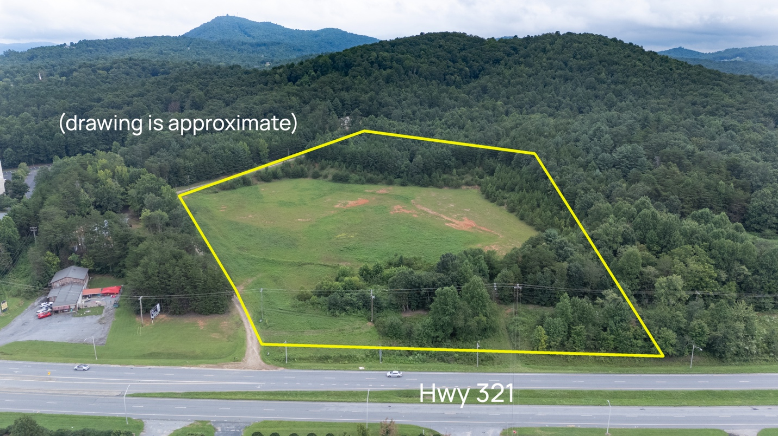



Deborah Murray, Realtor. 828-729-3654
301 North Sterling Street
Morganton, NC 28655 828-438-3660

