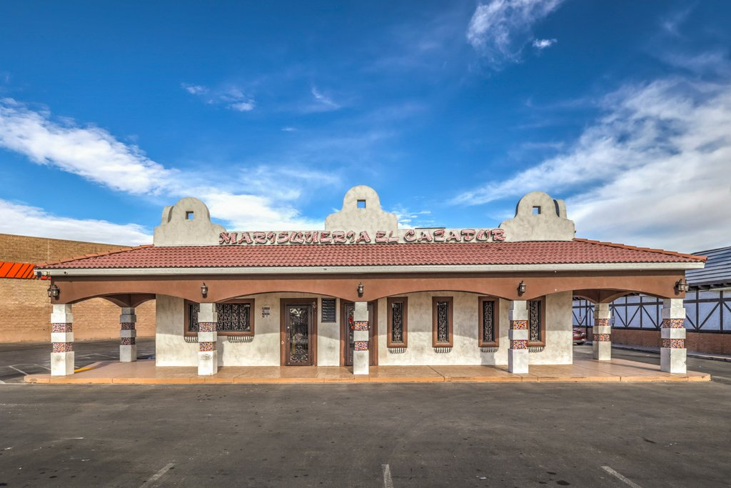
Table of Contents
Insert picture here
Disclaimer 3
Project Highlights 4
Aerials 5
Photos 6
Maps 7
Rent Roll 8
Financial Summary 9
Financial Projections 10
Tenant Descriptions 11
Building Information 12
Site Plans and Floor Plans 13
Area/City Description 14
Demographics 15
Broker Biography 16

Project Highlights

Turn Key Restaurant!!
Fabulous Location in in food concentrated corridor 300 ft off the hard corner of Las Vegas Blvd. and Lake Mead Blvd adjacent to a developing Pink Box donuts right next door, Burger King, McDonalds across the street Arby’s few hundred feet away neighboring German American Club. A 21,000 sq. ft. medical center going in across the street and North Vista Hospital half a block away. The restaurant currently serves Beer and Wine and there are NO Liquor establishments with 1500 feet so obtaining a liquor license is very possible. Property has active grease interceptor as well as additional secured storage behind the building. All equipment in kitchen will convey with the sale. Owners are requesting discretion and viewings are by appointment with listing agents on Tuesday only. Dining area has seating for 99 people with combination of booth & table seating 28 parking spaces with additional storage in back that could add more. A 21,000 sq. ft. medical center going in across the street. 14,000 car count on N. Las Vegas Blvd. 44,000 car count on E. Lake Mead. Blvd

Aerials
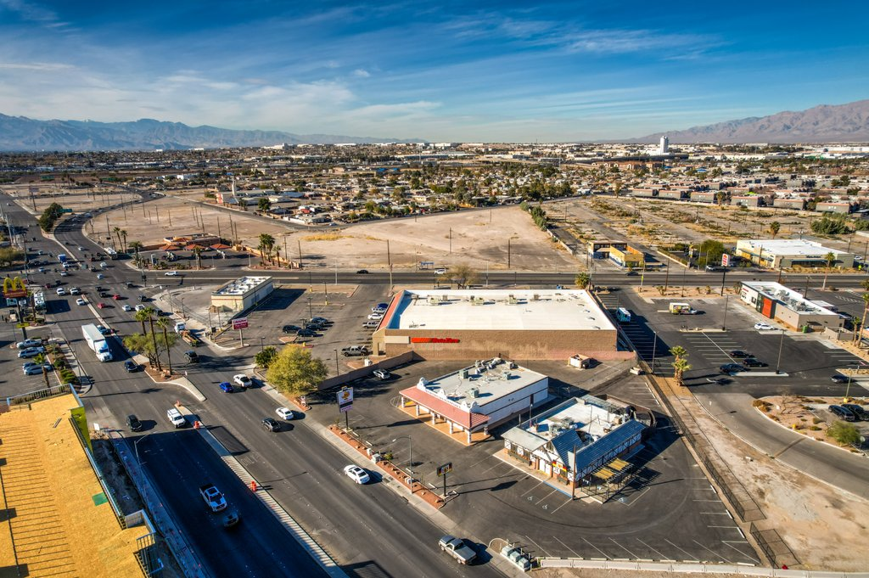

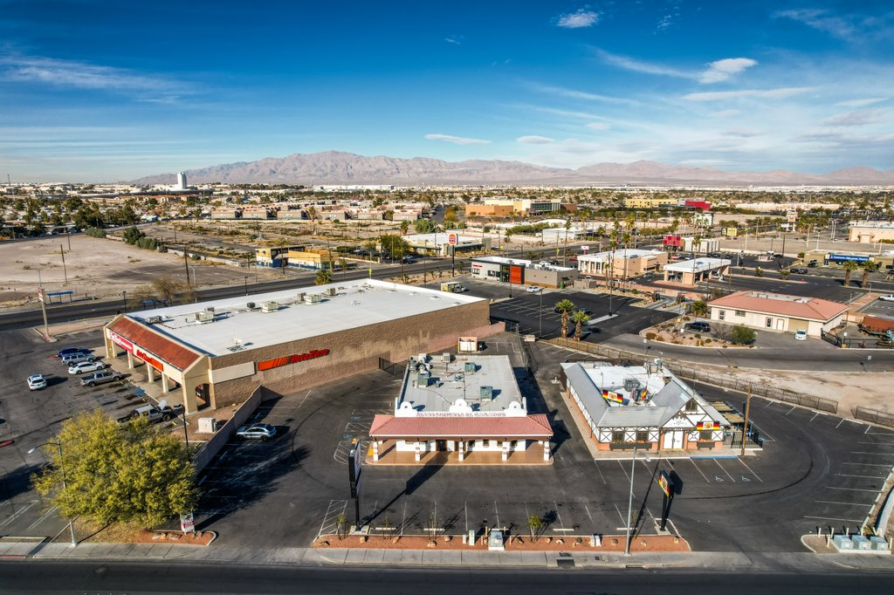
AMAZING LOCATION TURN KEY RESTAURANT WITH FULL KITCHEN BEER & WINE LICENSE NO LIQUOR ESTABLISHMENT WITHIN 1500 FT OF PROPERTY!
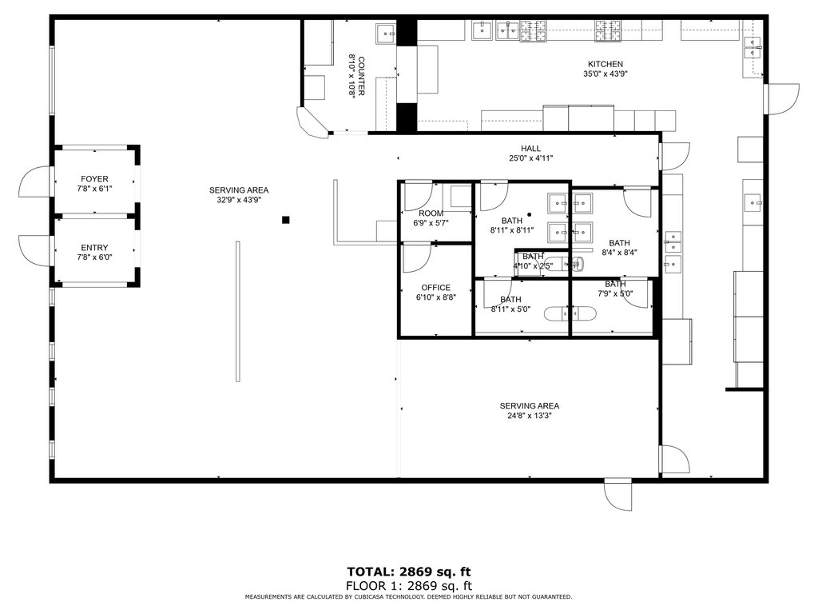

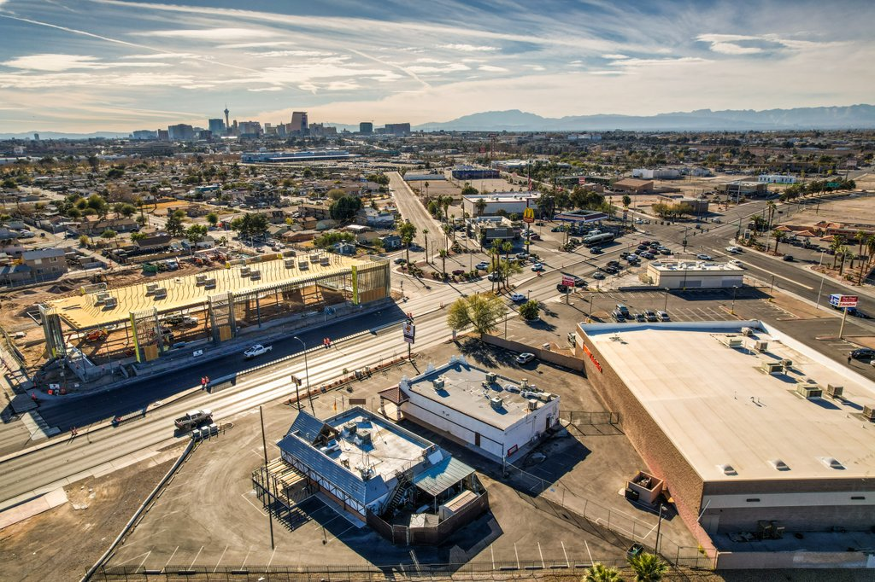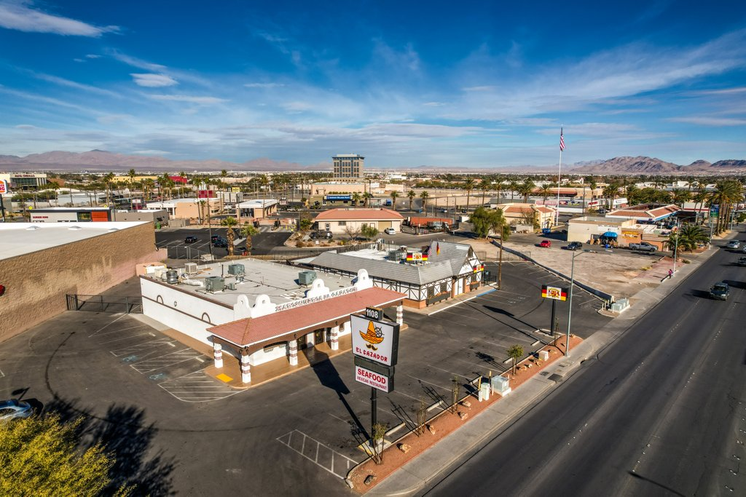
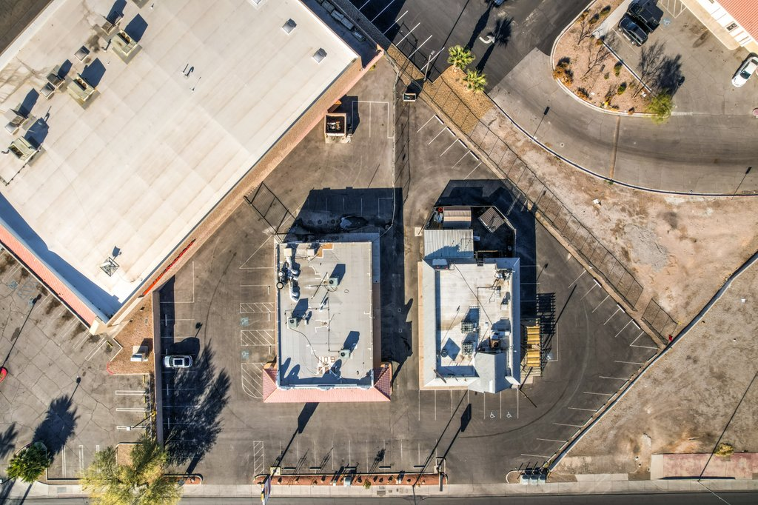

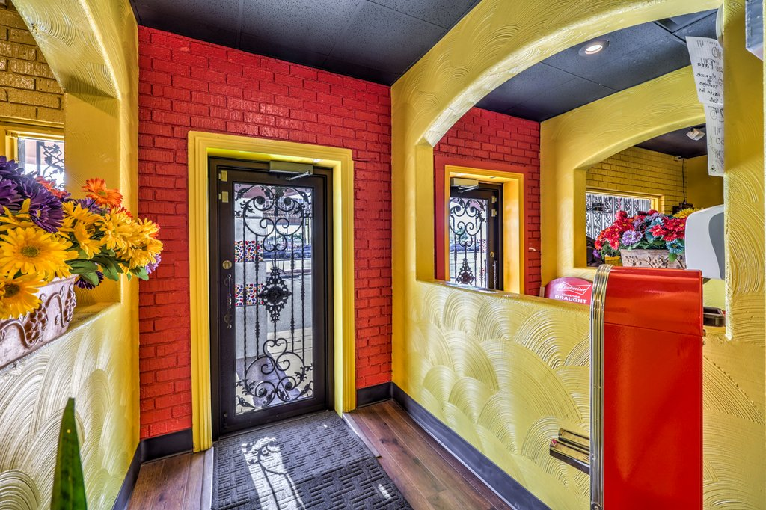
Photos

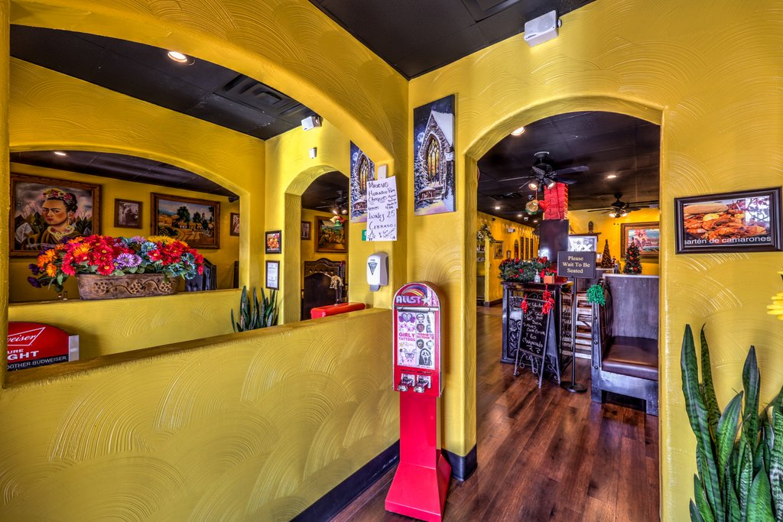

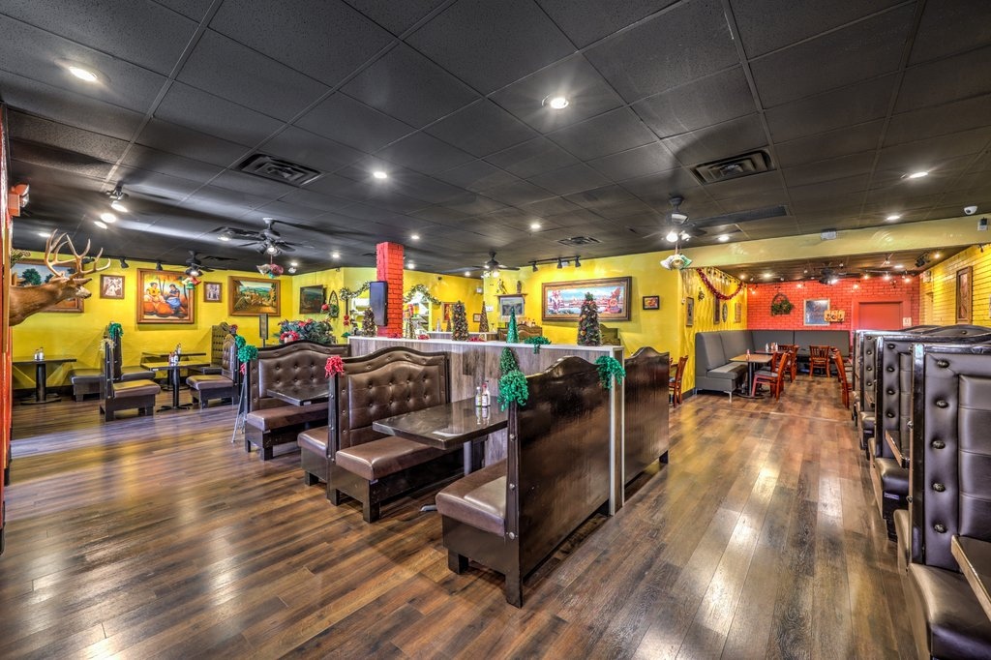
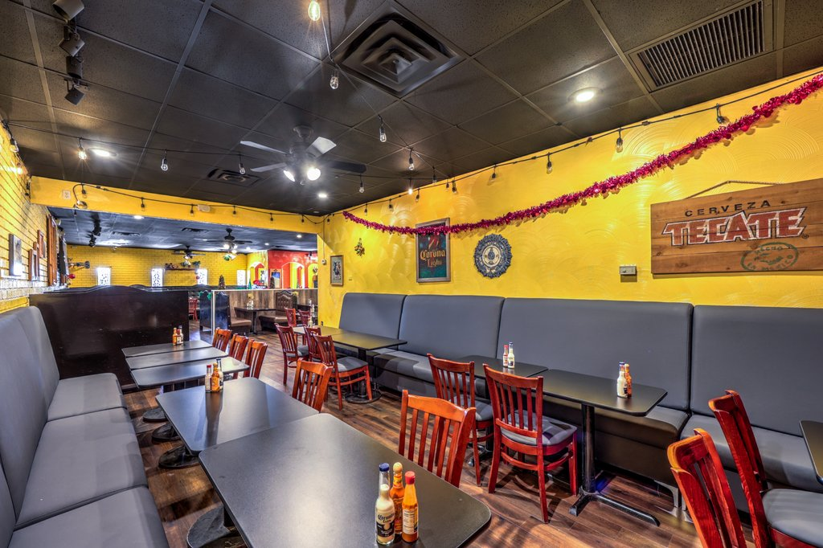

Maps

AMAZING LOCATION HIGH TRAFFIC COUNT 44,000 ON LAKE MEAD 14,000 ON LAS VEGAS BLVD

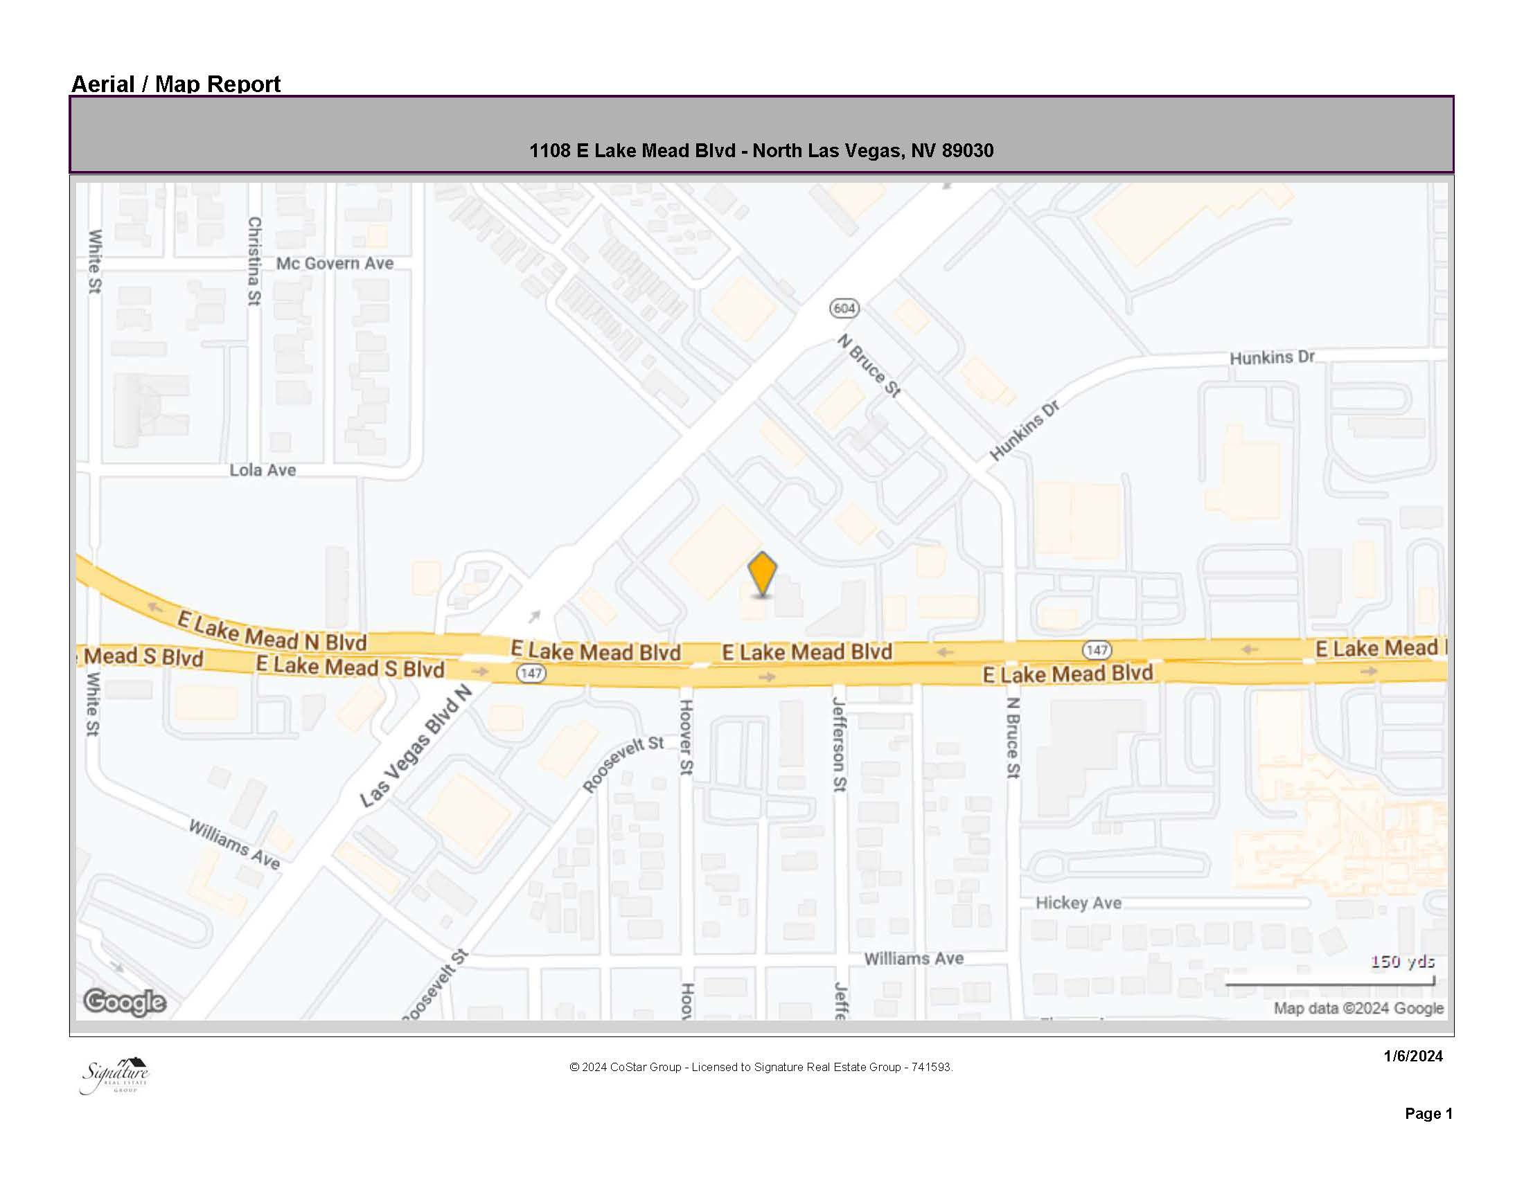
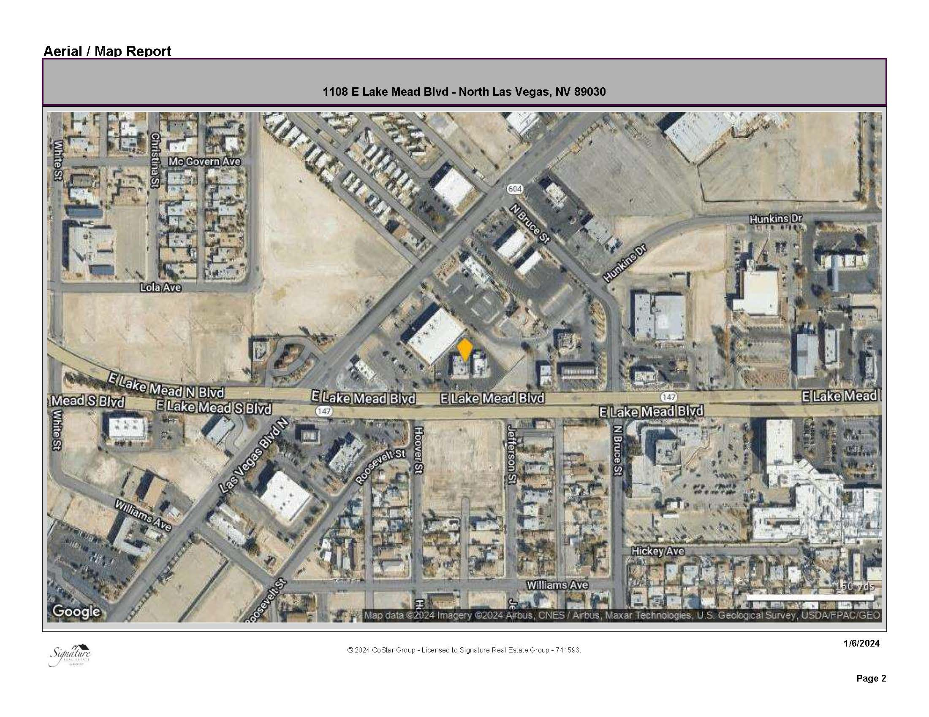

LINKS
Matterport Link

https://my.matterport.com/show/?m=EzJzmKtnAa3

Video Link

https://drive.google.com/file/d/1l7eUcrkl-pl2BIWeaWfL8TJuY1BMyaXd/view?usp=sharing

Tenant Descriptions
Current Tenant is Owner User

Building Information
TURN KEY RESTAURANT!!!!
-2869 Sq. Ft. 69 feet deep 49 feet wide building +/-
-Commercial Zoning
Fabulous Location in in food concentrated corridor 300 ft off the hard corner of Las Vegas Blvd. and Lake Mead Blvd adjacent to a developing Pink Box donuts right next door, Burger King, McDonalds across the street Arby’s few hundred feet away neighboring German American Club. A 21,000 sq. ft. medical center going in across the street and North Vista Hospital half a block away. The restaurant currently serves Beer and Wine and there are NO Liquor establishments with 1500 feet so obtaining a liquor license is very possible. Property has active grease interceptor as well as additional secured storage behind the building. All equipment in kitchen will convey with the sale. Owners are requesting discretion and viewings are by appointment with listing agents on Tuesday only. Dining area has seating for 99 people with combination of booth & table seating 28 parking spaces with additional storage in back that could add more. A 21,000 sq. ft. medical center going in across the street

Site Plans and Floor Plans

Area/City Description
LAS VEGAS & NORTHLAS VEGAS – ONE OF THE FASTEST GROWING CITIES IN THE U. S.
Las Vegas is an internationally renowned major resort city known primarily for gambling, shopping
and fine dining and is the leading financial and cultural center for Southern Nevada. The city
bills itself as The Entertainment Capital of the World, and is famous for its consolidated
casino/hotels and associated entertainment. It has also become a world- class city for sporting
events, now home to the Las Vegas Raiders, Vegas Golden Knights, National Finals Rodeo and UFC.
This year, Las Vegas also became one of only three U.S. cities to host the Formula 1 Las Vegas
Grand Prix (and made a 10-year commitment) and will host the 2024 NFL Super Bowl. MLB’s Athletics
were recently granted approval to move their MLB team to Las Vegas and should start playing ball
here in 4-5 years. A growing retirement and family city, Las Vegas is the 26th most populous city
in the United States, with a population at the 2022 census of 656,274. The 2022/2023 population of
the Las Vegas metropolitan area is 2,899,000.

TODAY, LAS VEGAS and NORTHLAS VEGASs IS ONE OF THE TOP TOURIST DESTINATIONS IN THE WORLD.
Established in 1905, Las Vegas was incorporated as a city in 1911. Las Vegas often refers to the
city plus some areas beyond the city limits, especially the resort areas on and near the Las Vegas
Strip, and sometimes the entire Las Vegas Valley.

Las Vegas is situated within Clark County in an arid basin on the desert floor,
surrounded by dry mountains. The Spring Mountains lie to the west. Within the city there are many
lawns, trees, and other greenery. The city enjoys abundant sunshine year-round: it has an average
of about 300 sunny days per year. The primary drivers of the Las Vegas economy are tourism, gaming,
sporting events and conventions, which in turn feed the retail and restaurant industries.

Demographics
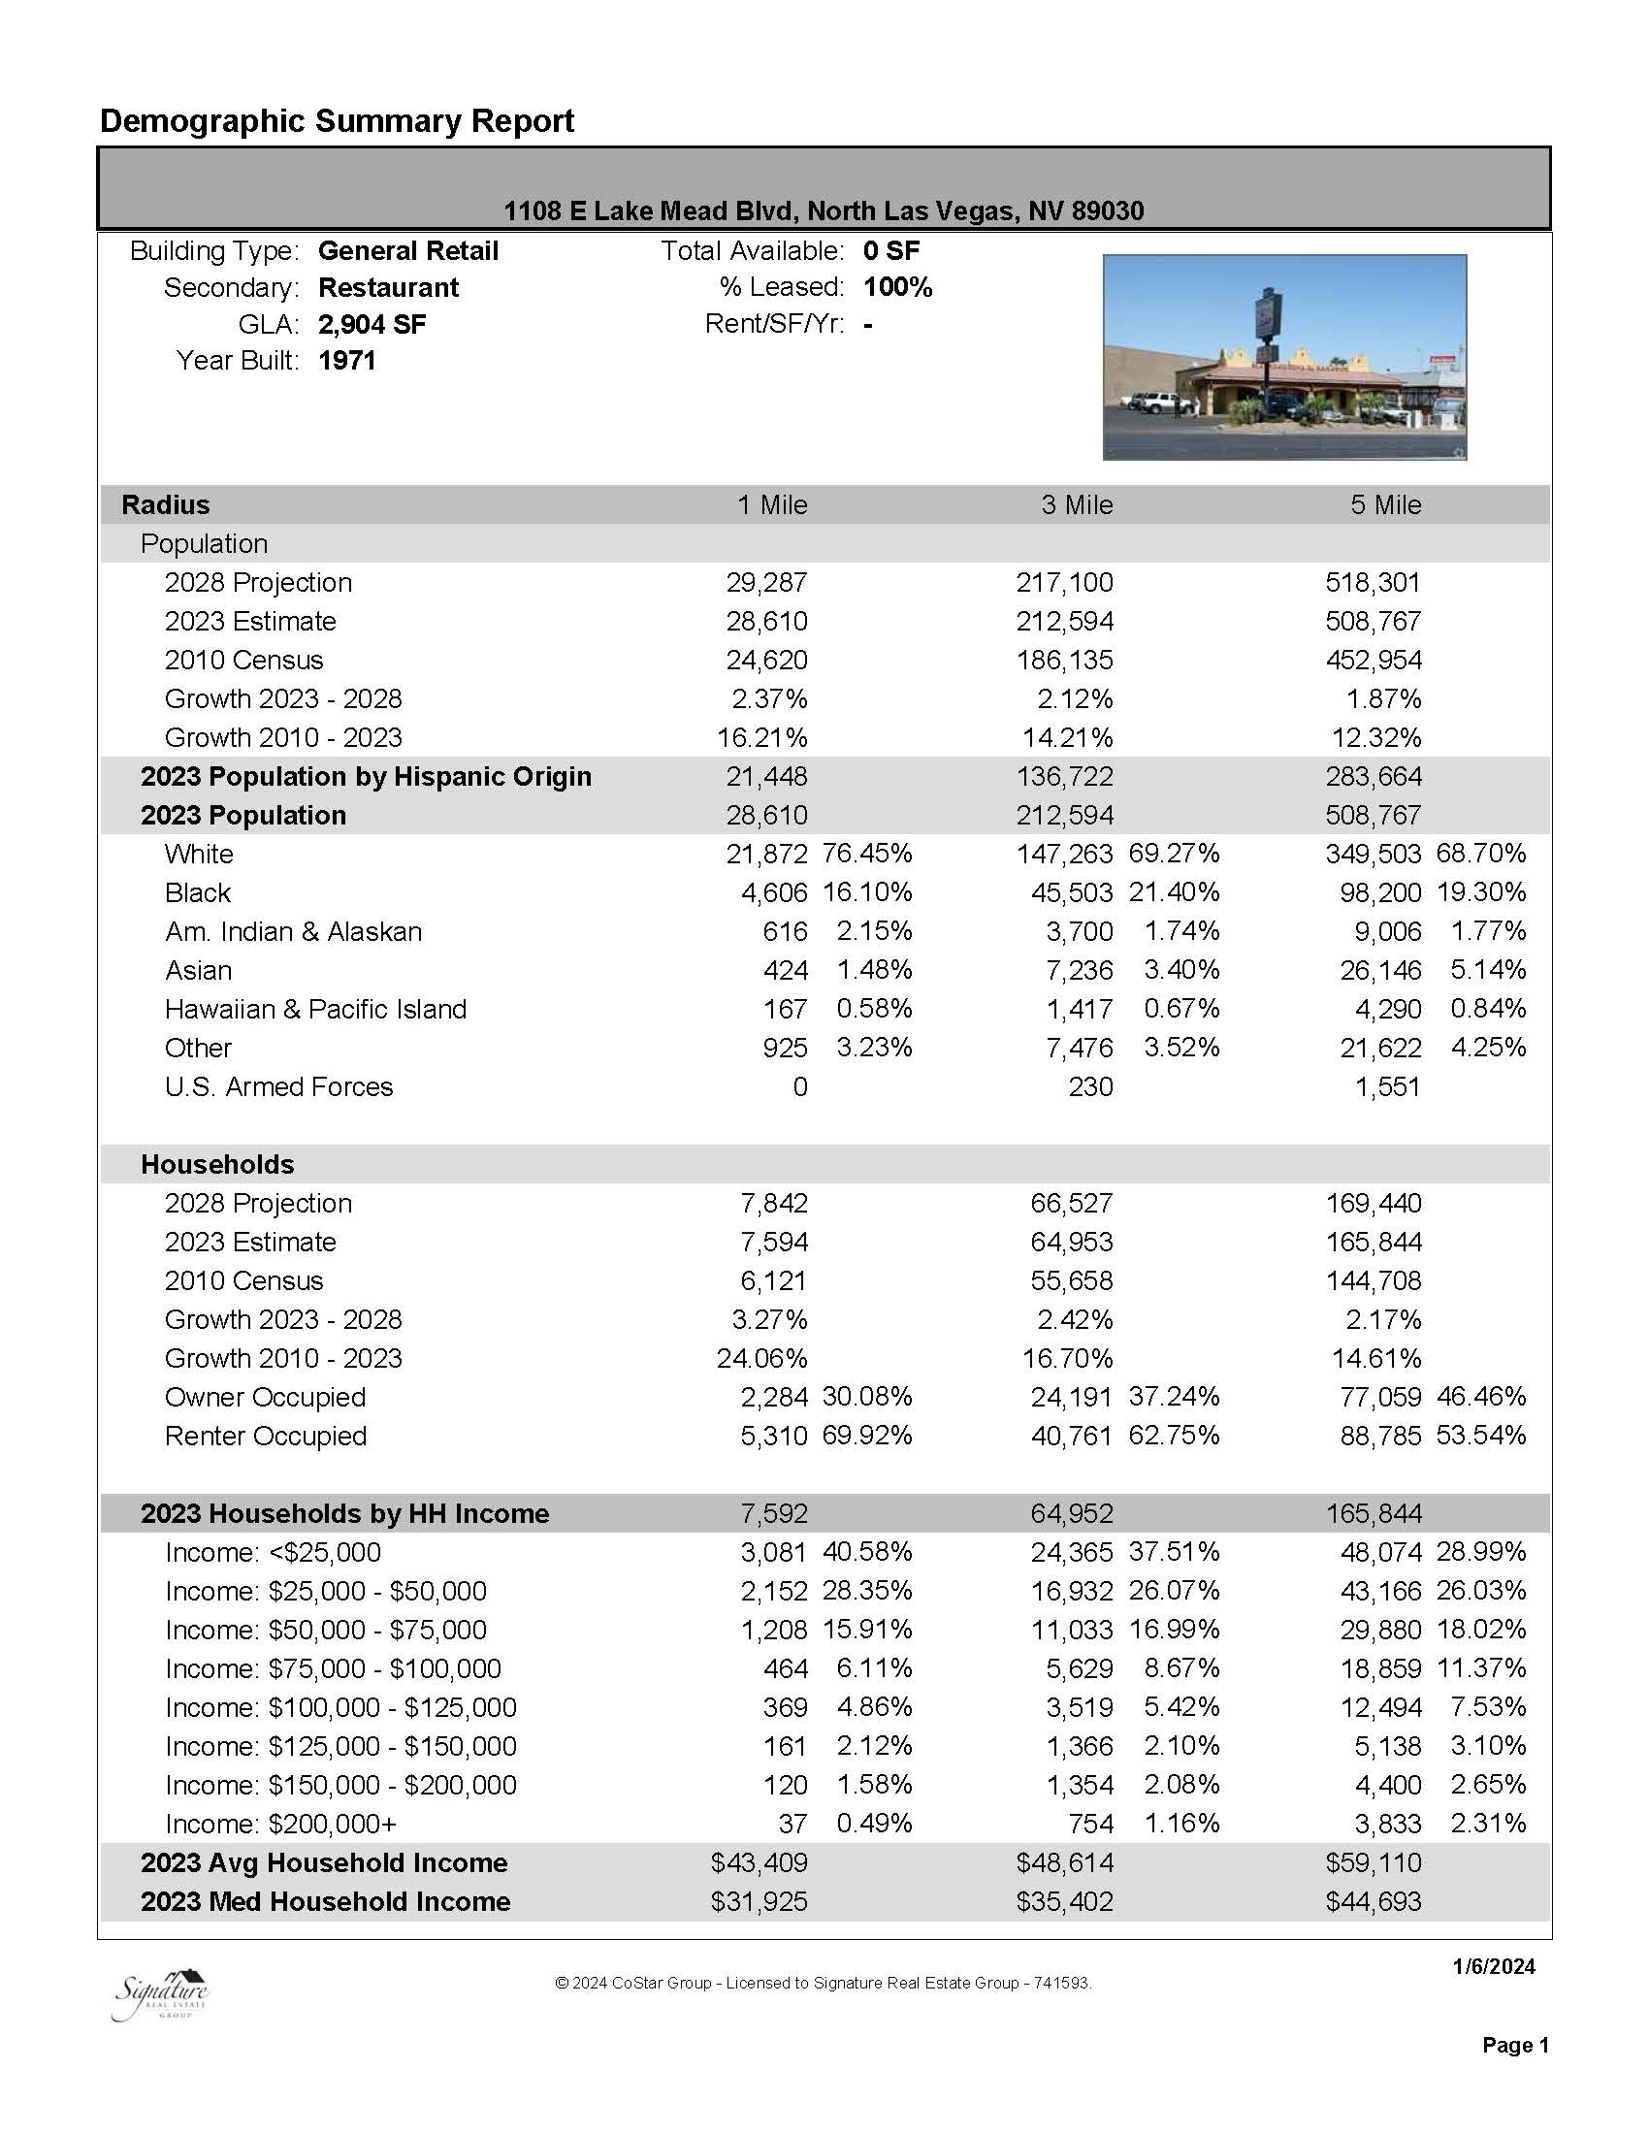

Broker Biography
Native to las Vegas William J Schlaf has extensive knowledge of the Las Vegas and surrounding area marketplace starting out in Real Estate acquisitions for over 30 yrs.. graduate of University of Nevada Las Vegas 92’. Food & Beverage executive for 20 years on the Las Vegas Strip.

Land Specialist & Asset Manager with 30yrs +++ experience

William J. Schlaf,
Sales Agent, Property Manager

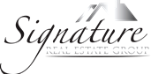
REALTOR® LN: #174418
Signature Real Estate Group
Commercial Division
8912 Spanish Ridge Ave. #210
Las Vegas, NV 89148
Office Phone: 702-799-9598
Cell: 702-274-6398

