Sec. 28-2-13. - Downtown district (DD).
(a) Purpose. Refer to section 28-2-3, districts established.
(b) Applicability.
(1) Character. The character of the downtown district (DD) is established by the types of buildings, where they're placed on a lot, and the context of these buildings in relation to one another and to the street. The buildings provide for a variety of land uses subject to the functional design of buildings, streets, and civic spaces as set out by the standards of this section.
(2) Future land use. The DD is designated as urban mixed-use on the future land use and character plan.
(c) Building standards and building types. Displayed in table 28-2-13-1, building standards, and figure 28-2-13-1, building frontage types, are the standards for developing the uses listed below. The design standards for this district are found in section 28-2-13, downtown district.
Table 28-2-13-1
Building Standards
Building Types |  | SF Detached |  | SF Attached |  | Townhome | Mixed-Use
 |  | Single-Family | Patio | Duplex | Twin Home | Townhome | Retail | Mixed-Use
Building Frontage |  | OY/PO | OY/PO | OY/PO | OY/PO | PO | AG/SF | AG/FC/SF
Legend: OY = Open Yard; PO = Porch; FC = Forecourt; SF = Storefront; AG = Arcade/Gallery; See Figure 28-2-13-1, Building Frontage Types.
Maximum Density and Bulk
— | Units Per Acre ¹ | 6.5/6.0 | 8.6/8.0 | 9.7/8.8 | 9.7/8.8 | 15.5/14.0 | 45.0 | 75.0
— | Floor Area Ratio (FAR) | — | — | — | — | — | 1.85 | 2.70
Minimum Lot (per dwelling unit) ⁸
 | Area (square feet) | 6,000 | 4,500 | 4,000 | 4,000 | 2,500 | 1,500 | —
 | Width (feet) | 50 | 45 | 40 | 80 | 25 | 35 | —
Minimum Building Setbacks (feet)
C | Front ^{2,3} | 25/19 | 25/19 | 25/19 | 25/19 | 6 - 8 | 0 - 5 ^{4, 7} | 0 - 5
D | Interior Side ^{3,5} | 5 | 5/0 | 12 | 7.5/0 | 7.5 | 7.5/0 | 7.5 | 8 | 0 | 15 | 0 - 5
E | Street Side | 20 | 20 | 20 | 20 | 12 | 0 - 5 ⁴ | 0 - 5
F | Rear ⁶ | 20 | 15 | 15 | 15 | 20 | 25 | 0
— | Abutting SR or SU | equal to applicable setback of SR, or SU |  |  |  | 25 | 30 | 30
Maximum Building
G | Coverage (percent) | 0.40 | 0.45 | 0.55 | 0.45 | 0.65 | see FAR above ⁴
H | Height (feet) | 35 | 35 | 35 | 35 | 35 | 45 | 45
Frontage (See Figure 28-2-13-2, Building Frontage Types)
I | Forecourt (1) Depth and (2) Width (feet) |  |  |  |  |  |  | 10/12
J | Storefront Canopy/Awning (1) Depth, (2) Setback from Curb and (3) Clearance (feet/percent/feet) |  |  |  |  |  | 4/75/8 | 4/75/8
K | Gallery/Arcade (1) Ground Floor Height, (2) Upper Floor Height and (3) Total Height (feet) |  |  |  |  |  | 11/9/20 | 11/9/20
NOTES
1. Density without/with alleys.
2. Where the front setbacks of existing dwellings are less than 25', the front setback of an infill lot may be the average of the dwellings along the block face; excluding the infill lot.
3. Where two numbers are divided by "/", they represent the setbacks for the Open Yard (OY) and Porch (PO) frontage types; when divided by "-", they represent a build-to range; and when divided by "|", they represent a zero interior side yard on one site and × feet on the other interior side setback.
4. Multiple Retail Sales and Service uses located on a single parcel shall be arranged in clusters of multiple attached buildings and with internal drives. Buildings shall be arranged so that there is a minimum eight-foot and maximum 15-foot walkway along the front and sides of each cluster of buildings. No such cluster shall exceed 20,000 square feet in gross floor area.
5. Patio homes, duplexes, twin homes, and townhomes have a common party wall and zero setback on one interior side.
6. A minimum of 20 feet is required for head-in parking along an alley.
7. A front setback of 10 feet shall be permitted only if all automobile parking is provided for in the back of the building.
8. Minimum area and minimum width requirements are per unit requirements.
*The applicable building types must take primary access to these street types; secondary access may be to a collector street.

Figure 28-2-13-1
Building Frontage Types
Open Yard (OY) | Porch (PO)
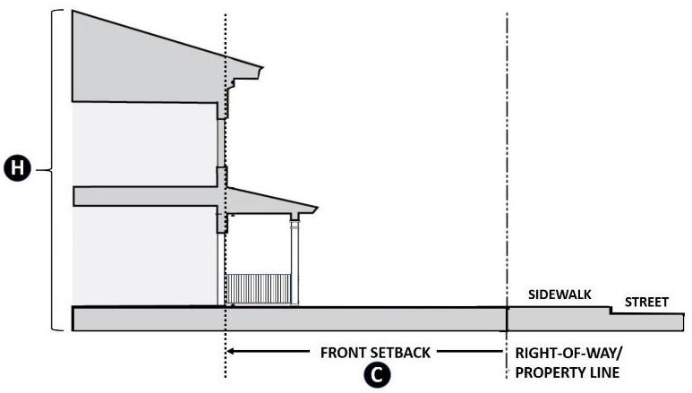 | 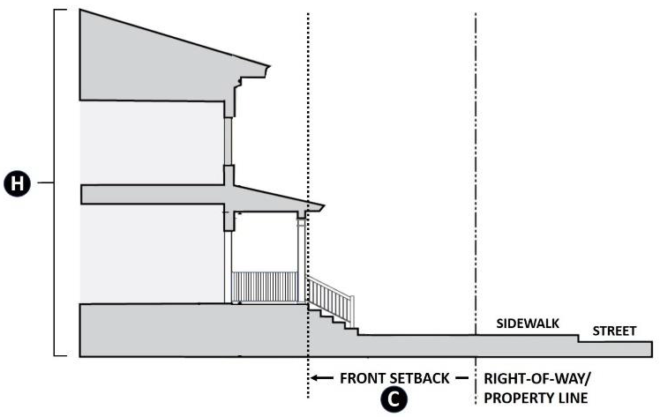
Forecourt (FC) | Forecourt (FC)
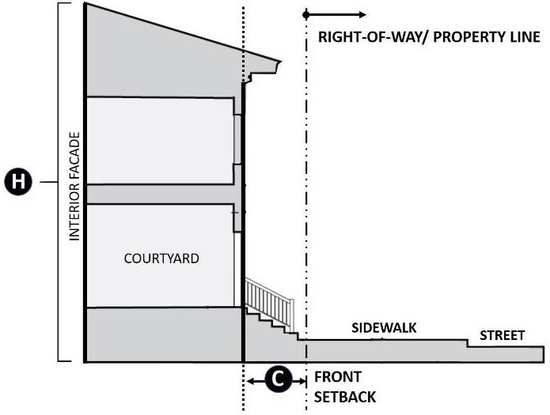 | 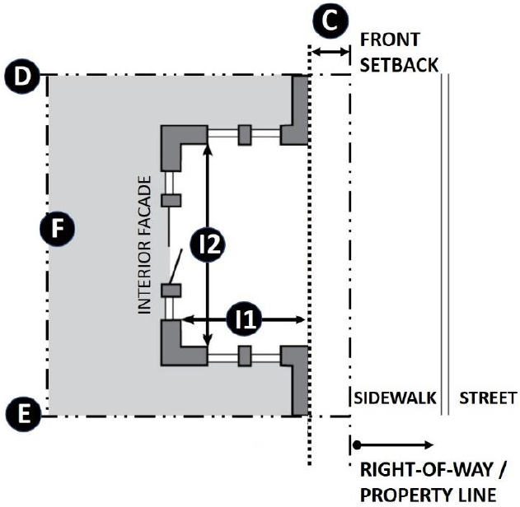
Storefront (SF) | Arcade/Gallery (AG)
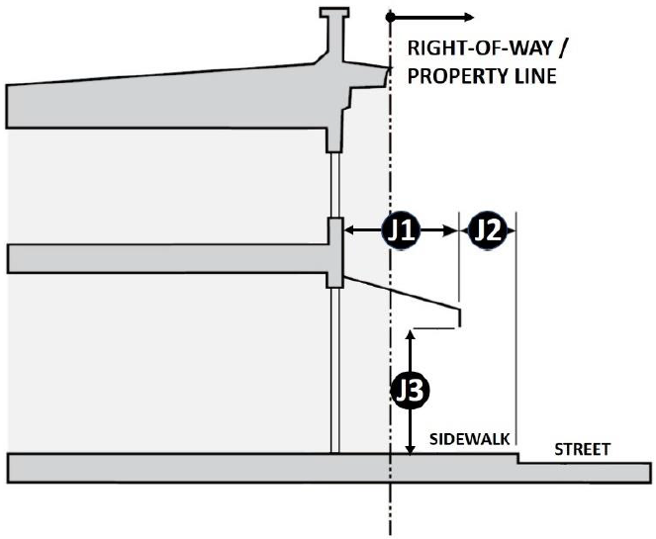 | 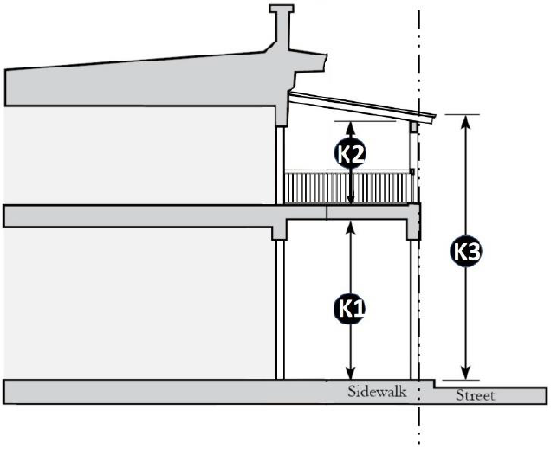

(d) Street types. The cross sections adopted in the city's master thoroughfare plan (MTP) and as shown in subsection 28-4-4.D, street types, are not applicable to the DD.
(e) Alleys. Homes may front on an alley in the DD provided that the requirements of subsection 28-4-5(c), alleys, is met.
(f) Land uses and off-street parking. Table 28-2-13-2, permitted uses and minimum off-street parking spaces, shows the uses and use categories that are permitted by-right, as limited, or as special uses. See section 28-2-16 conditional use standards for additional requirements. Any unlisted use category in table 28-2-13-2 is prohibited in this zoning district. See section 28-3-15, off-street parking and loading for more detailed provisions.
Table 28-2-13-2
Permitted Uses and Minimum Off-Street Parking Spaces
Use Category | Use Type | Minimum Spaces | Cross-Reference
Legend: P = Permitted; C = Conditional; S = Specific; All other uses refer to Sec. 28-2-20, New, Unlisted, and Prohibited Land Uses
Residential
Single-Family Detached Dwelling | C | 2 per dwelling unit | —
Patio Home | C | 2 per dwelling unit | —
Single Family Attached Dwelling (duplex, twin home) | C | 2 per dwelling unit | —
Townhome | C | 1.5 per dwelling unit | —
Apartment | S | 1.5 per dwelling unit | Sec. 28-2-17
Commercial and Mixed-Use
Gas Station | S | 1 per 600 sf. including service bays, wash tunnels, and retail areas | Sec. 28-2-17
Grocery/Retail | C | 1 per 400 sf. of GFA | Sec. 28-2-16
Hotel Full Service or Inn | P | .8 per guest room + 1 per 600 SF public meeting area and restaurant space | —
Mixed-Use | P | Refer to the highest requirement of all of the uses within the proposed development | —
Massage Parlor | C | 1 per 400 sf. of GFA | Sec. 28-2-16
Restaurant, Dine-In, no Drive-Thru | P | 1 per 250 sf. of GFA | —
Office, General | P | 1 per 400 sf. of GFA | —
Public, Institutional, and Utility
Government Office (Library, Post Office, Administration) | P | 1 per 400 sf. GFA | —
Government Service (Police, Fire, EMS) | C | 1 per 300 sf. GFA | Sec. 28-2-16
Parks and Outdoor Recreation, Noncommercial | P | 2 per 1 acre; minimum of 10 spaces | —
Place of Assembly, Indoor | C | Greater of: 1 per 350 sf. or 1 per 4 seats in assembly area | Sec. 28-2-16
TABLE NOTES: sf. = square feet; GFA = Gross Floor Area

(g) Off-street parking reductions. Within the DD district only, remote parking including structured parking may be provided on another parcel and qualify for off-street parking subject to:
(1) Access to the parcel proposed for development shall be on a property that is reasonably accessible to the parcel proposed for development; and
(2) The distance from the parcel proposed for development to the remote parking lot shall not exceed 600 feet.
(h) Landscaping and buffering. Provided in table 28-2-13-3, landscape standards, is the standards for development in this district on properties less than two acres in lot area. See section 28-3-26, planting standards, for more detailed provisions.
Table 28-2-13-3  Landscape Standards |  | Figure 28-2-13-2  Landscape Standards
Single-family Detached
One canopy tree per "x" feet of street frontage | 30 ft. | 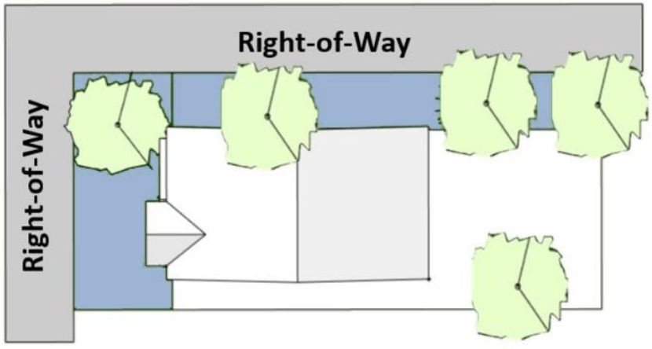
One canopy tree per dwelling unit | —
Single-Family Attached
One canopy per "x" feet of street frontage | 30 ft.
One canopy tree per dwelling unit | —
Multiple-Family (Apartment)
Pervious Area (min.) | 25%
One canopy per "x" feet of street frontage ¹ | 20 ft.
3 shrubs, 2 ornamental grasses or a combination per "x" linear feet of foundation ² | 10 lf.
1 canopy tree, 2 small trees, and 2 shrubs per "x" square feet of pervious area | 2,500 sf. | Commercial Buildings
One landscape island per "x" parking spaces ³ | 15 | Commercial Buildings
Bufferyard Type ⁴ | A | Commercial Buildings
Commercial and Mixed-Use |  | Commercial Buildings
Pervious Area | 5% | Commercial Buildings
One canopy tree per "x" feet of street frontage | 25 ft. | 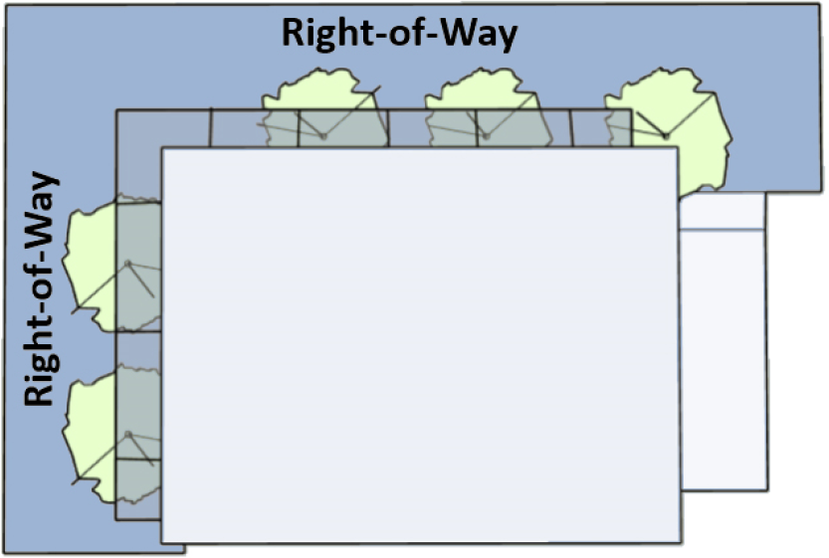
1 canopy tree, 2 small trees, and 2 shrubs per "x" square feet of pervious area | 2,500 sf.
TABLE NOTES:
1. Tree wells in the public right-of-way may count toward the LSR with approval of the Public Works Director.
2. Required along the foundation of building elevations parallel, or approximately parallel, to street right-of-way and parking lots.
3. A landscape island must be no less than 164 sf., which must include one canopy tree and shrubs or groundcover.
4. Required when adjacent to a street or an ER or SR district. (See Sec. 28-3-7, Bufferyards)

(i) Signs.
(1) Permitted sign types. The sign types listed in table 28-2-13-4, permitted sign types, are permitted only if the requirements of division III-4, signs, are met.
(2) Prohibited sign types. Sign types not listed are prohibited in this zoning district.
Table 28-2-13-4
Permitted Sign Types
Sign Type | Nonresidential and Mixed Use | Standards
Access | P | Sec. 28-3-33  and  Sec. 28-3-34
Awning | P | Sec. 28-3-33  and  Sec. 28-3-34
Hanging | P | Sec. 28-3-33  and  Sec. 28-3-34
Marquee | P | Sec. 28-3-33  and  Sec. 28-3-34
Projecting | P | Sec. 28-3-33  and  Sec. 28-3-34
Wall | P | Sec. 28-3-33  and  Sec. 28-3-34
Window | P | Sec. 28-3-33  and  Sec. 28-3-34
Temporary | P | Sec. 28-3-33  and  Sec. 28-3-34
TABLE NOTES: P = Permitted and sign permit required

( Ord. No. 2020-1331 , § 2(Exh. A), 9-15-2020)

