WESTWOOD SUPPER CLUB / LUMBERJACKS SPORTS BAR
1640/1642 US HWY 2 CRYSTAL FALLS, MI 49920
UPPER PENINSULA “UP”
9.8 ACRES ON ATV & SNOWMOBILE TRAIL
Call or Text 847-489-6060 DAVID

1640 US HWY 2 CRYSTAL FALLS, MI 49920
Natural Gas, City Water, its own septic
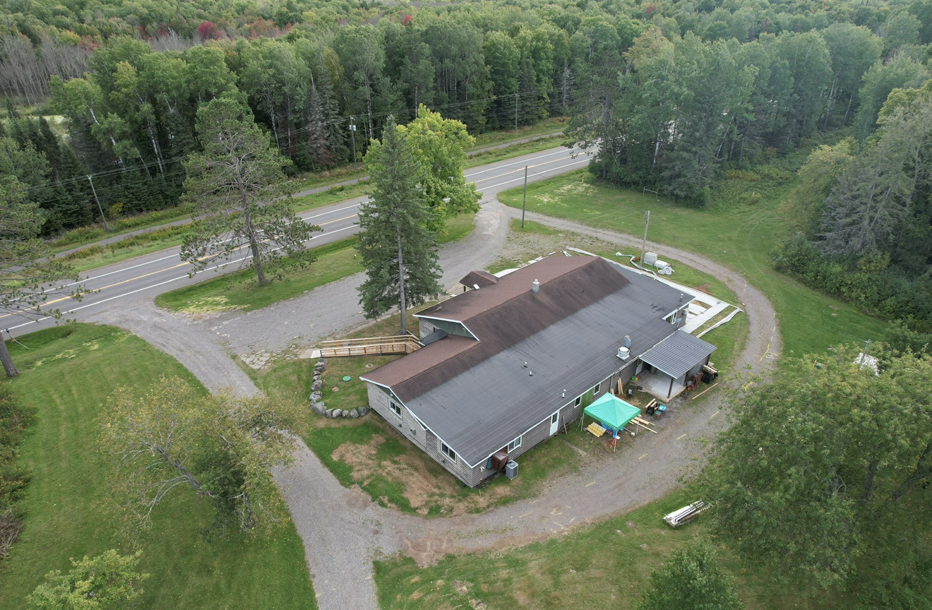

1642 US HWY 2 CRYSTAL FALLS, MI
UPPER PENINSULA “UP”
4 BEDROOM, 2 BATH, 2 CAR GARAGE

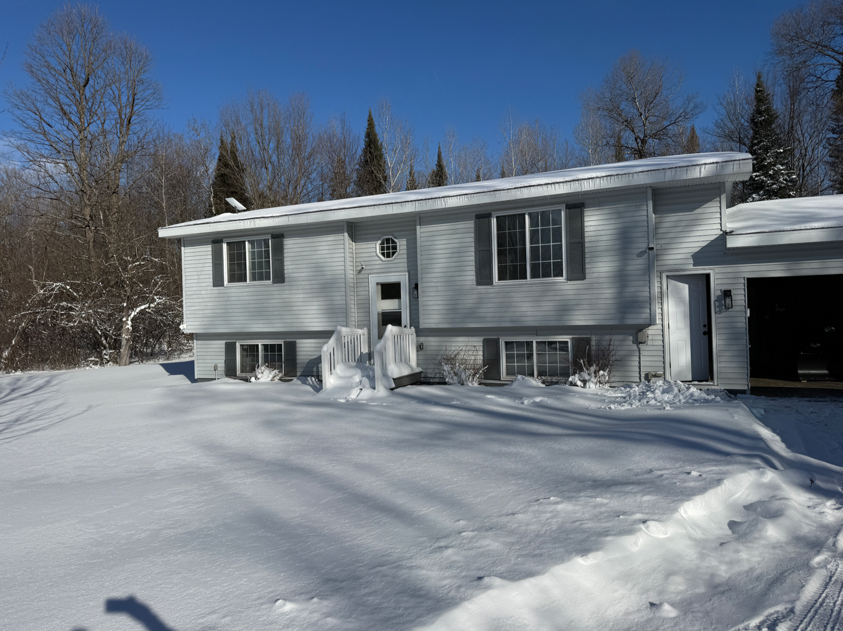

History

The current owner bought this property to obtain a Cannabis residency license in the city of Crystal Falls, Michigan. When he bought it from the current owner, he had no intentions on opening up the restaurant bar portion, and the previous owner owned it for a place to say to visit the casino about 60 miles to the west. Overall, the restaurant has probably been closed for at least 10 years that we know of, but when it was open from the local community, everybody loved coming here as it’s been here for a long time.
During the opening of the cannabis processing laboratory, there was a family renting out the house and maintaining the property for just about four years.
Then one day, a local businesswoman that owned another restaurant in town wanted to open up this facility because I had a classy liquor license with a full bar banquet room, and a lot more potential.
The current tenant at the house decided they did not want to be on property with an open restaurant so they went ahead and left and the tenant opened up at the end of the day. They had really good sales, but it was just too much to handle running two separate businesses going back-and-forth between the marketing, and all the fun stuff that comes with running a full restaurant.
The owner of the property realized that this was a Goldmine and saw wow we needed to improve this property and open up this place and change the name and get it going and that’s exactly what the intentions were.
The supper club is about 5000 ft.² and ownership did a complete remodel on the inside to include electrical mechanicals new hot water heaters all new furnaces installed new air conditioning which the property never had before all new kitchen floors ripped out the entire bar area and rebranded and reimaged inside.
The owner also installed the 2400 ft.² rock patio set with speakers and cameras for outdoor use to attract summer festivities bikers and ATV.
The entire property of the building has been repainted and most of the restaurant equipment has been purchased brand new and this is a fully turnkey set up at this point.
The liquor license is a Class C with an entertainment permit as well and the liquor investigator came out March 26 to approve the bar area.
The outdoor seating and the current license which you really can’t get today has been renewed and is an escrow just waiting to open.
The health department came out in the month of March 2026 and did a dry run and saw all the equipment. The new floors; pretty much told us to submit the application for a final inspection and we dont foresee any problems.
The owner currently invested close to $250,000 and it took almost 10 months to get this property where it needs to be at today. This is the definition of a full turnkey is exactly what this property is.
The menu is completed already, the smallwares are all brand new and some of them I have the logo already done as the rebrand was getting ready to launch.
Another key feature of the property is anybody can get a loan on the property because it’s still considered residential but zone commercial for the restaurant so getting a 30 year loan on this property would really help with the payment being extremely lower compared to a conventional five-year SBA loan.
New owners could rent out the building and live in the house or rent the entire property or even knock down some trees and do campers, potentially rent ATVs and rent snowmobiles as there is plenty of room for everything.
As you glide through the pictures, you will see all the improvements, the banquet room for celebration of life, birthday parties, business meetings, and separate bathrooms on one side of the facility, which would not hinder daily operations near the other side, where the bars located and the first dining room, so in terms of value, every base is covered for sure.
The glycol beer tap system comes with a batch system as well to make concoctions or cocktails in the large walk-in cooler as well. That system alone was close to $30,000 and it’s all brand new. The hood system has been inspected and fire has been tagged with 2026.
If the new owner wants to do a joint venture, I am open to opportunities as well to partner up and turn this into a real destination spot. For further large volumes, I did install a 40 foot high cube ocean container for storage towards the back of the trail for growth and tables and storage.
So the real question is how come the property is being sold or rented? The main reason is because the operator/partner that was going to run the facility had an accident and medically cannot continue to open the store under the new brand name.
Overall, I have a lot of experience which franchise development, marketing, and put a bunch of money into this facility and now we will wait for the next chapter.

LINK TO PHOTOS

The House
Natural Gas, City Water, its own septic
The tenant that was here before really took care of this property and really cared. After he moved out, I installed the brand new roof, added electrical into the garage.
Replaced all the flooring, all the hardware and fixtures, gutted both bathrooms with a full remodel with updated fixtures and one by six Pine and added stairs to the back patio deck.
All appliances are new, new sink in kitchen with touchless faucet, granite countertops, all new doors, including a sliding patio door going outside front door with screen door and both garage doors and all locks have digital access. The heating system was over $17,000 and that was replaced in 2025 in October and I believe that comes with a warranty.
This property is truly turnkey as well as it has fresh paint on the interior of the home.
1642 also comes with a Polaris 1000 sportsman 4 x 4 quad with a plow; a John Deere 42 inch riding lawnmower and a small little mini trailer for picking up brush around the compound.
All in all, the house is fully furnished and the two grills 6 burner Weber and one, 36 inch Blackstone grill on the deck.
Starlink Internet is installed at both facilities on separate circuits. We can transfer that very easily into your name.



