

COMMERCIAL PROPERTYFOR SALE
301 S. Main Street
"The Atrium" UNIT #3 West
Doylestown, PA 18901

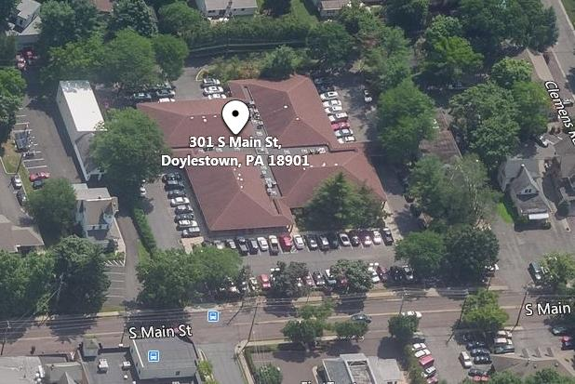

PROPERTY DETAILS

- PROPERTY:The Atrium - Commercial Condo Office - Medical or General office, Unit #3W

- SPACE SIZE:
1,800 Square feet, estimated.

- TAX ID:
08-008-465-0W3
- RE TAXES2023:
= $3,240
- CONDO FEES:
$384 /monthly. Fee covers CAM, common area electric & taxes, trash and exterior components of building, pavement , parking lot, snow removal

- SPACE DETAILS :
- Open waiting/ recept. area
- Four offices first floor
- Two powder rooms, first flr.
- Full basement for office or storage.
- Two entrances/exits

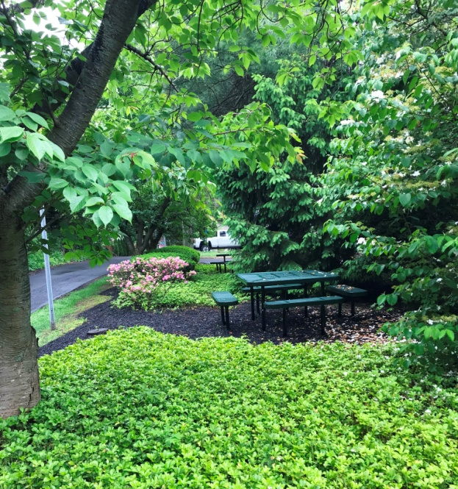
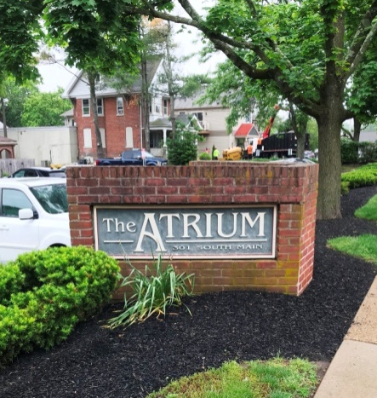

Garden area retreat for owners, rear of property


Demographics - w/in 5 mile
▪ 2013 population = 77,517 (2010 to 2024= +4.3%)
▪2013 AVG household Income
= $134,135
SEPTA Transit Stop - 7 min walk

Permitted Uses
General Offices/Medical
Financial Establishment
and more

- 2013 population = 41,680. 2000 to 2013= +18%.
- 2013 Household Income Ave.
$123,902

No warranty or representation, express or implied, is made as to the accuracy of the information contained herein,
and same is submitted subject to change in price, conditions, omissions, errors, prior sale or rental, or withdraw without notice.
5895 Lower York Rd. Lahaska, PA 18931
(888)482-2666 ▪ (215)357-2880
www.cbhcommercial.com
Presented by: Larry Peseski

As built floor plan first level
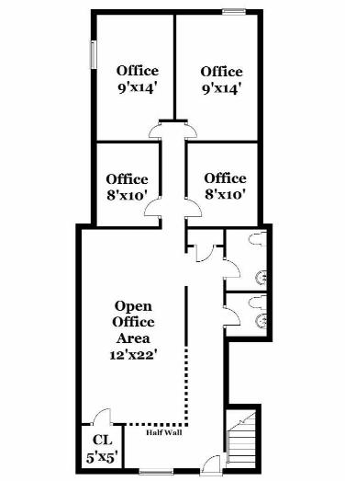

301 S. Main St. #3W

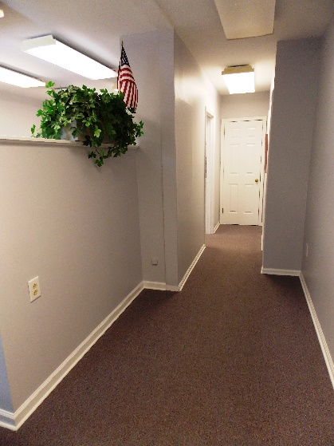
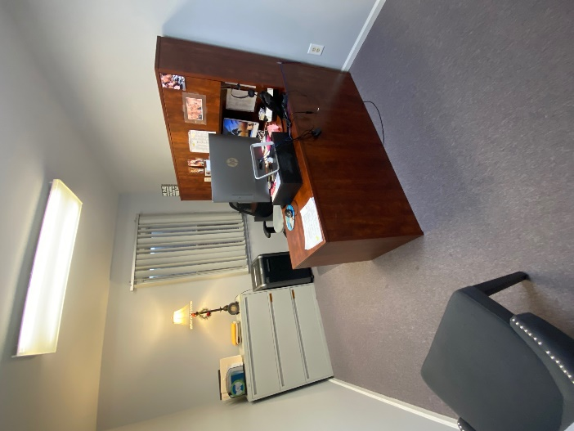
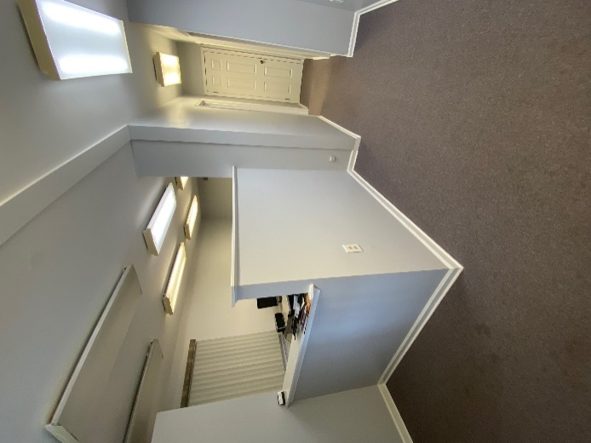

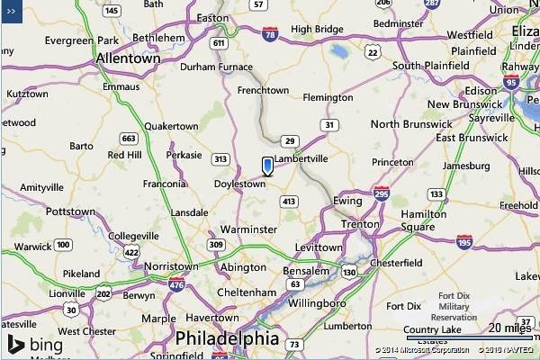
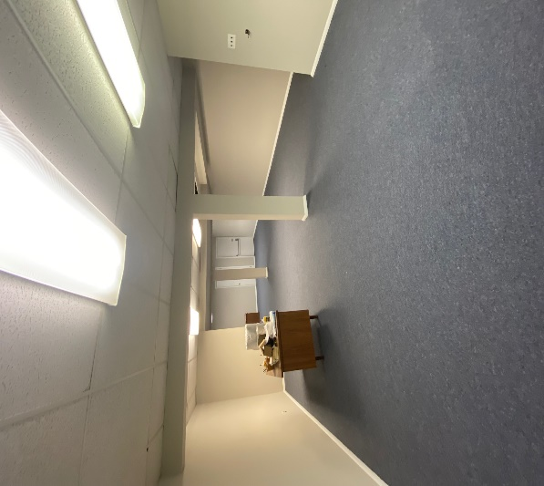
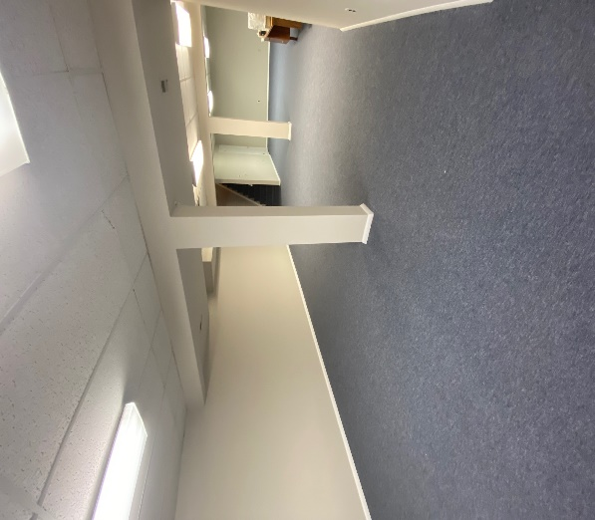
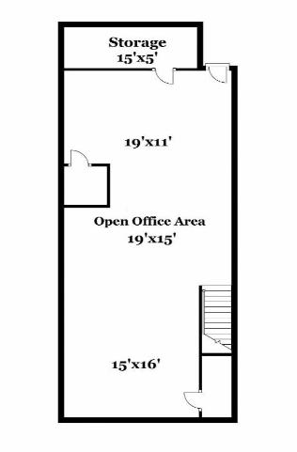
Lower Level for office, open work area and storage

