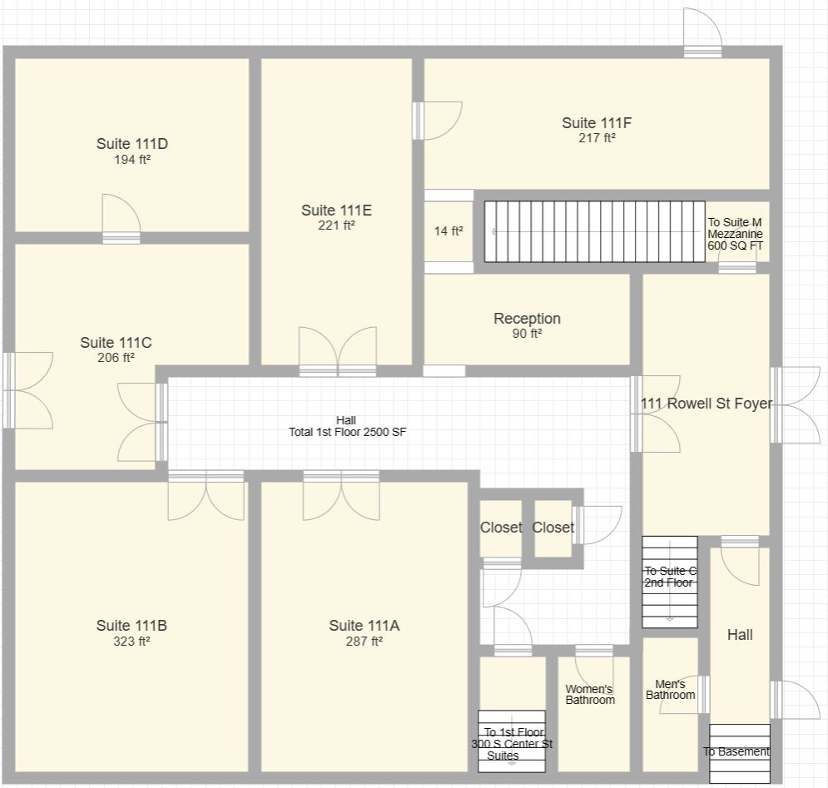

111 Rowell St – 1st Floor

