Sec. 2.082. San Jacinto overlay district.
(a) Purpose. The San Jacinto overlay district is designed to:
(1) Promote the health and well-being of residents by encouraging pedestrian modes and greater social interaction;
(2) Promote an aesthetically significant, high density, mixed-use area, which encourages pedestrian activity, promotes services, and enhances the aesthetic value of an area;
(3) Permit a combination of office, retail, commercial, and residential uses within a single development, with the non-residential uses on the ground floor and residential units on the upper floors; and
(4) Minimize the impact of uses that have a higher intensity.
(b) Applicability. This section applies to all non-residentially zoned property. The San Jacinto overlay district is to be combined with only non-residential base zoning districts. The adoption of this overlay district should not be construed as a change in zoning.
The overlay district is divided into three tiers. Each tier may have different zoning regulations. Each tier is designated in Figure SJ0-1 and shall govern the property in the tier. If any portion of a lot or tract falls within more than one tier, the entire property must be developed using the standards that apply to the lowest numbered tier.
• Tier 1 (T1) includes any lot that is within a 700-foot radius from the centerline of the right-of-way at the intersection of (i) San Jacinto Boulevard and Hunt Road, as well as, (ii) San Jacinto Boulevard and Lone Star Street; and any lot that is within a 500-foot radius from the centerline of the right-of-way at the intersection of San Jacinto Boulevard and Santavy Street. Tier 1 is intended to govern the key intersections throughout this overlay district. Tier 1 is intended to produce an urban aesthetic with closely developed buildings, taller buildings, and hidden parking.
• Tier 2 (T2) includes parcels outside of the Tier 1 boundary that are 700 feet from the centerline of the San Jacinto Boulevard and Hunt Road rights-of-way. Tier 2 is intended to incentivize the aforementioned corridors to achieve a compatible development with T1, however, it doesn't emphasize the urban density as much.
• Tier 3 (T3) would include all other properties within the overlay district that are not determined to be within Tier 1 or Tier 2. Tier 3 is intended to permit a less dense and less urban profile, while maintaining compatibility with the other tiers.

Figure SJO-1. Boundary and Tiers
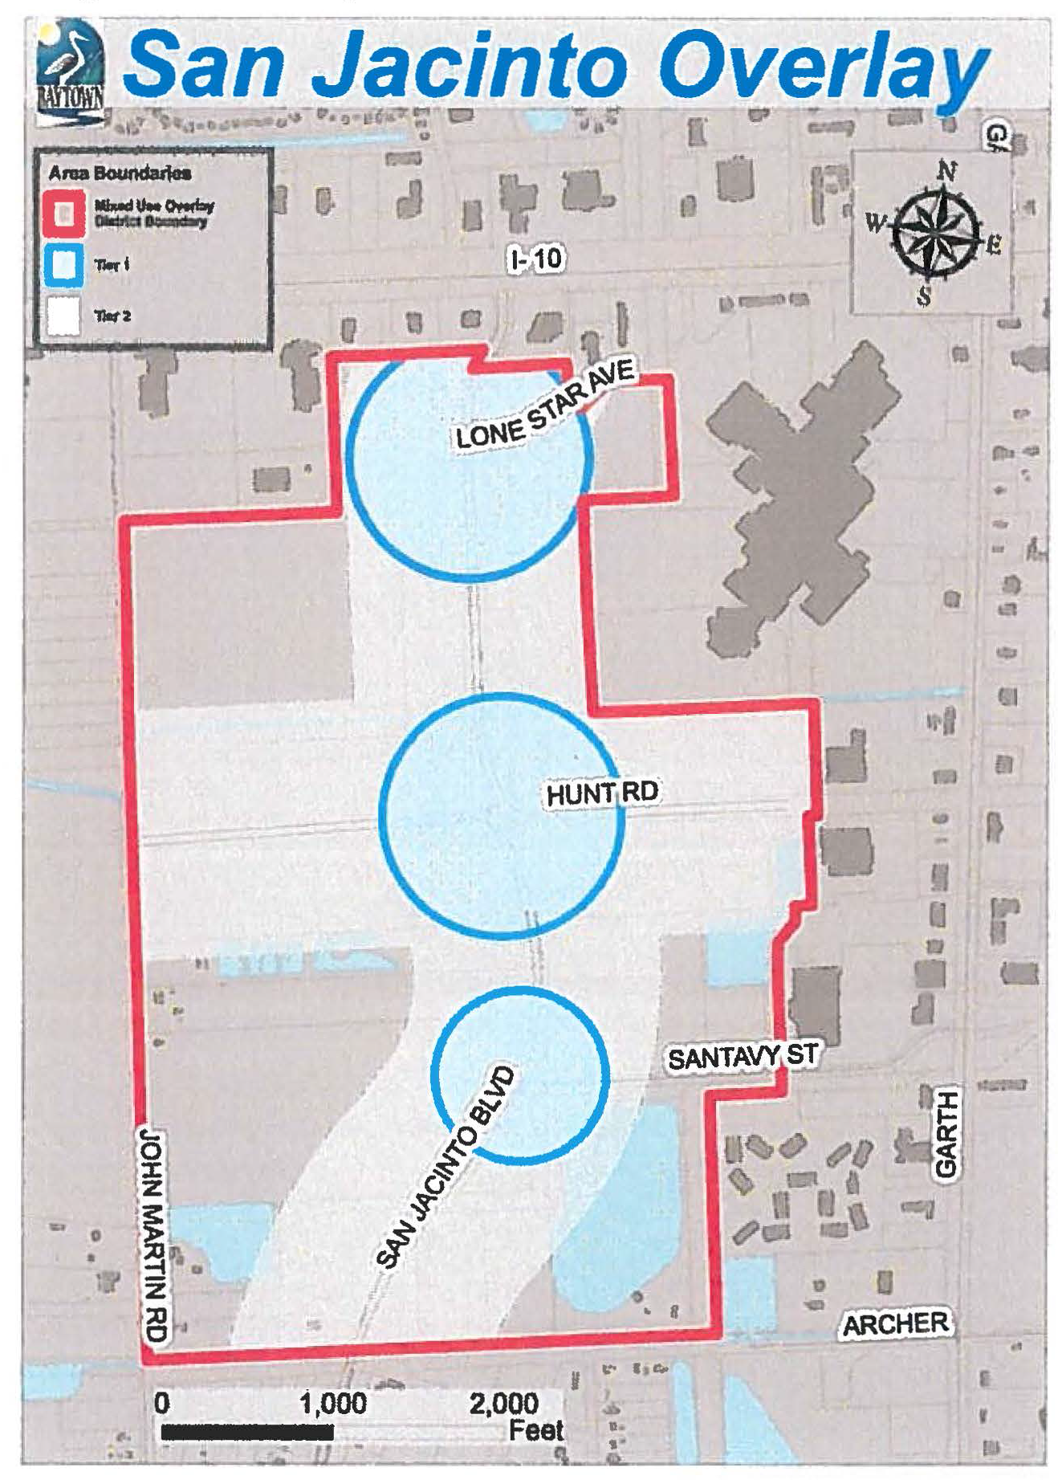
(c) Procedures for appeals and interpretation. Procedures for appeal and interpretation shall be governed by the processes within sections 1.28, 1.29, and 1.30 of the ULDC.
(d) Utilities.
(1) Underground utilities are required. Poles and overhead wires and associated overhead structures are prohibited.
(2) Exterior onsite facilities and mechanical equipment, including sewer, gas, water, electric, telephone, and communications equipment, shall be installed underground. Transformers and other mechanical equipment that must be aboveground shall be screened with solid material that is architecturally compatible with the primary building and incorporated into the landscape.
(3) The use of regional or subregional stormwater detention is required as capacity permits. Thereafter, underground stormwater detention facilities are permitted.
(e) Definitions. The following words, terms and phrases, when used in this section, shall have the meanings ascribed to them in this section, except where the context clearly indicates a different meaning:
(1) Mixed-use building means a building that contains at least one floor, or a portion thereof, devoted to permitted nonresidential uses, and at least one floor devoted to permitted residential uses.
(2) Multi-family means any residential dwelling complex consisting of five or more units to include, but not be limited to, common accessory structures such as garages, laundry buildings, and guest parking.
(3) Horizontal mixed-use development means a development consisting of two or more attached or detached buildings of differing use categories (e.g., residential and nonresidential) within the same project area.
(4) Project area means a single parcel or multiple parcels, planned and constructed as one, coordinated and unified project.
(5) Plot plan means a site plan of the project area, which identifies residential boundaries where residential uses are proposed in this overlay district.
(6) Usable open space means accessible hardscape or landscape areas, including, but not limited to, plazas, courtyards, pocket parks, and other publicly accessible amenities.
(7) Monument sign means any permanent low-profile sign built on a monument base as opposed to a pole base, solid from the ground up, and which has no clear space for the full width of the sign between the bottom of the sign and the ground. Poles or supports must be concealed.
(8) Window sign means a sign affixed to the surface of a window with its message intended to be visible to and readable from the public way or from adjacent property.
(9) Primary building(s) means a structure that is developed along the street frontage that is subject to the front yard setback standards.
(10) Secondary building(s) means a structure that is developed in the project area but does not have direct street frontage to the adjacent street due to a primary building that has been constructed along the street frontage.
(11) Drive-through restaurant means an establishment in which food or drink is served to customers within automobiles outside of the confines of the building and/or where the consumption of such food or drink is intended to occur off the premises.
(12) Primary entrance(s) means an ingress and egress point of a building or suite, which is designed for pedestrians, that is oriented towards the street frontage and usable open space.
(13) Secondary entrance(s) means ingress and egress point(s) of a building or suite, which is designed for pedestrians, that is not the primary entrance(s).
(14) Small box discount retail means a single retail establishment consisting of 12,000 square feet or less of gross floor area, offering for sale an assortment of discounted general merchandise directly to the consumer. Such merchandise may include, but not be limited to, food and beverage for off-premises consumption, processed foods, household products, personal grooming and health products, clothing, and other consumer goods. This term does not include a retail establishment providing a prescription pharmacy, gasoline or diesel fuel, specialty gifts or food and beverage items intended for on-premises consumption.
(f) Non-residential uses. Unless otherwise stated, this section only applies to the uses that are permitted (P) and/or permitted with conditions (PC) within the land use table for ACE, NSC, GC, and LC zoning districts. Such uses shall be subject to section 2.10 "land use conditions" and the additional regulations within the overlay table. Where there are conflicts, the requirements of this section shall prevail.
(1) Prohibited uses. Prohibited uses pertain to both primary and accessory uses. Any of the following land uses shall not occur unless it is approved by city council as part of a planned unit development (PUD):
a. Auto body;
b. Vehicle repair;
c. Boat and R-V storage;
d. Carwash;
e. Drive-through restaurant;
f. Gas station;
g. Kennel;
h. Outdoor sale and display;
i. Outdoor storage;
j. R-V park;
k. Self-storage;
l. Supply house;
m. Truck stop;
n. Manufacturing light;
o. Sandblasting;
p. Warehouse;
q. Small box discount retail.
(2) Tier 1. Within Tier 1, single-tenant buildings and/or suites shall not exceed 15,000 square feet on the ground floor. Each floor of a multi-story building within Tier 1 may not exceed the square footage of the ground floor.
(3) Tier 1 and Tier 2. In addition to other uses allowed within the underlying zoning district, hospitals shall be allowed within Tier 1 and Tier 2.
(4) Uses permitted with conditions. In addition to other uses allowed within the underlying zoning district, the following uses shall be permitted with conditions within the tier indicated:
Non-residential Uses Permitted with Conditions
Land Use | Tier | Cond Ref | Additional  Regulations
Equipment sales and rental | 2 | A53 | 1. All equipment shall be displayed or stored interior to a building.  2. No facility shall be permitted to have bay doors facing a residential use or a street identified on the major thoroughfare plan.
Manufacturing Custom | 1 and 2 | A49 | A minimum of 1,500 square feet or a minimum of 10% of the total building floor area, whichever is greater, shall be designated for retail sales, services, and/or showroom of the custom manufactured goods and associated products (e.g. food and merchandise).
Mixed-Use  Building | 1 and 2 | 1. There shall be a minimum of 4,000 square feet on the ground floor of this building.  2. General retail, personal service, grocery store, and/or food service establishment uses shall occupy at least 50% of the area of the ground floor.  3. A minimum of four (4) dwelling units shall be required within a mixed-use building.  4. Dwelling units shall have a minimum of 750 square feet of floor area.  5. Access to dwelling units shall occur from the interior of the building.

(g) Property development standards. The following non-residential development standards shall be applicable within the San Jacinto overlay district and shall control over those of the underlying zoning district:
Non-residential Development Standards | T1 | T2 | T3 | Additional  Regulations
Block length (min/max) | 300—700 feet
Minimum lot area | 32,670 square feet  (¾ acre)
Site coverage | 60% | 70% | 80% | Developments with mixed-use buildings with more than 7 dwelling units shall be permitted a site coverage of 80%.
Minimum Lot Dimensions
Minimum lot width at primary  building line | 100 ft. |  |  | Minimum lot dimensions shall only apply to lots with frontage along arterial roads.
Minimum Road Frontage
Frontage requirement along arterial | 100 ft. |  |  | A minimum of 75 ft. of street.
Frontage requirement along  non-arterials | 50 ft. |  |  | Frontage is required for a parcel with curb cut(s).
Building Form and Location
Minimum height | 24 ft. | 20 ft. | N/A
Maximum height | 75 ft. |  |  | Buildings adjacent to existing or planned residential uses shall follow the building orientation standards found in section 3.12 of the ULDC.
Minimum front setback | 12 ft.
Maximum front setback | 25 ft. | 85 ft. | 85 ft.
Side-yard interior lot setback | 0 ft. | 10 ft. | 10 ft.
Street-side setback | Same as front setback
Minimum rear-yard setback | 15 ft.

Figure SJO-2. Public and Private Realm
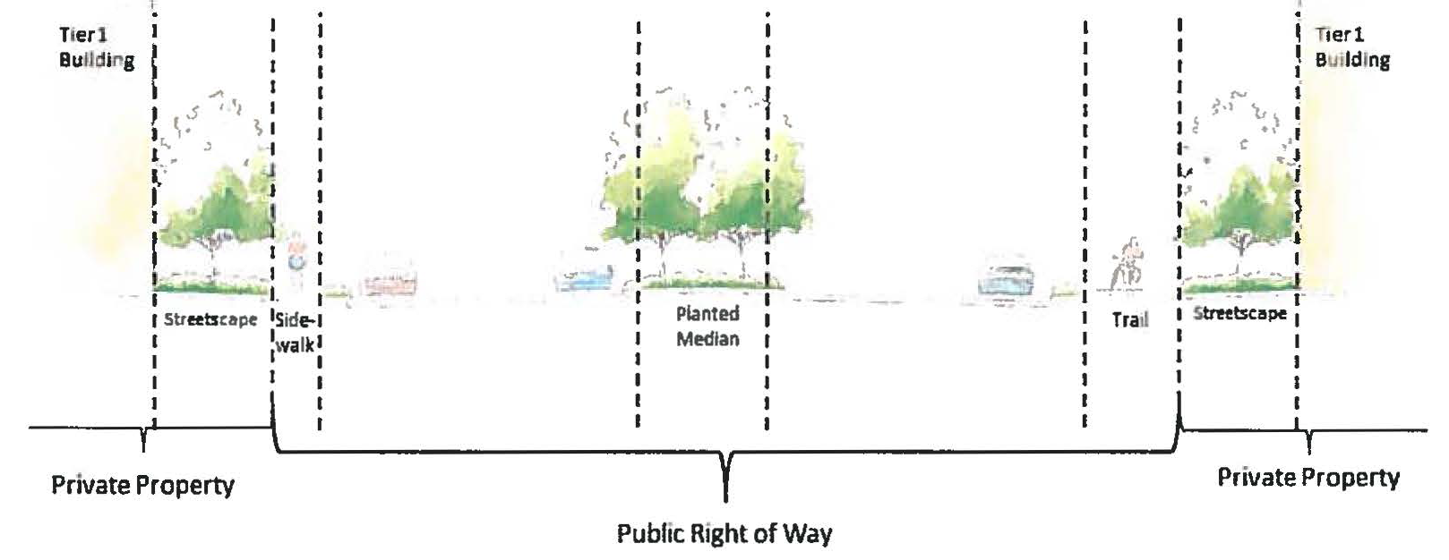
(1) Site design. Site design goals include clustering of buildings in multiple building projects. This method encourages pedestrian walkable/sitting areas and usable open space as part of the building placement and design.
a. Building orientation.
1. Building(s) and the primary entrances shall be oriented towards the primary street frontage, public plazas, and usable open space - not to a parking lot. This does not preclude the additional use of secondary entrances.
2. Primary buildings located on a corner lot may provide a primary entrance(s) at the corner of the building.
3. The secondary buildings constructed and all subsequent buildings may not be further than 185 linear feet from another building.
b. Usable open space. This subsection (g)(l)b shall only apply to Tiers 1 and 2 of the San Jacinto overlay district and shall be required for 20,000 square feet or more of non-residential development proposed within a project area.
1. All usable open space, with the exception of the trail system, shall have a minimum depth of 20 feet and a minimum total area of 650 square feet.
2. Park benches and bike parking racks/facilities shall be incorporated into the usable open space.
3. Unless arranged as a courtyard with buildings on three sides, usable open space shall abut a street.
4. Two or more of following amenities shall be required:
(a) Natural and undeveloped landscaped area that is not already required by this San Jacinto overlay district or the ULDC;
(b) A patio or plaza with shaded spaces (shade structure) with flexible or permanent seating;
(c) A play area with amenities or equipment suitable for children such as, but not limited to, seesaw, merry-go-round, swing set, slide, and jungle gym;
(d) Ponds designed as an amenity with shade spaces (shade structure) with flexible or permanent seating and approval by the director;
(e) Multi-use trail that is directly extended from the Goose Creek Trail or any existing and adjacent trails that are connected to the Goose Creek Trail along the local or collector streets in the circulation plan; and
(f) Ground floor patio and decks for dwelling units shall only be oriented towards public or private streets that are not designated as an arterial road on the major thoroughfare plan.
(2) Architectural/urban design standards. The following principles intend to promote quality design appearance and visual interest. The buildings should enforce a street edge establishing a better pedestrian corridor. However, long, unarticulated building facades should be eliminated.
a. Entrances. Entrances (excluding service doors) into buildings shall be easily identified through building design with at least one of the following:
Canopies or porticos | Recesses and/or projections
Peaked roof forms | Arches
Raised cornice parapets | Other features approved by the director

b. Materials. Building materials used for all four sides of buildings shall follow the masonry standards and percentages within the ULDC. This overlay district prohibits the use of synthetic stucco and/or EIFS.
c. Articulation. Facade articulations shall occur with a minimum of ten-inch plane variation each 35 feet.
d. Wall heights. Wall heights shall be varied and articulated with a minimum of 24-inch variation each 35 feet.

Figure SJO-3. Articulation
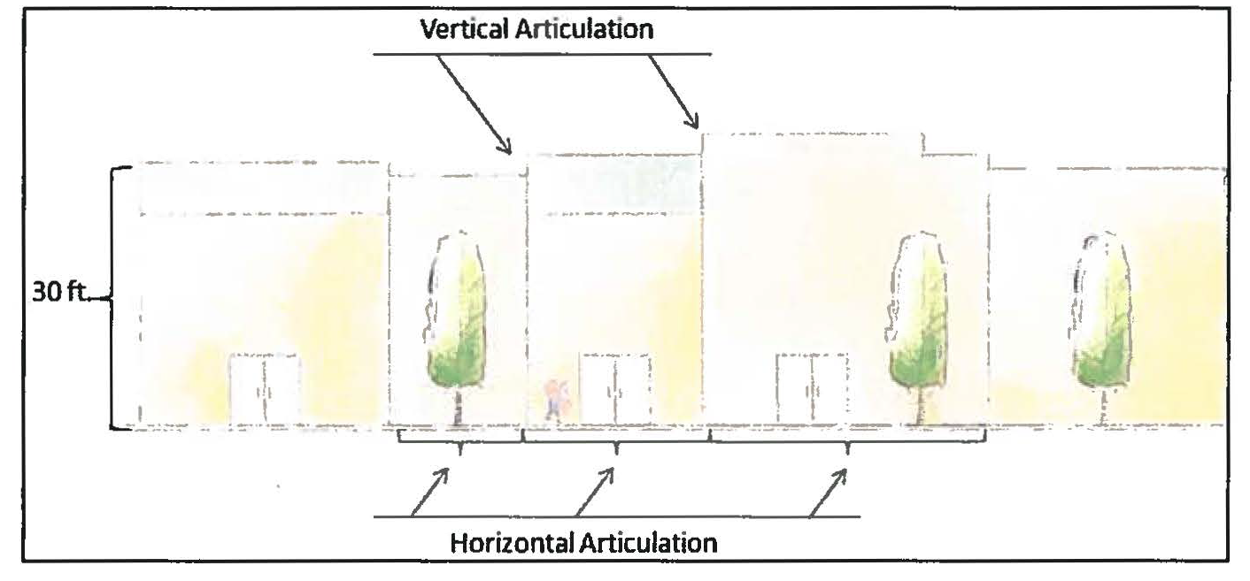
e. Glazing. A minimum of 50 percent of the street-facing facade between two feet and eight feet in height on the ground floor must be comprised of windows. A minimum of 30 percent is required for all other facades, except where a facade faces or uses an area designated and constructed for service delivery or business storage.
f. Colors.
1. A minimum of three different colors shall be used for building exteriors. Colors shall be only natural rock colors and earth tones. Neutral colors include browns, beige, ivory, taupe, muted greens, gold, grey, and white. Earth-tone colors should be flat or muted.
2. The use of high-intensity colors, neon, or a fluorescent color is prohibited. Neon tubing shall not be an acceptable feature for building trim or accent areas.
g. Awnings. Awnings:
1. Shall be required for primary buildings in Tier 2.
2. Shall be broken into segments as to match the door and window openings beneath them.
3. Shall overhang the entrance and windows along the front and side facade for a minimum of five feet.
4. Shall be made of glass or metal construction materials.
5. Shall not include domed and convex-shaped awnings.
h. Rooftop equipment. Rooftop mechanical equipment, including HVAC and utility equipment, shall be screened. Screening shall consist of parapet walls or an opaque enclosure around the equipment that is constructed of one of the materials used on the primary facade of the principal structure.
i. Fences and gates.
1. No opaque walls, fences, gates, or chainlink fences with a height greater than four feet shall be located within a front yard.
2. Walls, fences, or gates shall be consistent in style and material, complementing the surrounding architectural styles within this overlay district.
3. The structural supports of the fence shall face interior to the property so as not to be visible from the street or neighboring property.
j. Signage. The following signs shall be permitted for non-residential uses:
1. Limitation. Only monument signs, window signs, and wall signs are permitted. Pole signs, pylon signs, roof signs, banners, wall murals, digital signs, neon signs, flat signs, and spectacular signs are prohibited.
2. Monument signs.
a. One ground-mounted monument sign shall be permitted for each parcel or for every 300 feet of linear frontage of one parcel.
b. The sign structure shall be constructed of the same materials that are used on the facade of the primary building(s).
c. Each monument sign shall incorporate the following features:
(See Figure SJ0-4)
• CorTen metal material as a part of its sign face.
• An extended decorative arch.
• A monument base with a minimum of eight inches above grade.
• At least one masonry support column with a minimum of 16 inches in width.
d. The maximum monument sign dimensions for non-residential uses shall be as shown in the following table:

Building Gross  Floor Area | Maximum Area |  | Maximum Height  (above street grade)
 | Arterial  Streets | Local Streets | Arterial  Streets | Local Streets
0—25,000 sq. ft. | 48 sq. ft. | 24 sq. ft. | 8 ft. | 6 ft.
25,001—50,000  sq. ft. | 64 sq. ft. | 32 sq. ft. | 8 ft. | 6 ft.
Over 50,000 sq. ft. | 96 sq. ft. | 48 sq. ft. | 12 ft. | 6 ft.

Figure SJO-4. Sign
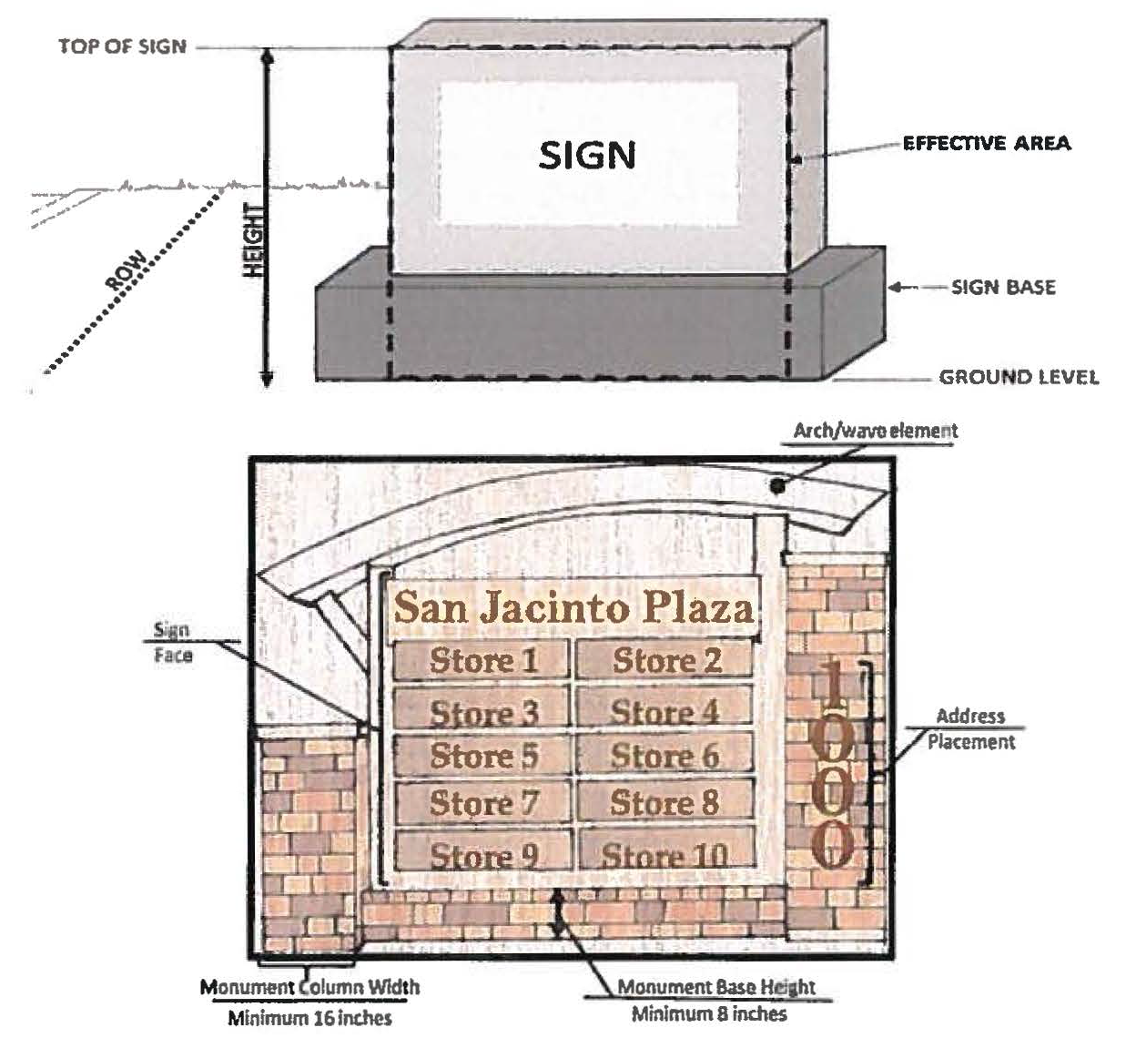
e. Sign measurement.
i. The size of a sign is measured by its effective area. For monument signs, the effective area includes the entire structure on which the sign is placed or mounted, including only the portion of the sign base that extends directly below the sign face. (See Figure SJ0-4).
ii. No decorative features of the sign shall extend beyond 16 inches from the sign face.
f. Sign setbacks and placement.
i. No minimum setback from property line is required for a monument sign.
ii. Placement of a monument sign shall in no case be allowed to extend into the right-of-way or to obscure vision at a street or driveway intersection.
3. Wall signs.
a. Sizes shall be calculated by one square foot per linear foot of storefront up to maximum of 64 square feet.
b. Wall signs shall be of individual channel letter. Framed or cabinet signs are prohibited.
c. One wall sign shall be permitted along the facade of the public entrance.
d. Buildings located on corner lots are permitted to have a second wall sign on a second facade which faces the street front.
e. Window signs shall be limited to a maximum of two signs, each with a maximum of four square feet within the frontage.
f. Illumination.
i. Internal illumination is prohibited.
ii. Wall signs shall be back lit, halo lit, or externally illuminated.
k. Lighting.
1. Internal to the project area, lighting design shall be of the gooseneck variety as presented in Figure SJ0-5.
2. Lighting posts and extensions shall be a black-powder-coated aluminum or metal.
3. Fixtures shall be shielded to reduce light pollution by facilitating a downward-directed light.
4. All lighting fixtures internal to the development shall have poles with a maximum height of 16 feet.
5. Lighting shall be of a consistent style throughout the project area/development site.
6. All light fixtures shall use an LED lighting source.
7. Lighting fixtures shall be placed to add illumination to areas such as, but not limited to, the usable open space, pedestrian facilities, and parking area.
8. Lighting fixtures shall be of similar dimension and proportion as presented in the Figure SJ0-5.

Figure SJO-5. Lighting
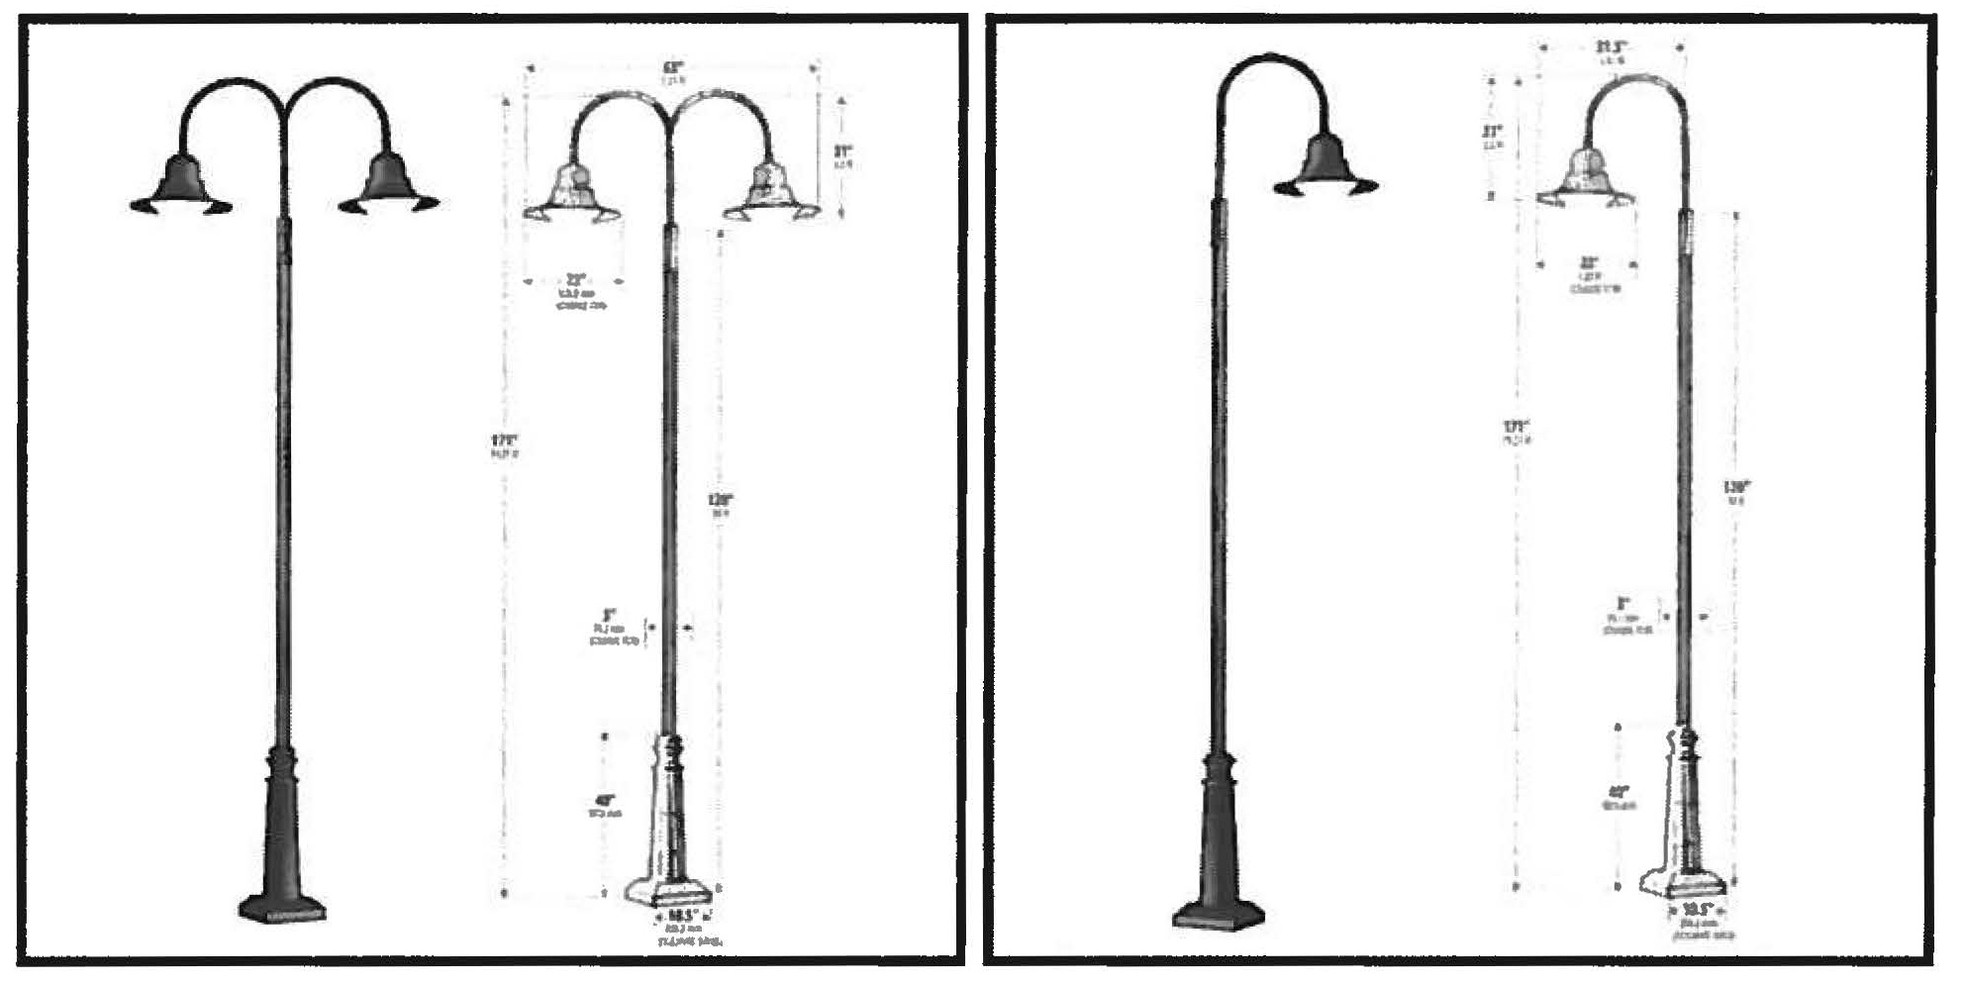

(h) Circulation and connectivity.
(1) Streets, sidewalks, and trails. The San Jacinto overlay district shall be organized into blocks created by a grid of public streets and/or private streets. A variety of street types and block sizes may be incorporated to create the grid, including diagonal, off-set, and angled streets as approved by the director or the director of engineering. The street network goals aim to prioritize the mobility of pedestrians and bicyclists by improving safe mobility choices and community character. Values of the section should be placed in compatibility, livability, sense of place and urban design that enhances pedestrian facilities and streets. Where possible, cul-de-sacs and curvilinear streets shall be avoided.
a. Access management.
1. Access management along roadways designated as arterial shall have a minimum curb-cut separation of 200 feet from the centerline of an existing curb cut.
2. Access to properties without a curb cut along an arterial shall be permitted via connection to another collector street, local street, or shared access easement through an adjoining parking area.
3. The project areas shall incorporate the following:
i. A maximum design speed of a drive aisle shall be 15 mph.
ii. If necessary to ensure access to the streets by the general public, the director and/or director of engineering may require shared access driveways within the site to adjacent properties.
iii. Installation of driveway aprons, stub-outs and other design features to indicate that abutting properties can be connected to provide shared/cross access is required.
4. All curb cuts that are aligned with pre-designed median cuts shall be constructed as local streets.
5. The maximum block length for local and collector streets shall be 700 feet or as specifically approved as a part of a preliminary plat by the planning and zoning commission.
b. Bicycle and pedestrian circulation.
1. Direct pedestrian access from any street that is adjacent to the property line to a building entrance is required.
2. Marked pedestrian access from a parking area to a building entrance is required.
3. Pedestrians and bicycle facilities, such as sidewalks and trails, shall be separated from facilities designed for the movement of vehicles, such as streets and access drives.
4. Where complete separation of movement of pedestrians from movement of vehicles, such as a pedestrian crossing, is not possible, the site plan must use special paving (stamped concrete, stone pavers, etc.), grade separations, signs, bollards, median refuge areas, traffic calming features, landscaping, lighting, or other means to clearly delineate pedestrian areas for both day and night use. Pavement markings and striping is only permitted if required by the director of engineering.
5. Where pedestrians and bicyclists share walkways, the trail shall have a minimum width of eight feet.
6. All development with frontage along John Martin Road shall install a paved trail with a minimum of eight feet along the arterial street.
(2) Circulation plan. A circulation plan shall be submitted with a plot plan, preliminary plat application, or site plan. A circulation plan must demonstrate:
a. How the onsite circulation system meets the narrative and standards of this section;
b. How the onsite circulation system integrates with existing and planned streets, bicycle and pedestrian facilities, and trails in the surrounding area;
c. How the proposed street alignments conform with or deviate from the San Jacinto Boulevard area general road network plan with an explanation how deviations from the plan in terms of street placement, alignment, and design, are consistent with the intent statements in this overlay district;
d. That the street and pathway system will contribute to safe and convenient pedestrian connections between development occurring onsite and adjacent to the development.
(3) Plan approval.
a. A circulation plan must be reviewed and approved by the director under the requirements of this section.
b. The director may waive the requirement for a circulation plan if the director finds that a plan is not necessary due to the nature of the proposed development on the site, the existence of surrounding incompatible development, or other factors unique to the property which make strict compliance unnecessary.
c. Revisions to the circulation plan may be approved by the director after considering the circulation characteristics of a proposed development plan, the need for access to adjoining properties, and the compatibility of surrounding development.
d. A plot plan, preliminary plat, subdivision, or site plan may not be approved if the circulation plan is not approved by the director. If there is disagreement on the issue, the applicant, by request, or the staff may take this pre-preliminary information to the planning and zoning commission for its determination.

Figure SJO-6. Road Network Plan
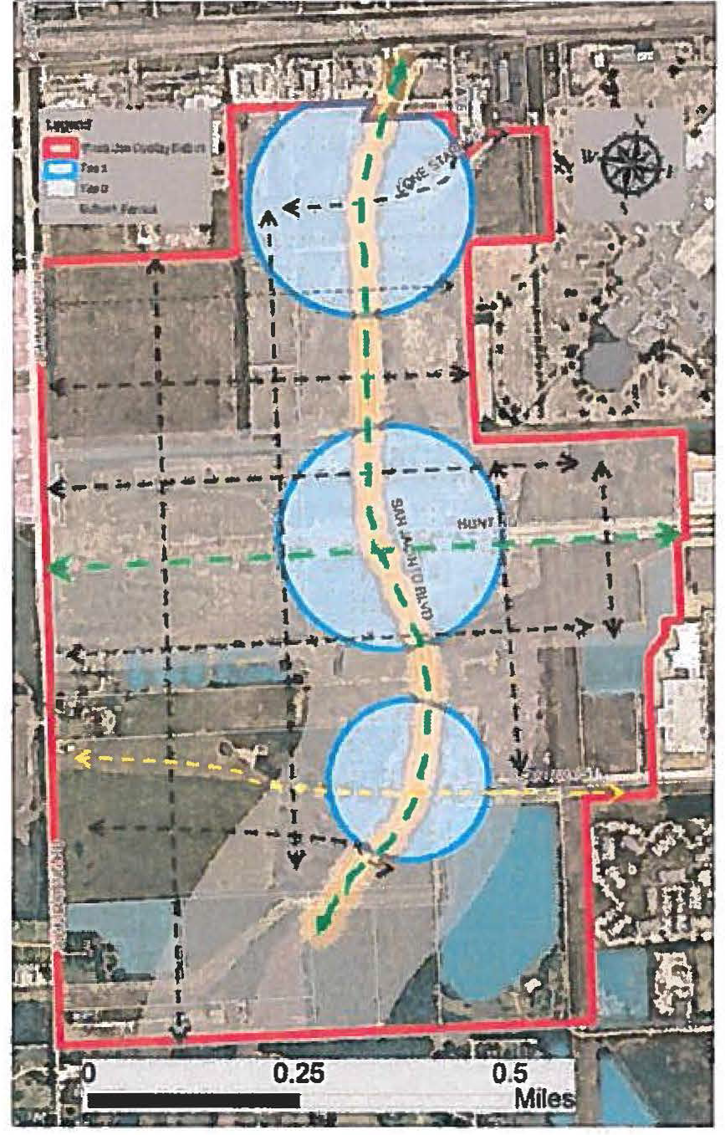
(i) Parking. Parking lot design shall be aesthetically pleasing and assure pedestrian safety. Additionally, this section encourages a reduction in surface parking counts, smaller parking areas over vast parking lots, promotion of shared parking through shared access and the creation of on-street parking. This section reassures alternative modes of travel by accommodating bicycle parking for all uses.
(1) Off-street parking.
a. Off-street parking spaces for non-residential developments shall not exceed the number required by chapter 112 of the Code of Ordinances and not be less than 70 percent of the maximum number allowed.
b. Off-street parking spaces for dwelling units associated with a mixed-use building shall comply with chapter 112 of the Code of Ordinances.
c. Parking for any residence associated with a mixed-use building shall be secured and separated from public parking.
d. In Tier 1, off-street parking areas shall only be located in the side and rear yards.
e. Tier 2 and Tier 3 off-street parking areas are permitted in the front yard.
f. In Tier 1 where off-street parking occurs in the side yard and in Tier 2 and 3 where off-street parking occurs in the front yard, the parking shall be limited to the maximum of two rows of parking being divided by one drive aisle.
g. No singular surface parking area may contain more than 120 spaces.
h. A landscape island shall be required after ten parking spaces and at the end of every parking aisle. (See Figure SJ0-7).
i. Surface parking areas with more than two parking bays shall require a continuous landscape island between every other parking bay. (See Figure SJ0-7).
j. A continuous landscape island may be utilized for safe pedestrian connectivity. It shall contain a five-foot sidewalk to provide direct pedestrian access to building entrances. (See Figure SJO-7).

Figure SJO-7. Parking
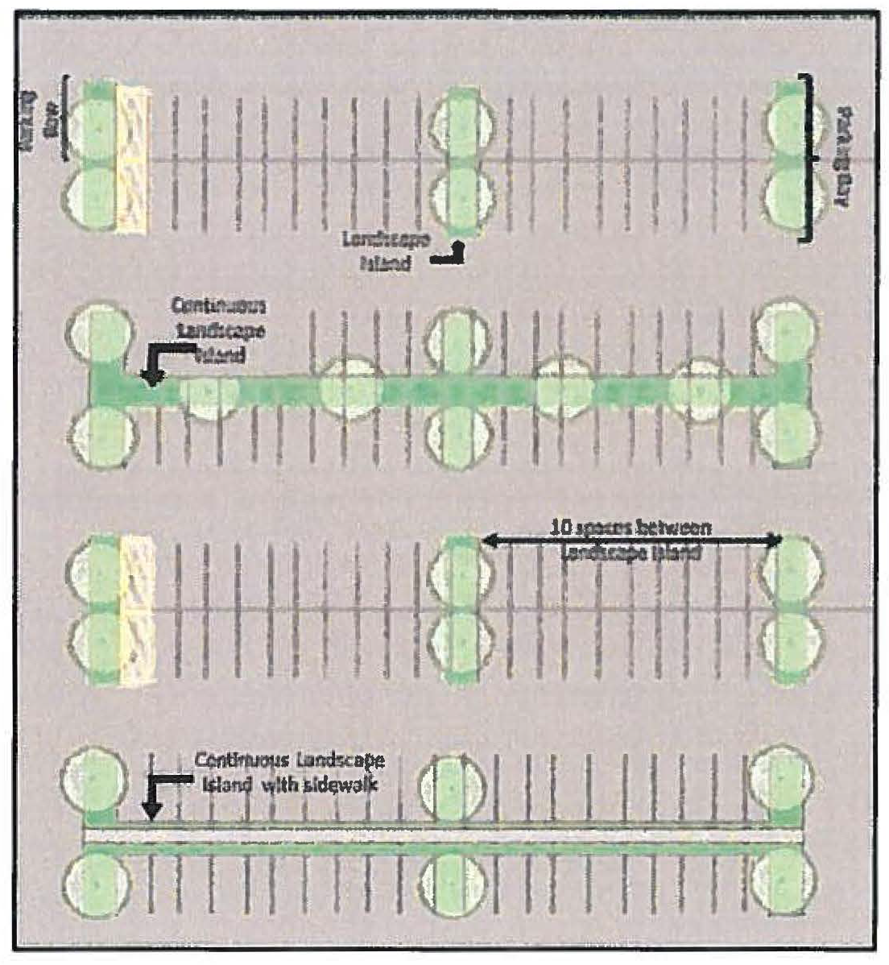
k. Off-street parking provided as part of a building or parking structure adjacent to a public street shall be designed and constructed to accommodate non-residential uses such as retail and commercial services on the ground floor of the building or parking structure.
(2) On-street parking.
a. On-street parallel parking is encouraged along all local streets where feasible. On-street parking is subject to the approval of the director of engineering.
b. A reduction of minimum off-street parking may occur by two spaces for each on-street parking space installed along the extents of the subject property for non-residential uses.
c. The director of engineering may determine that on-street parking is not feasible due to limited right-of-way width or lack of appropriate and adequate easement, transit activity conflict and interference, inadequate sight distance caused by vertical or horizontal curvature of a street, high roadway speeds, or other safety concerns.
(3) Bicycle parking.
a. Bicycle parking shall be required for retail and personal service uses at a rate of one bicycle space per ten parking spaces.
b. No less than 50 percent of the bicycle parking shall be located along the primary street within 50 feet of the primary building entrance. Other locations shall be incorporated within the usable open spaces or within 50 feet of secondary entrances.
c. Bicycle parking facilities shall either be lockable enclosures in which the bicycles are stored or black-powder-coated wave or coil racks that require a user-supplied lock that accommodate locking the frame and wheel(s). (See Figure SJ0-8).

Figure SJO-8. Bicycle Parking
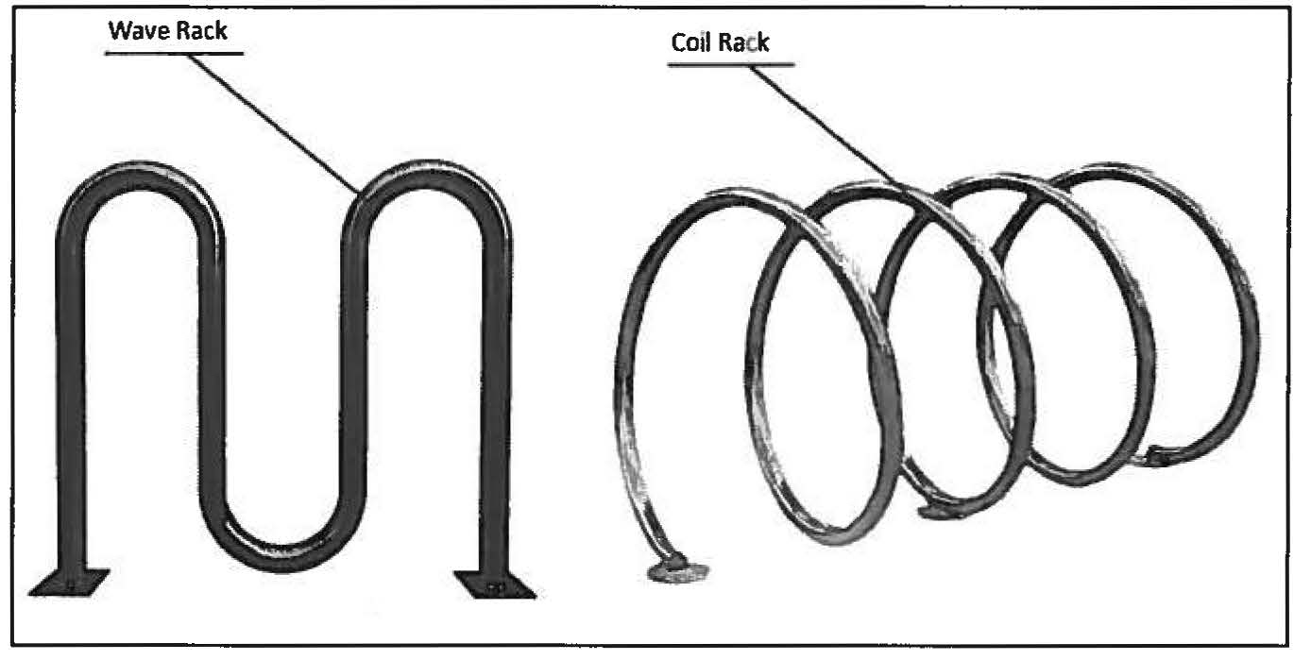
d. Bicycle parking facilities shall be securely anchored and located in lighted and visible locations.
e. Bicycle parking facilities shall have a minimum depth of eight feet and shall be installed in a fashion that a parked bicycle does not extend into a sidewalk or trail.
(j) Landscaping. Landscaping should enhance the development aesthetically and functionally by adding natural and vegetated elements to the San Jacinto overlay district. Landscaping helps with identifying transition from public realms to private and from non-residential uses to residential uses. Additionally, landscaping can be used for various functions of rain water capture, shading, and sound buffering.
(1) Streetscape.
a. Except where driveways or intersecting streets are required, streetscape shall be required along the entire length of the property that is adjacent to a street or primary access drive where developed land is located.
b. Along arterial streets, streetscape shall be no less than 12 feet wide.
c. Along collector and local streets, streetscape shall be six feet wide.
d. The streetscape shall be planted with deciduous shade trees five feet tall with a two-inch caliper, DBH, at time of planting, and no less than 20 feet tall at maturity, planted 30 feet on center, and shrubbery forming an intermittent hedge not less than three feet in height designed to provide an adequate screen of off-street parking.
e. As part of the landscape plan, shrubs may be clustered or spaced at various intervals based on specific site requirements, but the total number of shrubs planted shall be no less than the amount required by linear planting spaced three feet apart.
(2) Parking area landscaping.
a. A landscaping island shall be located at the end of every parking row.
b. A landscaping island shall be no less than eight feet wide and 18 feet in length.
c. The island shall be planted with ornamental grasses and the required trees based upon the tree species table in subsection (j)(4) of this section.
d. One shade tree shall be provided within each required landscaping island.
e. A maximum of ten continuous linear parking spaces are permitted within a parking row before a landscape island must be installed. (See Figure SJ0-7).
(3) Compatibility buffer.
a. Compatibility buffers shall create a planted screen between residential uses and non-residential uses or activities.
b. Where a non-residential use abuts property zoned or planned for single-family residential, the minimum buffer width shall be 25 feet, except in areas where cross-access for pedestrian circulation is planned and/or constructed.
c. Compatibility buffers shall be installed with at least one of the following specifications:
1. Compatibility buffer one.
a. A staggered double row consisting of evergreen trees and deciduous trees with an expected growth to a minimum height of 16 feet and a minimum width of ten feet at its maturity;
b. Tree planting for each row shall be installed with a maximum separation of 25 feet;
c. A transparent fence with a minimum height of six feet shall be installed if an opaque fence has not been constructed along the boundary of the adjacent residential use; and
d. If an opaque fence is installed, it shall be interior to the plantings of the buffer.
2. Compatibility buffer two.
a. A single row of evergreen trees planted with 25 feet of separation;
b. Intermediate planting of three understory trees per 100 linear feet;
c. Forty shrubs per 100 linear feet; and
d. Six-foot opaque fence or wall is required and shall be interior to the plantings of the buffer.
(4) Appropriate tree planting species. (Arterial and local streets). Appropriate shade tree species for landscaping parking lots include the following:
Tree Species | Streetscape  12 ft. | Streetscape  6 ft. | Landscape  Island | Compatability  Buffer
Lacebark Elm | X | X | X
Eastern Hophornbeam | X | X | X
Golden Rain Tree | X | X | X
Flowering Dogwood | X | X | X
Little Gem Magnolia |  |  | X | X
American Holly |  |  | X | X
Carolina Laurel Cherry |  |  |  | X
Eastern Red Cedar |  |  |  | X
Anacua |  |  | X | X
Wax Myrtle |  | X | X
Yaupon |  | X | X | X
American Elm | X |  | X
Leyland Cypress |  |  | X | X

(k) Residential uses. The San Jacinto overlay district facilitates medium residential density into commercial zones by using a variety of housing products such as townhouses, duplexes, triplexes, and fourplexes. This section helps to manage compatibility with commercial adjacency and integrates the residential uses with the non-residential uses.
(1) [Subject to property development standards.] All the residential uses associated with this overlay district shall be subject to the property development standards for the Medium Density Mixed Residential (MF1) zoning district found in article II of the ULDC. In the event of a conflict between the provisions of the San Jacinto overlay district and the provisions of the underlying zoning district or any referenced zoning district, the provisions of the San Jacinto overlay district shall prevail when a residential project is being developed.
(2) Platting process. In project areas that utilize a mixture of housing types (single-family attached, duplex, triplex, or fourplex), during the platting process, the applicant shall notate the designation of the housing product for each lot on the plat.
(3) Prohibited uses. The following are prohibited uses in the San Jacinto overlay district:
a. Golf course;
b. Industrialized home; and
c. Laundry building.
(4) Uses permitted with conditions. The following uses are permitted with conditions in the San Jacinto overlay district:
Residential Uses Permitted with Conditions
Land Use | Tier | Cond Ref | Additional Regulations
Multi-family dwellings | 1, 2, 3 |  | 1. Must be located at least one-half mile from any existing garden-style multi-family complex.  2. Shall have a maximum build out of three hundred (300) dwelling units.  3. Shall be located on not more than fifteen (15) acres.
Single-family detached | 3 |  | 1. Shall be built to a maximum density of nine (9) units per acre.  2. Minimum floor area of 2,000 square feet per unit.
Single-family attached dwelling (Townhouses) | 2, 3 | B14 | 1. Maximum building length of 200 feet.  2. Minimum floor area of 1,200 square feet per unit.
Two-family dwelling duplex | 2, 3 |  | Minimum floor area of 750 square feet per unit.
Three-family dwelling, triplex | 2, 3 |  | Minimum floor area of 750 square feet per unit.
Four-family dwelling, fourplex | 2, 3 |  | Minimum floor area of 750 square feet per unit.

a. The maximum residential density shall be 15 units and a minimum density of eight units per net acre of residential uses.
b. No front facade of a residential dwelling shall face onto an arterial street within a neighborhood.
c. When a residential use is developed on a double frontage lot with a major thoroughfare as the rear lot line, a masonry wall shall be installed with streetscape standards found in the non-residential section of the San Jacinto overlay district.
d. Compatibility buffer one, found in subsection (j), shall be installed when a residential use is developed adjacent to an existing commercial use that has not previously installed an opaque screening.
e. Architectural, masonry, and design requirements shall comply with article 3, division 4 of the ULDC.
(5) Property development standards. The following residential development standards shall be applicable within the San Jacinto overlay district and shall control over those of the underlying zoning district:
Residential Development Standards | T1, T2, and T3 | Additional Regulations
Internal block length (min/max) | 300—700 ft.
Minimum lot area (sq. ft.) | See article II, table 2-1 in the ULDC
Site coverage | 80%
Minimum Lot Dimensions
Frontage | Single-family  attached | Multi-family  dwellings | Minimum frontage shall also determine the minimum lot width.
Frontage | 25 ft. | 50 ft. | Minimum frontage shall also determine the minimum lot width.
Building Form and Location
Maximum building height | 35 ft.
Minimum building setbacks | 20 ft.
Maximum front building setback | 25 ft.
Minimum Side Setback
Interior side setback | 7.5 ft. | Single-family attached dwellings
Street-side setback (ft.) | Same as front
Minimum rear setback | 10 ft.

( Ord. No. 14,029 , § 1, 3-14-19; Ord. No. 14,380 , §§ 1, 2, 5-14-20)

