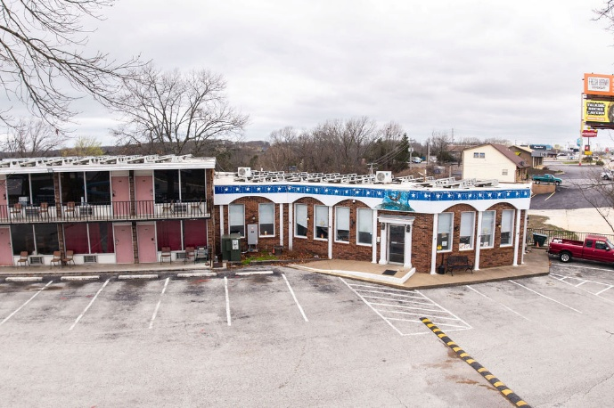
Colonial Mountain Inn / Yummm Sizzle and Scoop

Ownership: Fee Interest Type: Motel / Restaurant
Chain: Independent Zoned: C2 Corridor: Exterior
No. of Keys: 51 Restaurant Seats: 65 Room SF: 288
Building Status: Refreshed # of buildings: 2 Stories: 3
Parking Type: Surface Parking Spaces: 70
Site Size: 3.9 AC Year Build: 1980 Year Renovated: 2026
Construction Type: Masonry Sprinklers: None

This is a perfect opportunity for an owner operator or first time hotel owner. The property is located close to Branson, Mo and Silver Dollar City which is considered a major family vacation destination in the mid-west. There is a huge upside potential for the next owner to brand this property and/or renovate it to a very new condition. Offered at only 35,000 per key, it is a great deal! The property includes 3.9 acres of land, 51 room motel, restaurant and a separate 5 Bedroom house for an owner to occupy.
The primary economic influence for the area is the tourism industry with its eight million annual visitors to the Tri-Lakes area. The primary draw for tourists continues to be the entertainment and amusement industry coupled with the lakes area with its extensive forests and high-quality water in the lakes and streams which provide excellent hunting, fishing, boating, swimming, camping, and other outdoor recreational opportunities.
The primary force with the area’s economy is tourism, with an estimated volume of over one billion dollars spent (an average visitor spent $244.12 per day).

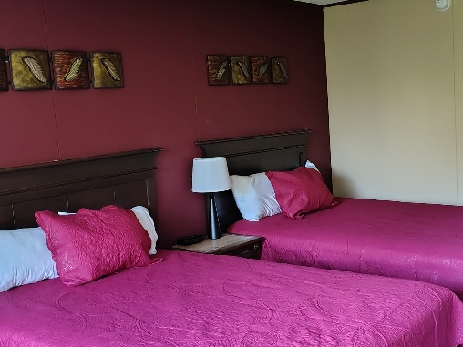
Hotel Inventory Description:
51 rooms with a mix of single & double queen beds and king beds
Common area amenities:
High Speed Internet, Outdoor Pool with 70 foot water slide
Restaurant Inventory Description
65 Seats, Ice Cream, Donut and Full Kitchen
Source of Business:
Group, Transient, Contractors and Leisure
Sale Note:
AS IS SALE , CASH AT CLOSING
Additional Links: http://Colonialmountain.com http://Yummm.menu




