

Bristol Borough
MULTI-FAMILY PORTFOLIO
301-303 Lafayette Street, 210 Pond Street,
421 Otter Street & 205 Mill Street
Bristol, PA
FOR SALE | MULTI-FAMILY PORTFOLIO
Anthony Messina Real Estate — Independently Owned and Operated
101 Jefferson Avenue
Bristol, PA 19007
215-788-0456
messinarealestate@gmail.com

Table of Contents
1 Property Information 3
Executive Summary
2 Location Information 5
Location Map
301 Lafayette Street
205 Mill Street
210 Pond Street
421 Otter Street
3 Financial Analysis 11
Financial Summary
Income & Expenses
Rent Roll
4 Advisor Bios 16
Advisor Bio & Contact 1

1 PROPERTY INFORMATION
Bristol Borough Portfolio | Bristol, PA

For Sale | Multi-Family Portfolio

Executive Summary
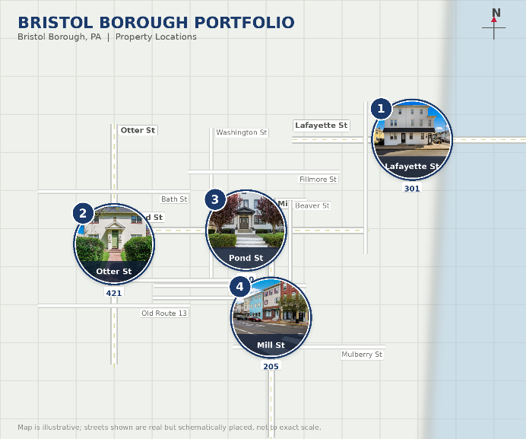
OFFERING SUMMARY
Sale Price:
$4,500,000.00
Number of Units:
23
Zoning:
Commercial & Residential
Market:
Bristol, PA
Submarket:
Bristol Borough
PROPERTY OVERVIEW
A rare opportunity to own 4 properties in Bristol Borough, PA. There is one 10 unit property, one 5 unit property with a Commercial unit on the first floor and two Quadplex properties. Each Property has a newer roof and has been freshly painted. All tenants pay for their own heat, hot water, cold water and sewer. At 95% occupancy and all units current on rent, it is time to own your piece of Historic Bristol Borough.

2 LOCATION INFORMATION
Bristol Borough | Bristol, PA

For Sale | Multi-Family Portfolio

Property Map
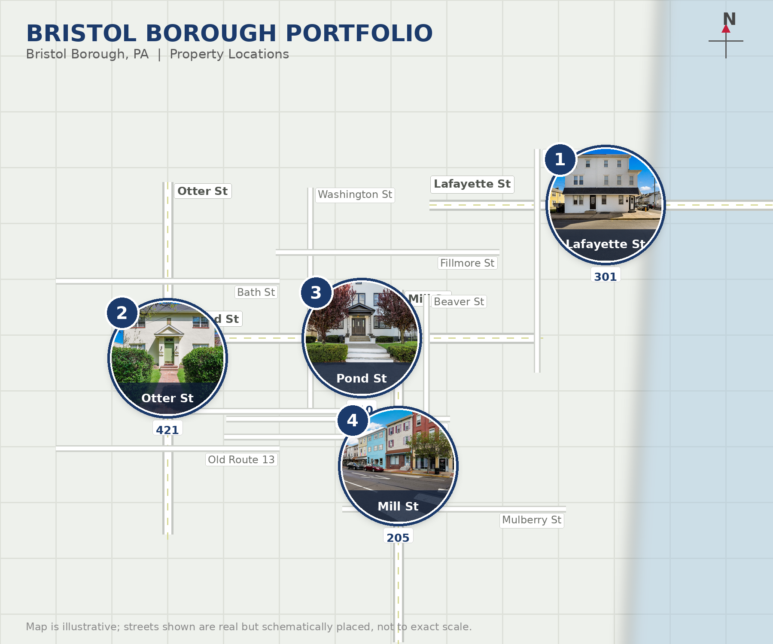
301-303 Lafayette Street
10 unit property  1- 3 Bedroom 1 Bath  1- 2 Bedroom 2 Bath  1- 2 Bedroom 1 Bath  7- 1 Bedroom 1 Bath  Tax Parcel: 04-025-001  Gross Income = $146,818  Total Expenses = $32,567  NOI = $114,251 | 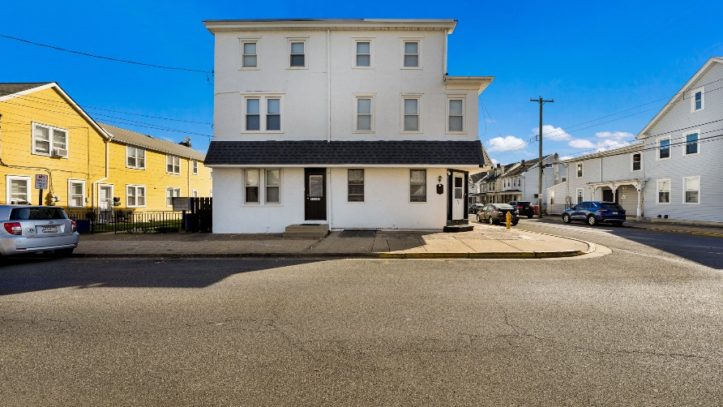
 | 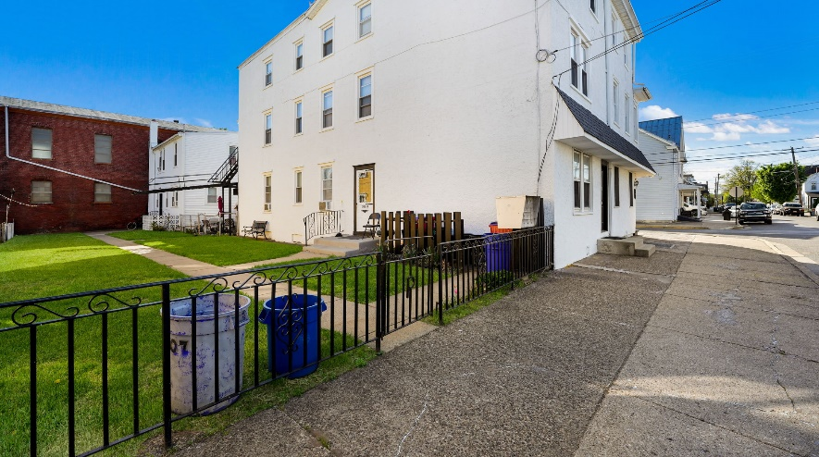

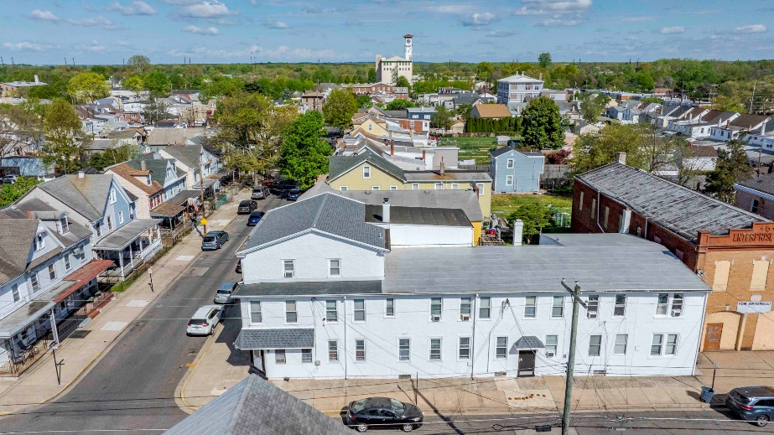

[Property Address 4]
205 Mill Street
5 Unit Property  1- Storefront Retail/Office Space  3- One Bedroom One Bathroom  1- Two Bedroom One Bathroom  Tax Parcel: 04-018-075-001  Gross Income = $78,000  Total Expenses = 16,031  NOI = $61,969 | 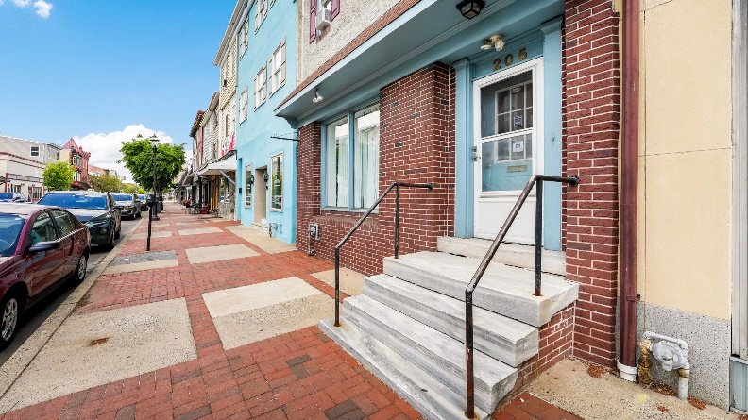
 | 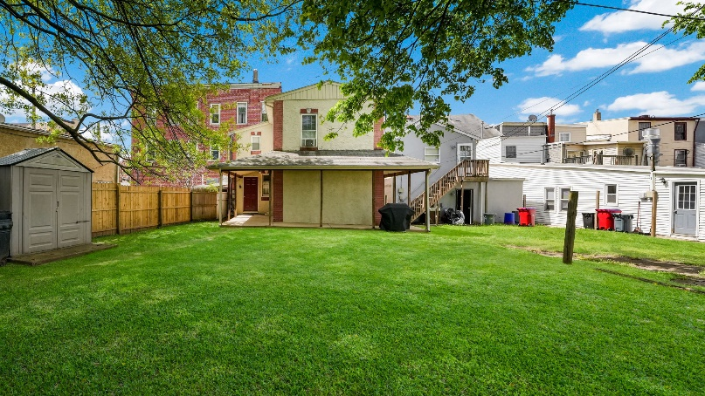

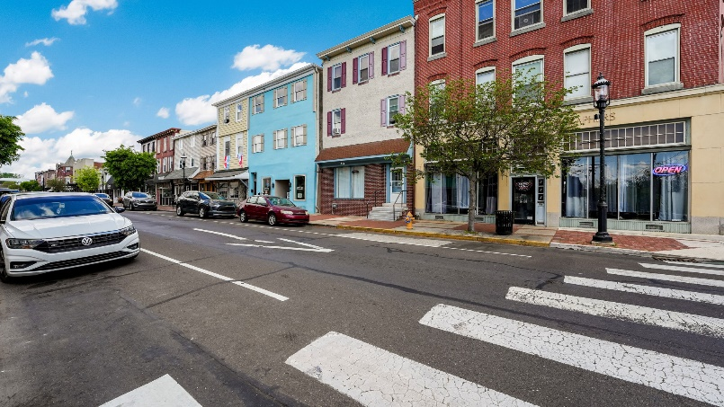
210 Pond Street
4 Unit Property  4- 2 Bedroom 1 Bath  Tax Parcel: 04-018-100  Gross Income = $73,800  Total Expenses = $19,455  NOI = $54,345 | 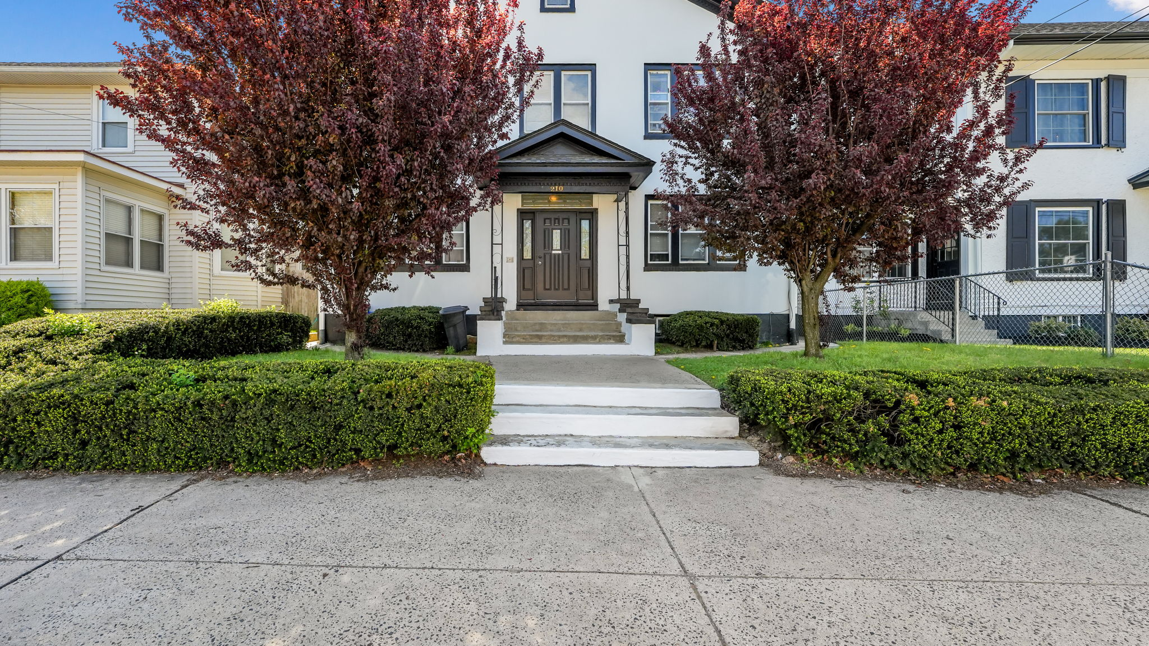
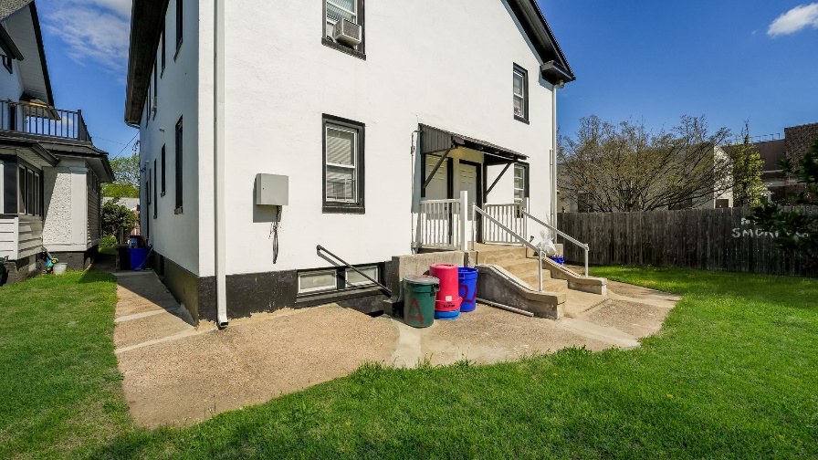
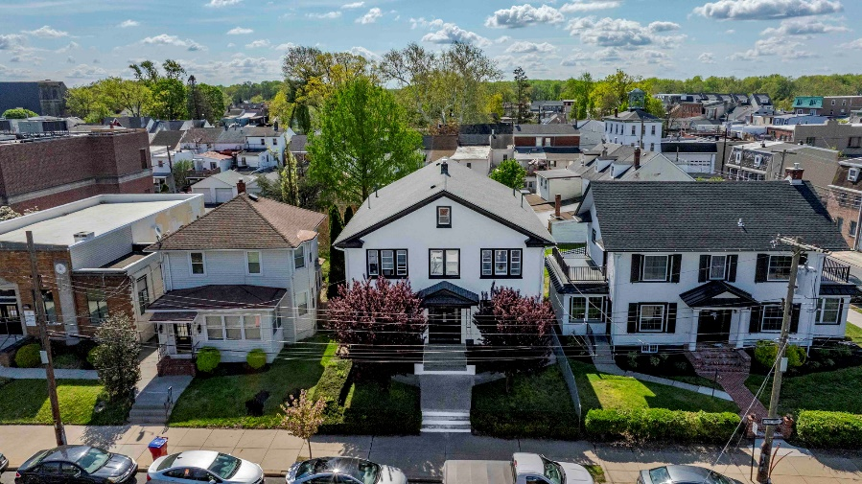
421 Otter Street
4 Unit Building  2- 2 Bedroom 1 Bathroom  2- 1 Bedroom 1 Bathroom  4 Garages  Tax Parcel: 04-006-006-001  Gross Income = $66,600  Total Expenses = $18,338  NOI = $48,262 | 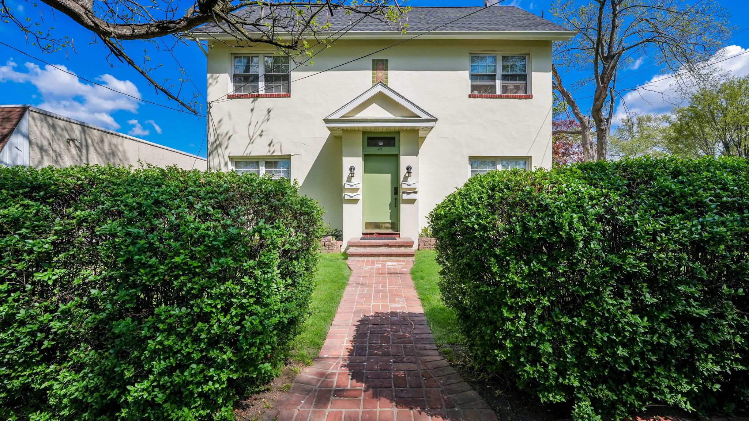
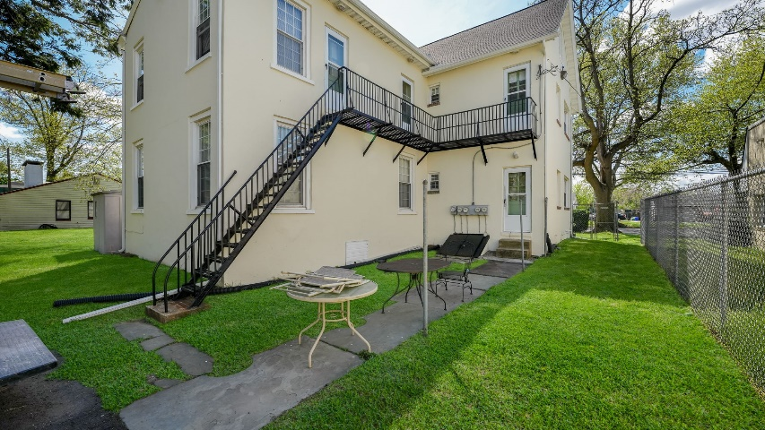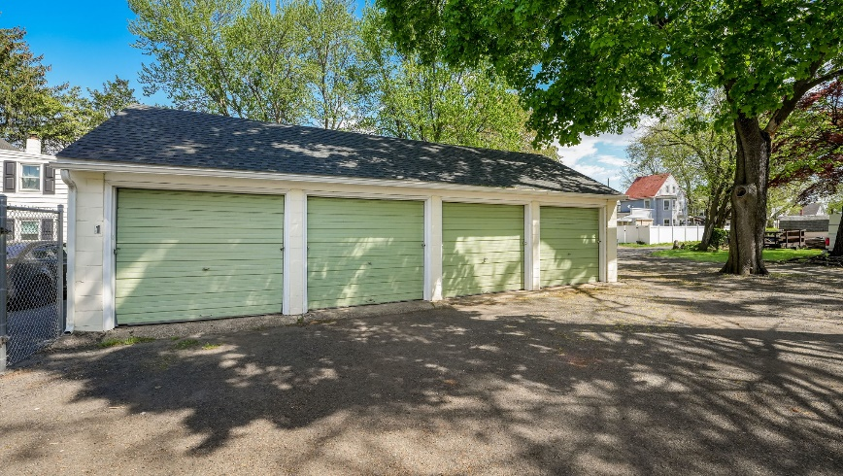

3 FINANCIAL ANALYSIS
Bristol Borough Portfolio | Bristol, PA

For Sale | Multi-Family Portfolio

Financial Summary
INVESTMENT OVERVIEW
Price | $4,500,000
Price per Unit | $1,125,000
GRM | 12.32
CAP Rate | 6.2%
Cash-on-Cash Return (yr 1) | -4.81%
Total Return (yr 1) | $47,499
Debt Coverage Ratio | .87
OPERATING DATA
Gross Scheduled Income | $349,140
Total Scheduled Income | $359,218
Vacancy Cost | $17,457
Gross Income | $341,761
Operating Expenses | $76,494
Net Operating Income | $265,267
Pre-Tax Cash Flow | $294,575
FINANCING DATA
Down Payment | $900,000
Loan Amount | $3,600,000
Debt Service | $322,087.59
Debt Service Monthly | $26,840.63
Principal Reduction (yr 1) | $90,759.84

Income & Expenses
INCOME SUMMARY (Total | Per Unit)
Rental Revenue | $359,218
Vacancy (5%) | $17,457
Gross Income | $341,761
EXPENSE SUMMARY (Total | Per Unit)
Utilities | $5,592
Taxes | $38,623
Insurance | $12,511
Maintenance | $12,000
Gross Expenses | 68,726
Net Operating Income | $273,035

Rent Roll
Unit / Address | Bed | Bath | Current Rent
205 Mill St, Storefront |  | 1 | $1,200
205 Mill St, Apt 1 | 1 | 1 | $1,200
205 Mill St, Apt 2 | 2 | 1 | $1,350
205 Mill St, Apt 3 | 1 | 1 | $1,450
205 Mill St, Apt 4 | 2 | 1 | $1,250
210 Pond St, Apt 1A | 2 | 1 | $1,550
210 Pond St, Apt 1B | 2 | 1 | $1,450
210 Pond St, Apt 2A (vacant) | 2 | 1 | $1,500
210 Pond St, Apt 2B | 2 | 1 | $1,600
210 Pond St, Bsmt 1 (storage, vacant) | - | - | -
210 Pond St, Bsmt 2 (storage) | - | - | $50
210 Pond St, Bsmt 3 (storage, vacant) | - | - | -
421 Otter St, Apt 1A | 1 | 1 | $1,050
421 Otter St, Apt 1B | 2 | 1 | $1,350
421 Otter St, Apt 2A | 1 | 1 | $1,200
421 Otter St, Apt 2B | 2 | 1 | $1,250
421 Otter St, Garage 1 | - | - | $175
421 Otter St, Garage 2 | - | - | $175
421 Otter St, Garage 3 | - | - | $175
421 Otter St, Garage 4 | - | - | $175
301A Lafayette St | 3 | 1 | $1,600
301B Lafayette St | 1 | 1 | $1,200
301C Lafayette St | 1 | 1 | $1,100
301D Lafayette St | 1 | 1 | $1,100
301E Lafayette St | 2 | 1 | $1,350
301F Lafayette St | 1 | 1 | $1,195
301G Lafayette St (vacant) | 2 | 2 | $1,450
303A Lafayette St | 1 | 1 | $1,050
303B Lafayette St | 1 | 1 | $1,050
303C Lafayette St | 1 | 1 | $1,050
301 Lafayette St Laundry |  |  | $1,078 (annually)

4 ADVISOR BIOS
Bristol Borough | Bristol, PA

For Sale | Multi-Family Portfolio

Advisor Bio & Contact
Janine Allan-DeCarlo
Broker & Owner of Messina Real Estate

101 Jefferson Avenue
Bristol, PA 19007
215-788-0456
215-820-8669
messinarealestate@gmail.com
RB068080
RM424999
PROFESSIONAL BACKGROUND
Janine was raised on Real Estate, being a third-generation Real Estate Broker. With her love for all things real estate and specifically Bristol Borough, she has become ingrained in the community and shedding a positive light by residing on the HARB board and working closely with Bristol Borough Community Members to help make a positive difference in the town. Janine owns the office and works alongside her sister and realtor Jacquelyn Keegan. Together, they manage over 250 rental units for 60 different owners and regularly have less than 5% vacancy. This is more than just real estate, this is family.
EDUCATION
West Chester University, Undergraduate Business Marketing
Lasalle University, Master’s in Business Management
MEMBERSHIPS & AFFILIATIONS
Bucks County Association of Realtors
New Member Success Committee Board Member
Historical and Architectural Board of Bristol Borough
Christine McCaffrey Fund Board Member

