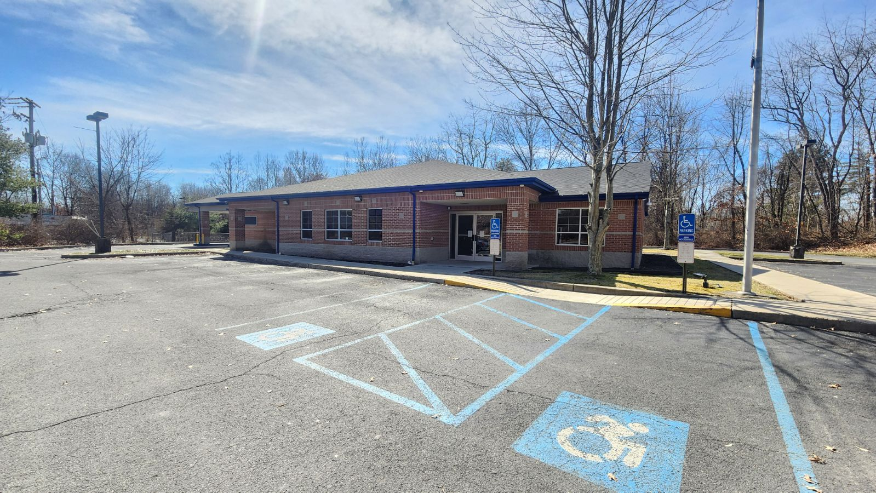 | CLASS A OFFICE FOR SALE  +/- 4268 SF Class A Office/Bank  NEWLY RENOVATED 2022  ASKING PRICE: $950,000.00
ADDRESS 110 Progress Street, East Stroudsburg, PA 18301
PROPERTY Two Parcels: Total 2.19 Acres
Parcel 1: 1.16 Acres Tax ID: 17730219504789
Parcel 2: 1.03 Acres Tax ID: 17730219503975
IMPROVEMENT +/- 4,268SF Class A Bank/Office Building – One Floor with Drive Thru Lanes
CONFIGURATION (8) Offices, (2) Conference Rooms, (1) Teller Position/ Reception Counter. Open Area.
ZONING M-1 Light Industrial
TAXES Parcel 1: Assessment Total: $809,000 Improvement: $558,680 Land: $251,150
Parcel 2: Assessment Total: $38,550 Improvement: $3,440 Land: $35,110
Taxes Total $33,715.71 (Approximated)
HVAC Central Heating and Cooling. 3 New Trane XR Air Handlers (2022)
FIRE SYSTEMS Smoke Alarm System. NO Sprinklers
SECURITY DSX Security System with Interior Cameras. Camera Monitoring Station.
ELECTRIC 120/208 Three Phase 400 AMP
ROOF Composite Shingle. New Roof installed 2022
CEILINGS Drop Ceilings with upgrade finish 2 x 4 Troffer Lights (fluorescent) in office areas.
FLOORING Commercial Carpet and Tile
PARKING 28 Spaces (including 2 ADA spaces)
UTILITIES Public Water , Public Gas, Public Electric (First Electric), Septic Tank

OTHER:
- (2) ADA Male/Female Lavatories
- Breakroom/ Kitchenette
- (2) Conference Rooms
BANKING FEATURES:
- Three (3) Drive Thru Teller lanes w/canopy
- ATM/Deposit Unit
- Drive Thru Lane Red/Green Light System
- Lobby Teller Positions
- Pneumatic Tube System - 2 lanes
- Bullet Resistant Teller Window & Drawer
- Night Deposit thru wall location
