FOR SALE
~ First Time Ever Offered Duplex ~
534 N. BROAD AVE.,
Wilmington, CA 90744
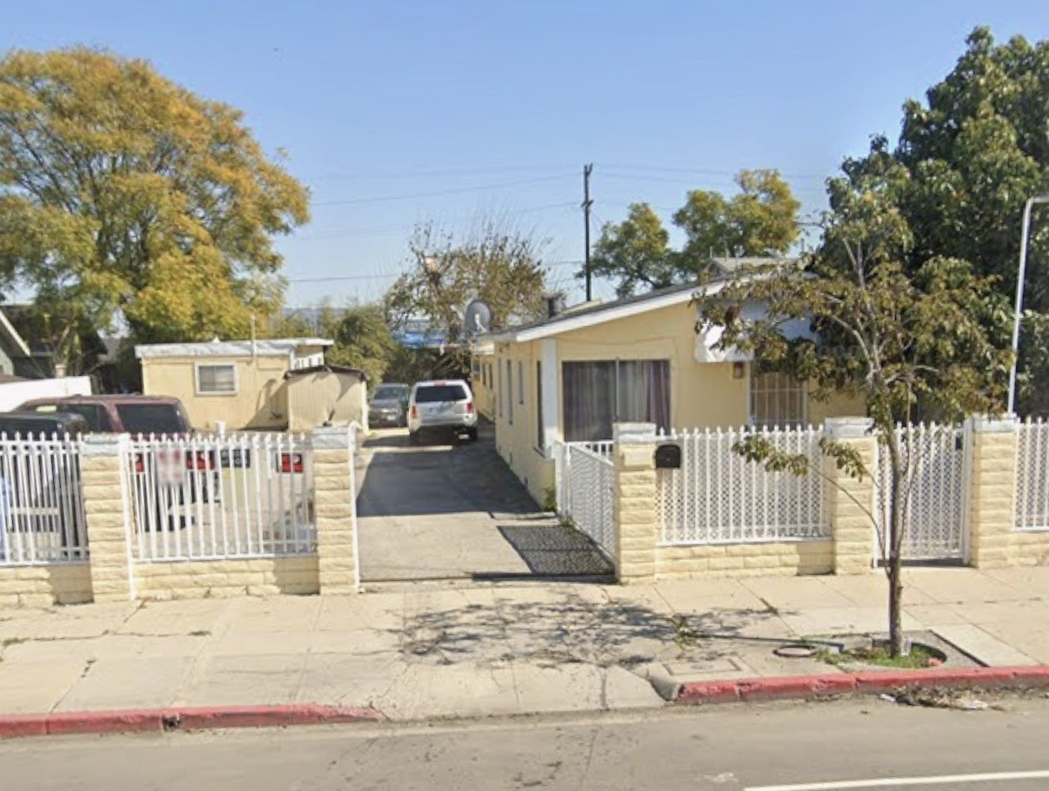
• $650,000.00 Asking Price
• 984 & 1,104 Sq. Ft. Duplex
• Situated on 11,056 Square Feet of LAC.2 Zoned Land
.
PROPERTY FEATURES

• Unbelievable Seller Financing Available!!!
• Fully Gated Property
• Located Near 110 Freeway
• 2 Residential Units
• One Additional Converted Residential Unit
• Excess Parking and Land
• Please Do Not Disturb Tenants

Please contact the exclusive marketing agents for additional information or to place an offer on this superb “As-Is” Property.


Sojka-Nikkel Commercial Realty Group, Inc.
Jessica J. Sojka Broker
(310) 534-8000
(310) 344-5207 Cell

