COMMERCIAL PROPERTY
FOR SALE OR LEASE
201 W. FRONT STREET
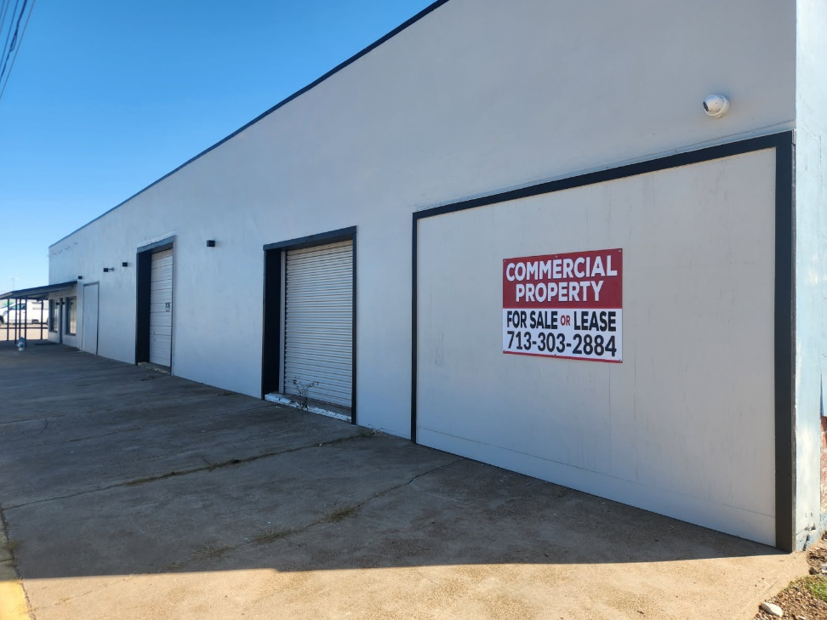
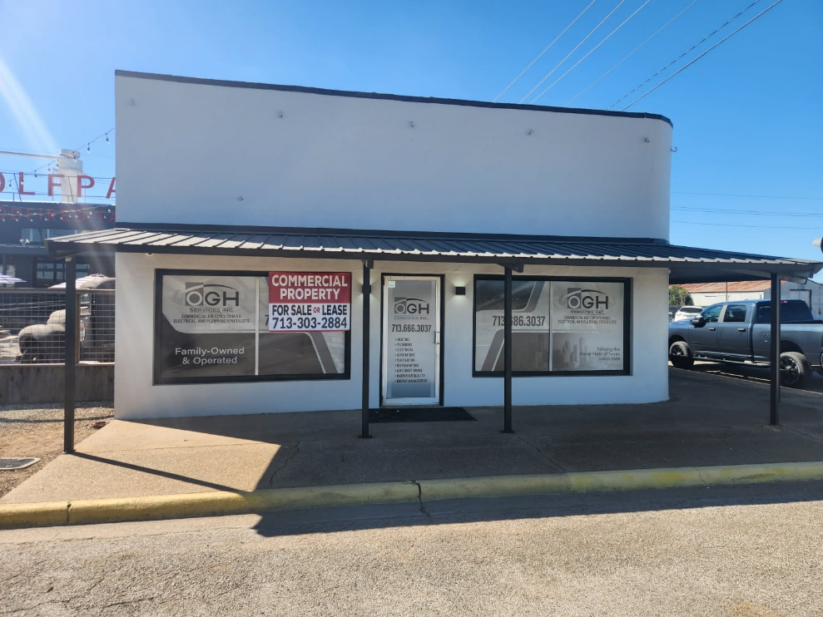
713.303.2884

