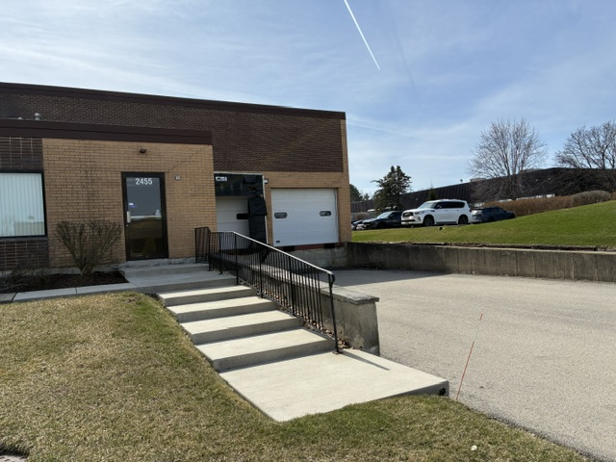
INDUSTRIAL SPACE FOR LEASE

PROPETY HIGHLIGHTS:
- Space available: 10,000 sq. ft.
- High Ceilings
- 2 truck level docks
- 1 drive-in door
- Two story offices
- Sprinkler buildings
- Ample parking
- Easy access to I-88 & I-355



