



PRICE REDUCTION !
3903 Danbury Road, ﻿Southeast, NY, 10509

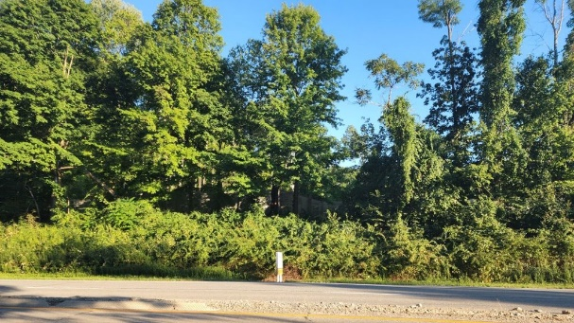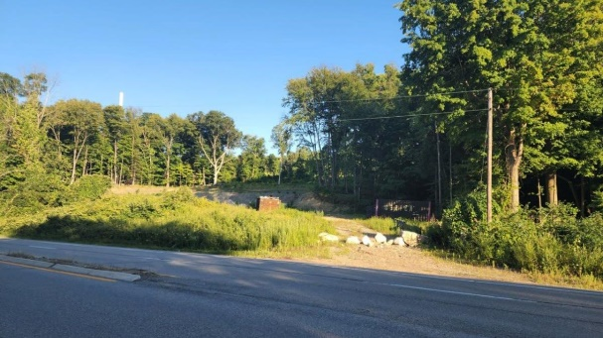

• PRICE REDUCTION – BRING OFFERS!
- Fully approved for a 20,000 SF two-level building, plus 2,000 SF of exterior storage on 3.68 acres
• SR-6 Zoning allows for Storage (cold storage, self-storage), Contractor Use (plumbing, trucks, trade shops - parts), General Repair, Office/Professional Services, Nursery, Customer Service, Repair Shops, and more!
- Detailed Engineering drawings and plans
• Use half and rent half! It’s approved for 38 parking spaces
• Owner constructed a 200’ long (up to 14’ high) large cement retaining wall, put in a well & excavated 16,000 cubic yards of soil
• Great commercial location, visible from Route 84 (signage), in a fast-growing area that is convenient to major highways
• On Route 6/ Danbury Road, only feet from the Danbury, CT border; easy on/off Route 84 East & West, Route 22 North & South, and Route 684

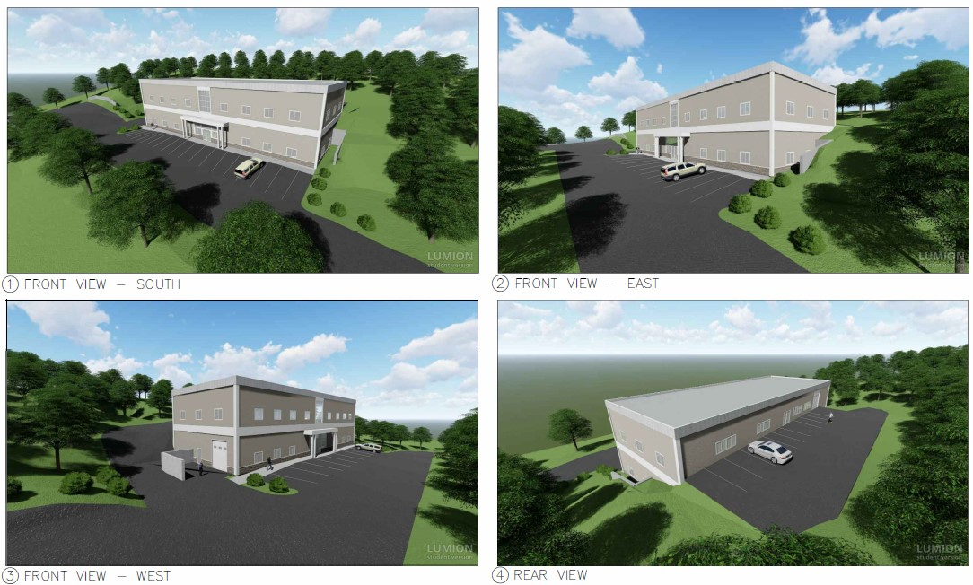

For additional information, please email or call me:
Lynn C. Kieper | 917-363-8877 | LKieper@scalzo.com
Commercial Agent
Scalzo Commercial & New Development

Paul Scalzo﻿, ﻿President
Scalzo Commercial & New Development



