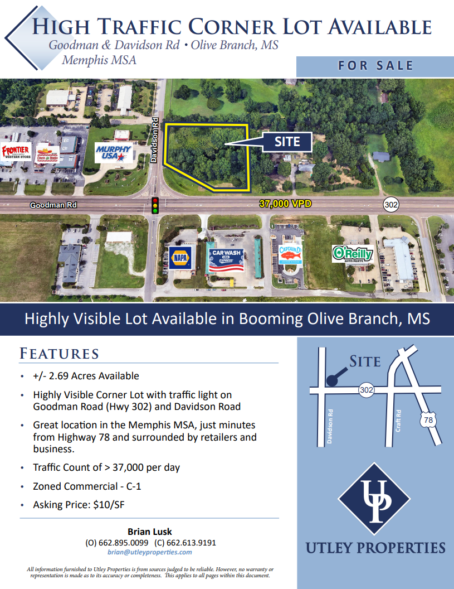

Mark Utley
(901)494-7080
Mark@utleyproperties.com
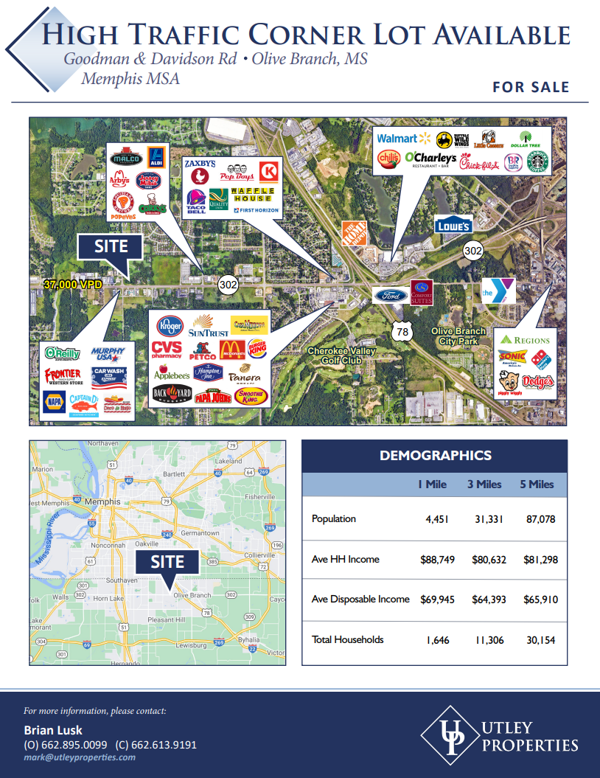


Mark Utley
(901)494-7080
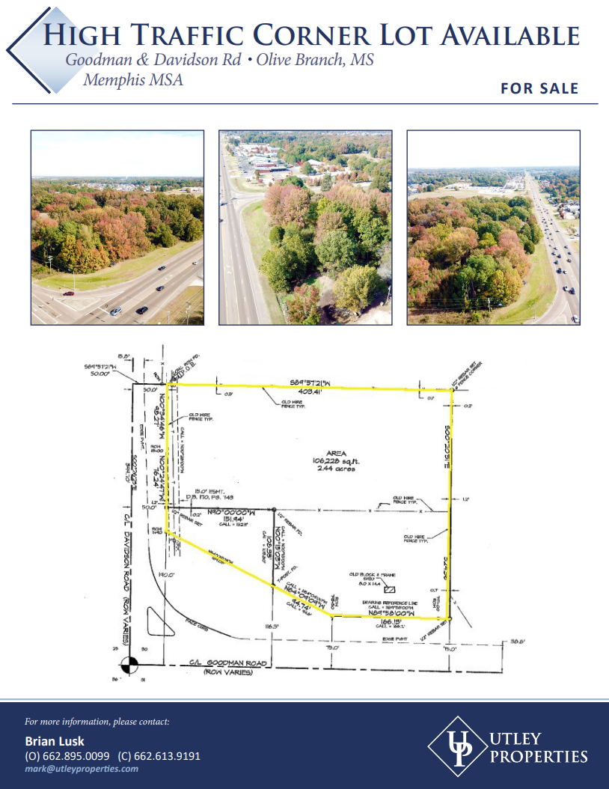
Mark Utley
(901) 494-7080

