for lease
4,450 sf office/shop-warehouse

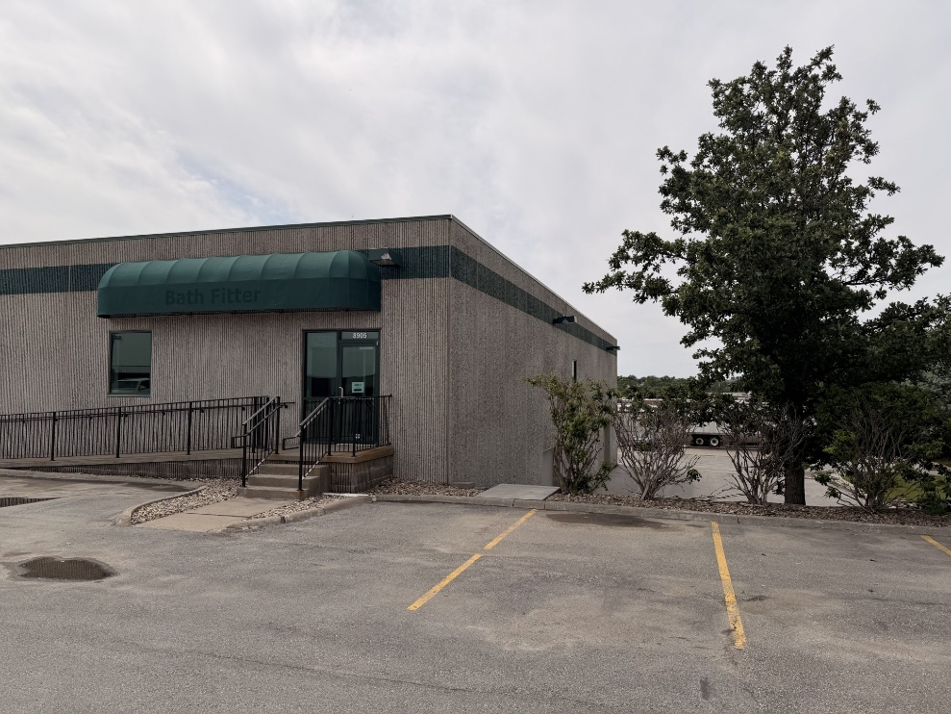

- AVAILABLE!! 8905 F St.
- 4,450 SF AVAILABLE
- QUICK ACCESS TO I-80, 84th St, CENTER St or L St.
- FLEX/ INDUSTRIAL SPACE
- APPROXIMATELY 1,400 SF OFFICE/RETAIL & 3,050 SF WAREHOUSE/SHOP
- 1 – 12’ x 10’ DRIVE IN DOOR
- 22.5’ CLEAR CEILING HEIGHT
- FLOOR DRAINS
- BENEFITS OF ENGAGED OWNER/ MANAGER – CALL DAY, NIGHT OR WEEKEND FOR NO OBLIGATION TOUR


