Business For Sale with property - Asking : $1,099,000
Own the Property, Operate the Business, and Live On-Site
Live-Work Opportunity in Port Coquitlam, BC
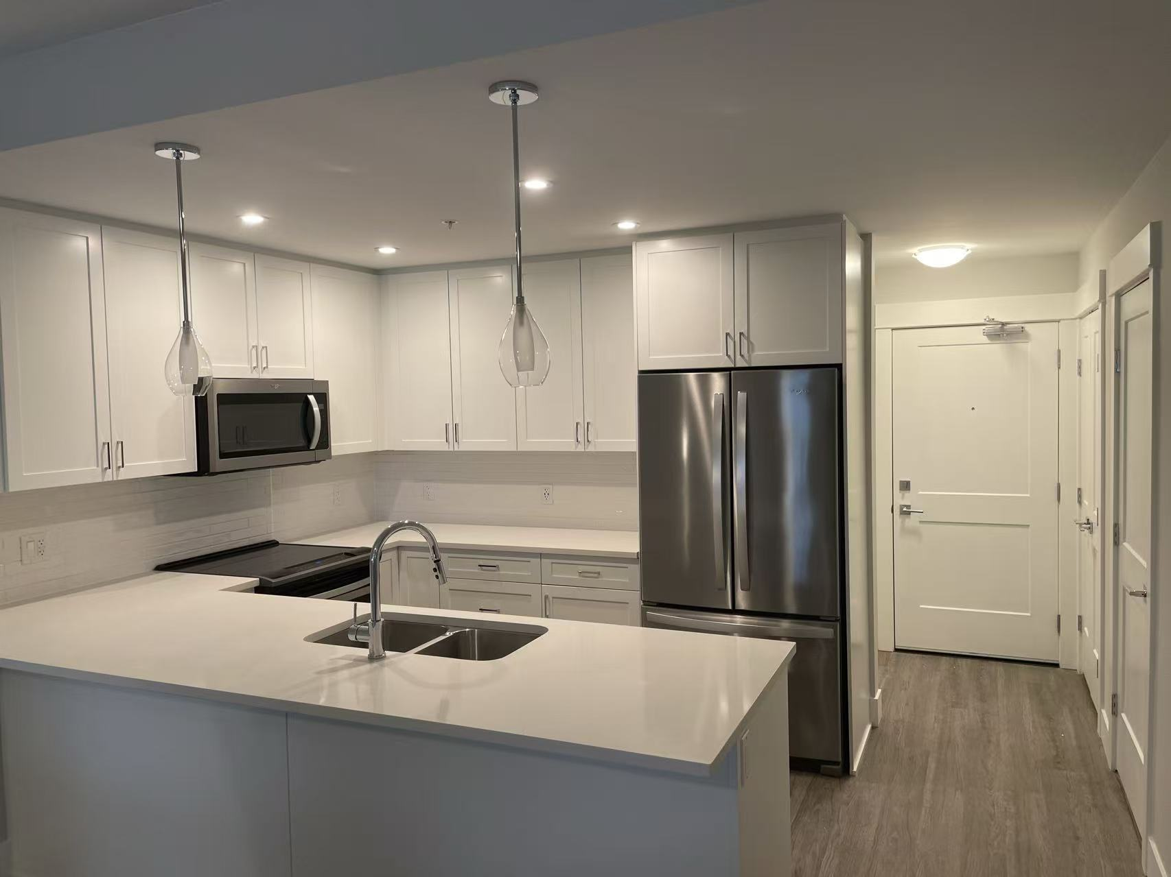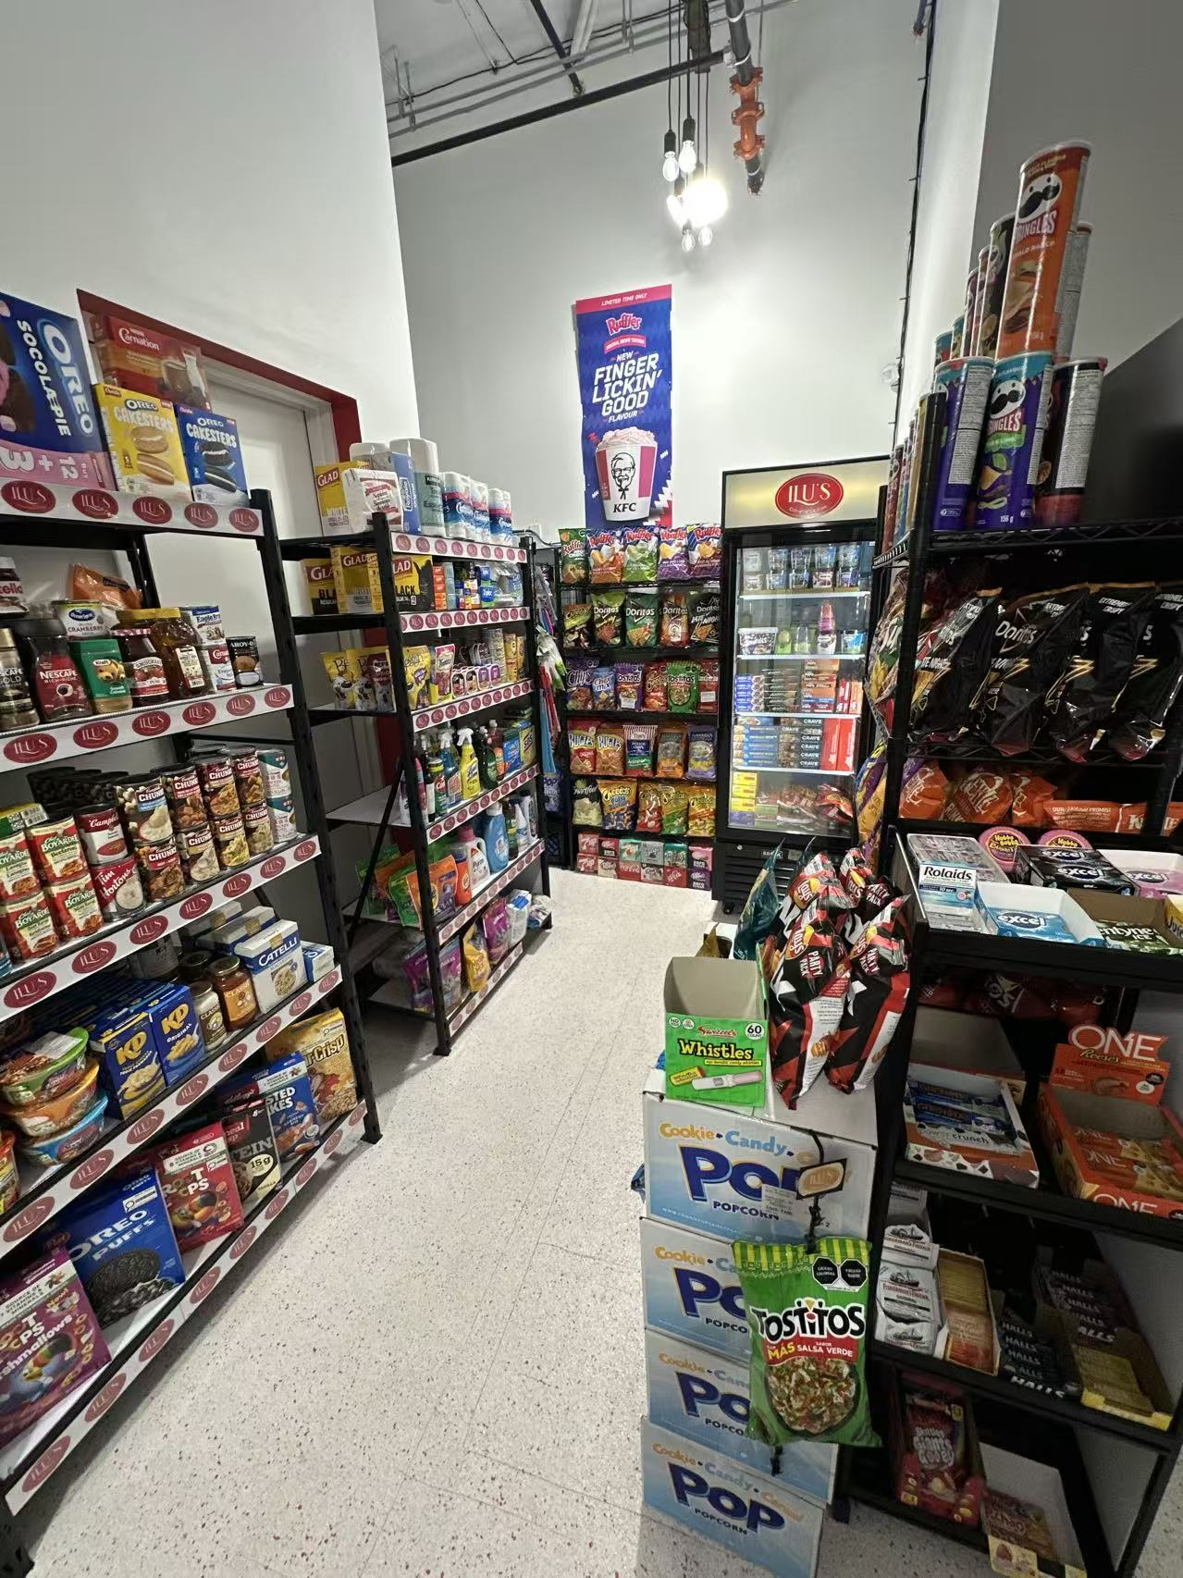

Rare chance to acquire a mixed-use property in Port Coquitlam with a convenience store business on the ground floor and comfortable living space on the second level.
The business is owner-operated and produces approximately $244,000 in annual sales with an estimated net income of $100,000 per year.
Perfect for an owner-operator seeking to live on-site, reduce overhead, and enjoy the benefits of owning both the business and property.

Property details :
Year built : 2021
Style : townhouse - 1 bedroom 1 full bath with deck
Size : 896 sq.ft. Upper (apartment); 512 sq.ft. Lower (Convenience Store)

