Hidden Haven RV Park
8 East Kagen Lane
Selma, NC 27576
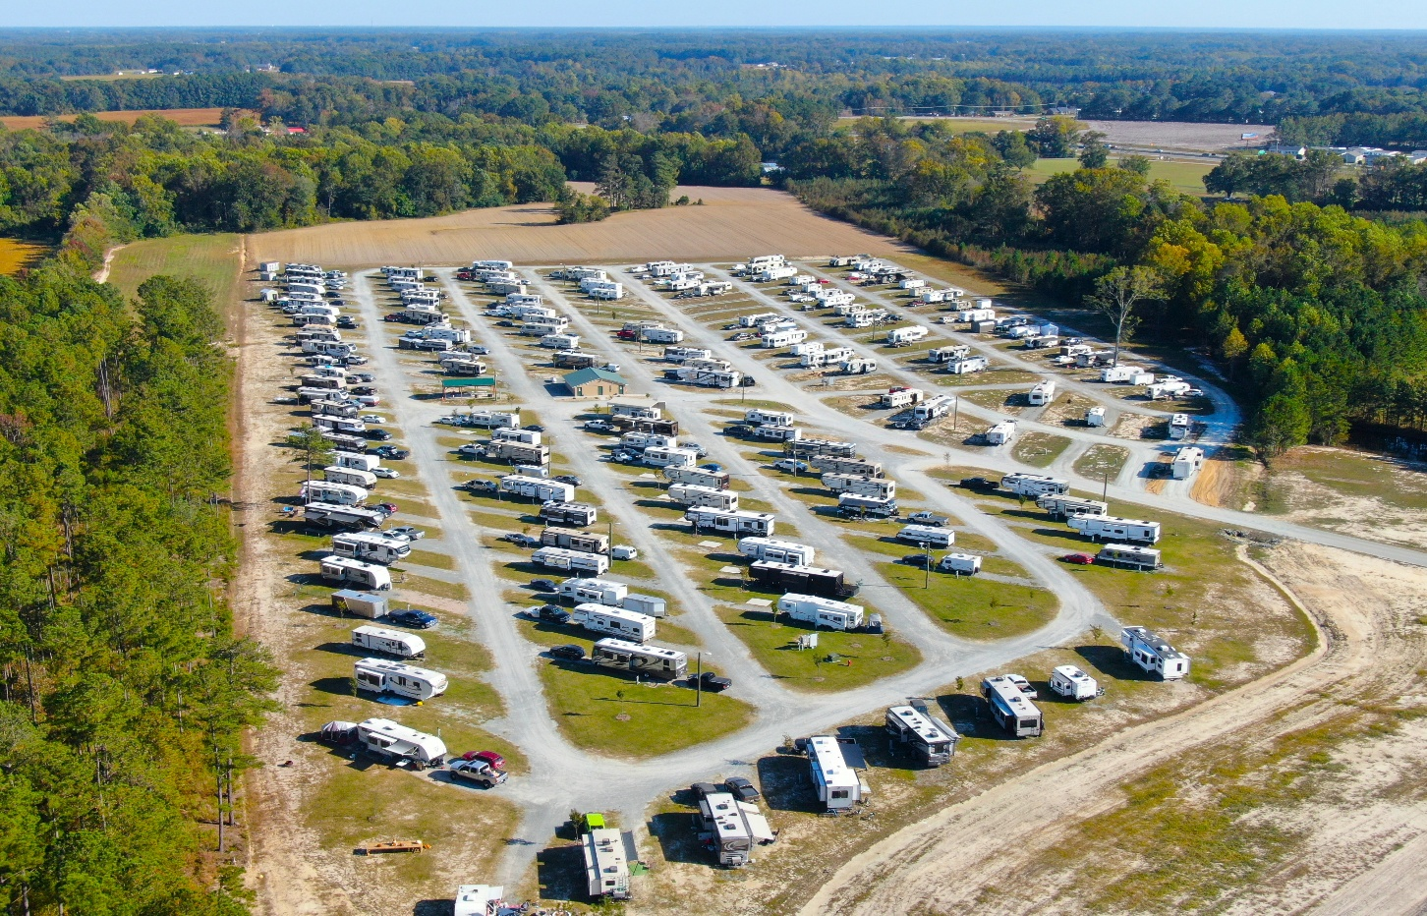

For Additional Information:
Adam O’Neal of O’Neal and Associates.
Real Estate Broker.
252-943-5939
Email: adam6931@gmail.com

