OFFERING MEMORANDUM
Multi-Residential Development Land
Fully Entitled • 8-Unit Townhouse Concept • For Sale

Part 1, Plan 21R-27030 — Newkirk Boulevard
Town of Bancroft, County of Hastings, Ontario
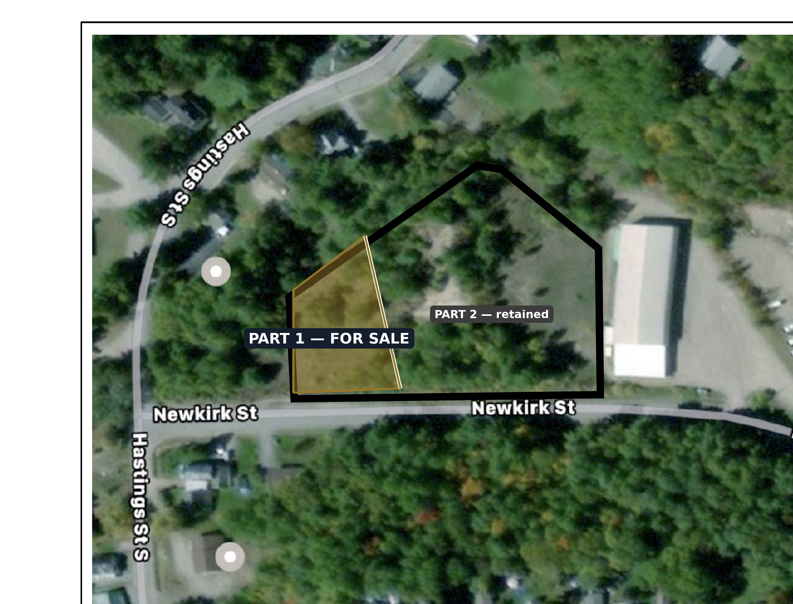
Part 1 (for sale) shaded in gold within the wider assembly; the balance (Part 2) is retained by the Vendor. Boundaries approximate — refer to Reference Plan 21R-27030.
ASKING PRICE $299,000
EXCLUSIVELY LISTED BY
Howard Meier, CCIM | Broker
CB Metropolitan Commercial Realty Inc., Brokerage
370 King Street West, Suite 805, Toronto, ON M5V 1L9
Howard.meier@CBmetcom.com • (416) 786-3478
June 2026 • Cooperating brokers welcome

Confidentiality & Disclaimer

This Offering Memorandum has been prepared by CB Metropolitan Commercial Realty Inc., Brokerage (the “Listing Brokerage”) on behalf of the vendor, M3 Developments (the “Vendor”), solely to assist the recipient in deciding whether to pursue further investigation of the property. It is not intended to be all-inclusive or to contain all of the information a prospective purchaser may require.
The information herein has been obtained from sources believed to be reliable, including the Vendor and its consultants. Neither the Listing Brokerage nor the Vendor makes any representation or warranty, express or implied, as to its accuracy or completeness. All areas, dimensions, frontages, zoning interpretations, unit yields and development concepts are approximate, are provided for general reference only, and must be independently verified by the recipient.
The property is offered subject to errors, omissions, prior sale, change or withdrawal of price or terms, and removal from the market without notice. Prospective purchasers are advised to conduct their own due diligence — including independent verification of zoning, the Holding (“h”) provision, servicing availability and capacity, development feasibility and costs, and all applicable municipal approvals — and to obtain independent legal, financial, planning and technical advice. Nothing in this document constitutes legal, tax, accounting, environmental, planning or investment advice.
This Offering Memorandum does not constitute an offer to sell or a solicitation of an offer to buy. Any transaction will be affected solely by a definitive agreement of purchase and sale executed by the Vendor and a purchaser.
By accepting this Offering Memorandum, the recipient agrees to keep its contents confidential, to use it solely for the purpose of evaluating the property, and to return or destroy it upon the Listing Brokerage’s request.
© 2026 CB Metropolitan Commercial Realty Inc., Brokerage. All rights reserved.

1. Executive Summary

CB Metropolitan Commercial Realty Inc. is pleased to offer for sale Part 1 of Plan 21R-27030 — a fully entitled, surveyed multi-residential development parcel of approximately 0.49 acres (±1,999 m²) fronting 42.29 metres (±138.7 ft) on Newkirk Boulevard in the Town of Bancroft. The land is zoned Multiple Residential – Exception Thirteen – Holding (R3-13-h) under By-Law No. 47-2024, which is in force with no appeals filed, and is conceptually designed for an eight (8) unit townhouse development.
For a builder, investor or operator, the parcel offers a rare combination in this market: completed planning approvals, a deposited reference plan and survey, an architectural site-plan concept, and immediate demand context from the 76-unit retirement residence being developed by the Vendor on the abutting parcel.

Investment highlights
- Fully entitled & de-risked — rezoned to R3-13(h); the by-law is in force and no appeals were filed.
- Shovel-ready concept — architectural site plan supports 8 townhouse units; site-specific relief for lot area, frontage and density already secured.
- Survey-ready — deposited reference plan (21R-27030) and a topographic survey are available for due diligence.
- Flexible product — R3-13(h) also permits triplex, fourplex and low-rise apartment forms within the approved envelope.
- Built-in demand — abutting 76-unit retirement residence under development, plus a regional housing shortage and aging population supporting rental and staff-housing absorption.
- Strong in-town location — walkable to the Bancroft core, at the Highway 28 / 62 hub of North Hastings County.
- Scarce asset — entitled multi-residential land rarely comes to market in Bancroft; most available land is raw and unzoned.

The offering at a glance
Address | Newkirk Boulevard, Town of Bancroft (Part 1)
Asking price | $299,000
Site area | ±0.49 acres • ±1,999 m² • ±0.200 ha
Frontage | ±42.29 m (±138.7 ft) on Newkirk Boulevard
Zoning | R3-13(h) Multiple Residential — in force (no appeals)
Permitted uses | Triplex, fourplex, townhouse, low-rise apartment
Approved concept | 8 townhouse units
Legal description | Part 1, Plan 21R-27030 (part of Block A, Registered Plan 1133)
What is included | Part 1 only — the Vendor retains the abutting Part 2 (retirement residence)

2. Property Overview

The subject is the severed front parcel of a larger Block A holding. Under Plan 21R-27030 the lands are divided into Part 1 (the multi-residential parcel offered here) and Part 2 (the larger parcel retained by the Vendor for a 76-unit retirement residence). The key plan below illustrates the split.
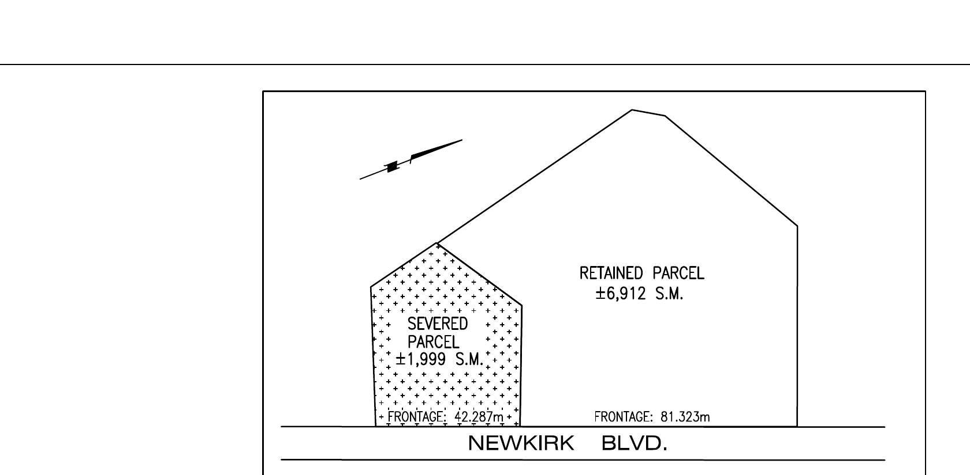
Key plan: the hatched SEVERED parcel (±1,999 m², 42.287 m frontage) is the offering. The RETAINED parcel (±6,912 m²) is excluded.

Site summary
Location | Newkirk Boulevard, Town of Bancroft (parent address 33 Newkirk Boulevard)
Legal description | Part 1, Plan 21R-27030, being part of Block A, Registered Plan No. 1133, Geographic Township of Faraday, Town of Bancroft, County of Hastings
PIN | Part of 40072-0084 (LT)
Lot area | ±0.200 ha • ±1,999 m² • ±0.49 acres
Frontage (Newkirk Blvd) | ±42.287 m (±138.7 ft)
Configuration | Irregular (5-sided) parcel; road frontage to the south on Newkirk Boulevard
Topography | Generally sloping; full topographic survey available for review
Surveys available | Topographic survey (2022) and reference plan 21R-27030 (deposited Sept 11, 2025)
Servicing | In-town location; purchaser to confirm municipal water / sanitary availability and capacity with the Town
Adjacent use | Abutting 76-unit retirement residence (Part 2) under development by the Vendor — not part of this sale
Surrounding context | Established residential neighbourhood; walking distance to the Bancroft town core and Hastings Street

3. Zoning & Development Opportunity

The defining feature of this offering is its completed entitlement package. By-Law No. 47-2024 rezoned the parcel to Multiple Residential – Exception Thirteen – Holding (R3-13-h), amending Comprehensive Zoning By-Law No. 27-2006. Council passed the by-law on June 26, 2024 and no notice of appeal was filed, as confirmed by the Town’s sworn affidavit — so the zoning is in full force.

Permitted uses
R3-13(h) permits a multiple dwelling, including triplex, fourplex, townhouse and low-rise apartment complex. A purchaser is not limited to townhouses; any permitted multi-residential form may be pursued within the approved site-specific envelope, subject to site plan approval and lifting of the Holding symbol.

Approved development concept & site-specific standards
The architectural site plan (Sheet A1.1b) demonstrates compliance for an 8-unit townhouse scheme. Key standards as approved:
Standard (R3-13-h) | General R3 requirement | This site (proposed)
Permitted use | Multiple dwelling | 8-unit town homes
Minimum lot area | 8,000 m² | 1,999 m² (relief)
Min. area per dwelling unit | 800 m²/unit | ≈250 m²/unit (relief)
Minimum lot frontage | 60 m | 42.29 m (relief)
Front yard (min.) | 10 m | 15.46 m
Rear yard (min.) | 10 m | 10.00 m
Interior side yard (min.) | 8 m | 8.00 m
Building height (max.) | 11 m | 7.0 m
Lot coverage (max.) | 30% | ≈11.3%
Min. dwellings / principal bldg. | 3 | 8
Off-street parking | Per Section 3.25 | 10 (8 + 2 guest)
Concept building statistics: footprint 227.62 m² (2,450 ft²); total floor area 455.36 m² (4,900 ft²); 8 units; 10 parking spaces.

Holding (“h”) provision
As is customary for entitled land of this kind, the Holding symbol must be lifted by Council before building permits issue. It ensures the owner satisfies standard municipal requirements (typically a site plan agreement, confirmation of servicing, and posting of securities). Purchasers should confirm the lifting requirements directly with the Town as part of their due diligence.

4. Area Overview & Demand Drivers

The Town of Bancroft sits on the York River at the southern edge of the Canadian Shield, at the intersection of Provincial Highways 28 and 62 — the commercial and service hub of North Hastings County and a gateway to Algonquin Park. The town has a population of roughly 4,500, anchors a regional catchment of about 40,000, and draws an estimated 150,000 visitors annually. In 2021 it was ranked by MoneySense as the best place in Canada to buy real estate.

Demand drivers for this parcel
- Adjacent seniors housing catalyst — the 76-unit retirement residence rising on the abutting parcel creates direct, on-site demand for nearby rental and staff housing of exactly the kind this parcel can deliver.
- Aging population — North Hastings has an older demographic and an identified housing shortage, supporting absorption of new purpose-built units.
- Constrained supply — serviced, zoned multi-residential land is scarce locally; most available inventory is raw, unentitled land requiring years of approvals.
- Supportive policy environment — the Town has prioritized housing, and the completed rezoning removes the single largest source of development risk and timeline.
- Lifestyle pull — Bancroft’s recreation, arts and natural setting (the “Mineral Capital of Canada”) continue to attract retirees, remote workers and seasonal residents to the area.
Sources: Town of Bancroft; Statistics Canada (2021 Census); MoneySense; publicly available regional profiles. Figures are approximate and provided for general context.

5. The Offering

Asking price | $299,000
Property | Part 1, Plan 21R-27030 — Newkirk Boulevard, Bancroft (±0.49 ac)
Interest offered | Fee simple; vacant land, sold as-is where-is
Included | The land, the benefit of the R3-13(h) zoning, and copies of available survey, plan and site-plan materials
Excluded | Part 2 (retained by the Vendor for the 76-unit retirement residence)
Vendor | M3 Developments
Cooperating commission | As published on the MLS listing
Listing type | MLS / ICX exclusive listing via CB Metropolitan Commercial Realty Inc., Brokerage

Pricing rationale
The asking price reflects a fully entitled and surveyed parcel — completed severance, in-force R3-13(h) zoning (no appeals), a deposited reference plan, a topographic survey, and an architectural site-plan concept for 8 units. At $299,000 the offering equates to approximately $37,400 per approved unit for land where the planning approvals, time and risk of entitlement have already been carried. Purchasers are encouraged to complete their own feasibility analysis.

Available due-diligence materials
The following are available to qualified parties on request:
- By-Law No. 47-2024 and the Town’s Affidavit Re No Appeal
- Reference Plan 21R-27030 (Part 1 identified)
- Topographic survey (2022)
- Architectural site plan A1.1b and zoning compliance matrix
- Aerial and key plan

Matters for purchaser verification
- Servicing — confirm municipal water / sanitary availability, capacity and connection requirements with the Town.
- Holding (“h”) lift — confirm the conditions and process to remove the Holding symbol.
- Development feasibility — independently verify unit yield, costs, soils/geotechnical and any other approvals required.

6. Offering Process & Contact

The property is offered for sale on an MLS / ICX basis. Cooperating brokers are welcome. Offers and expressions of interest may be submitted at any time and will be presented to the Vendor as received.

To submit an offer or request information
- Contact the Listing Brokerage to request the due-diligence package or to arrange a site visit.
- Offers should be submitted in writing on an Ontario Agreement of Purchase and Sale, addressed to the Vendor c/o the Listing Brokerage.
- All information requests, inspections and communications are to be directed through the Listing Brokerage — please do not contact the Vendor or the Town directly under the listing.
Exclusively listed by
Howard Meier, CCIM | Broker
CB Metropolitan Commercial Realty Inc., Brokerage
370 King Street West, Suite 805, Toronto, ON M5V 1L9
Howard.meier@CBmetcom.com • (416) 786-3478
All offers are subject to the Vendor’s acceptance. The property is offered subject to prior sale, change in price or terms, or withdrawal without notice. Please review the Confidentiality & Disclaimer notice at the front of this document.

