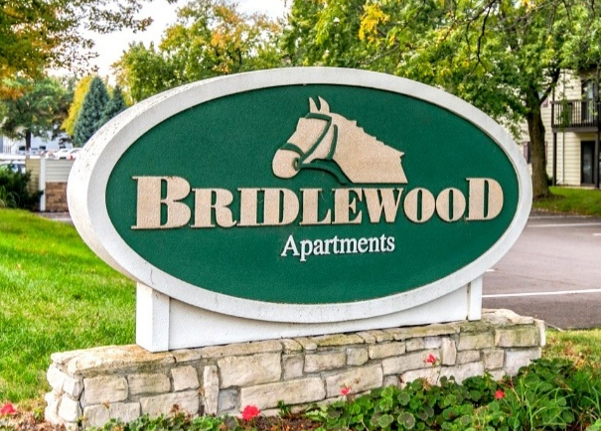
Broker Cooperation Policy – Bridlewood

Thank you for your interest in Bridlewood Apartment Homes. We welcome your participation and look forward to the potential of working with you. Following is a summary of our broker cooperation policies.

- Seller welcomes cooperation with licensed real estate brokers representing buyers.
- Seller has not retained any broker to market the property.
- Seller will only pay a brokerage commission if the obligation is expressly set forth in a fully executed purchase agreement signed by Seller.
- No oral agreements or buyer registrations shall create any obligation to pay a commission.
- We don't preregister buyers or sign one-party commission agreements.
- Broker represents that they have an active brokerage relationship with the buyer before presenting the property. If your buyer wishes to purchase the property, have them identify you as their broker in their written offer and specify any requested commission. If we accept that offer, we will pay the agreed commission at closing.

Full marketing information available at:
www.Daymarkofferings.com

