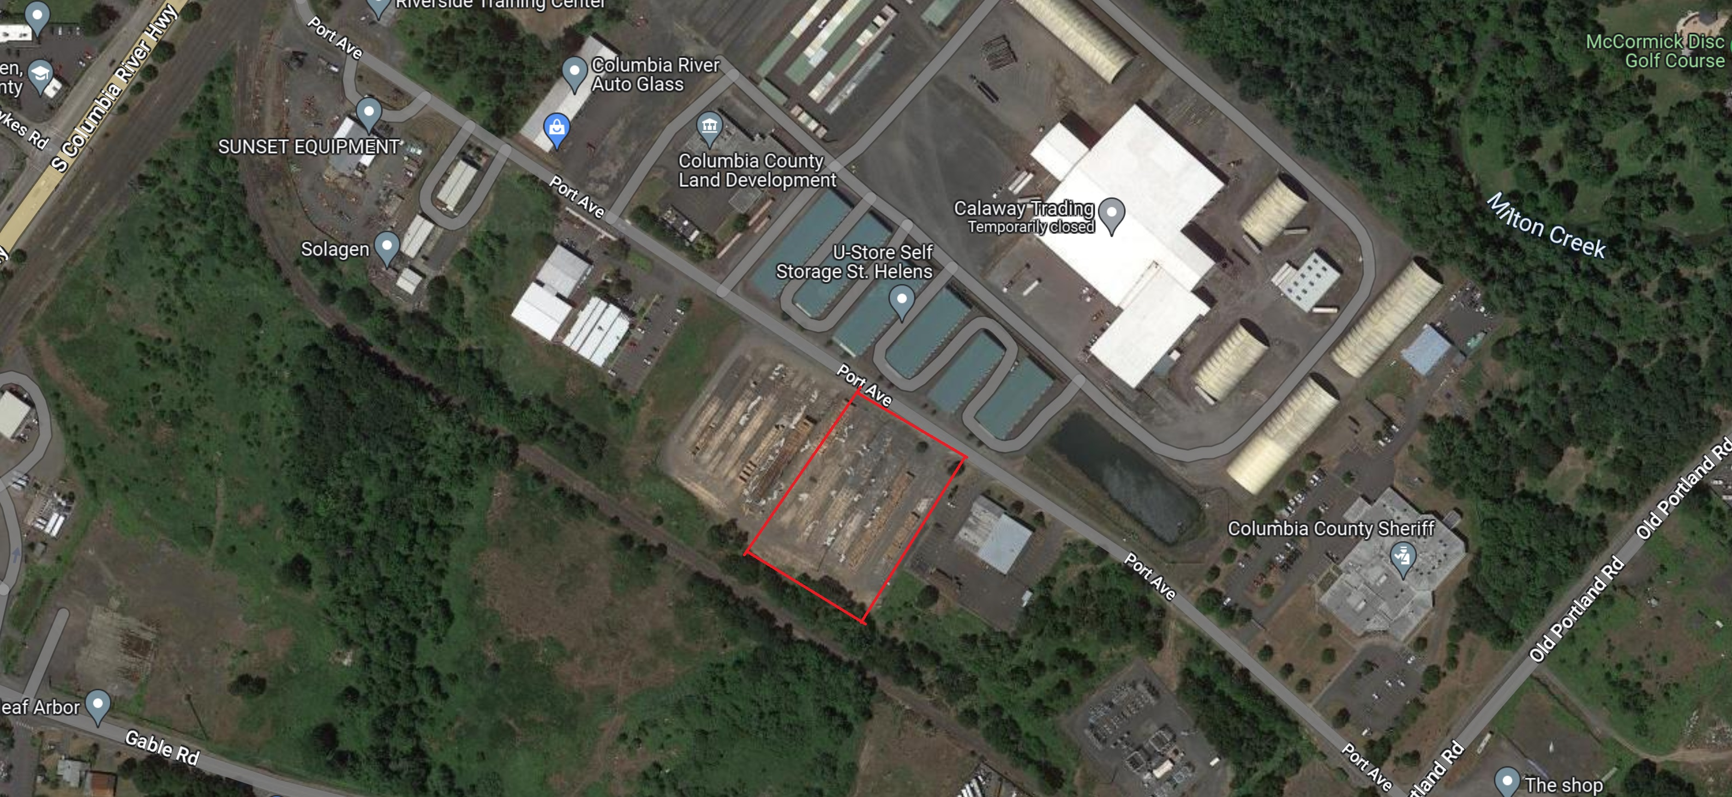

1.95 Acre Vacant Parcel for Sale
700 Port Avenue
St. Helens, Oregon
Description:
For Sale…..a vacant parcel of land with approximately 266’ of frontage on Port Ave. This parcel is the remaining parcel of property from a recently completed partition. The adjacent parcel, also 1.95 acres, will soon be developed as a light warehouse and storage yard.

Zoning:
Heavy Industrial (HI).

Price: $595,000 ($7.00 /sq.ft.)

Agent: Alan Wells, CCIM

Commercial Associates
202 NW 6th Street
Corvallis, OR 97330
(541) 754-6320
Cell: (541) 990-9613
E-mail:alan@commercialassociates.org
www.commercialassociates.org

The information contained herein was secured from sources deemed reliable but is not guaranteed by broker and is subject to price change, prior sale, error or omission, correction or withdrawal without notice.

