
OFFERING MEMORANDUM
3122 BROADWAY | EVERETT, WASHINGTON 98201
Prime Location Commercial Land — For Sale
SHOVEL-READY · PERMITS READY FOR PICKUP · COMPLETE APPROVED PLANS
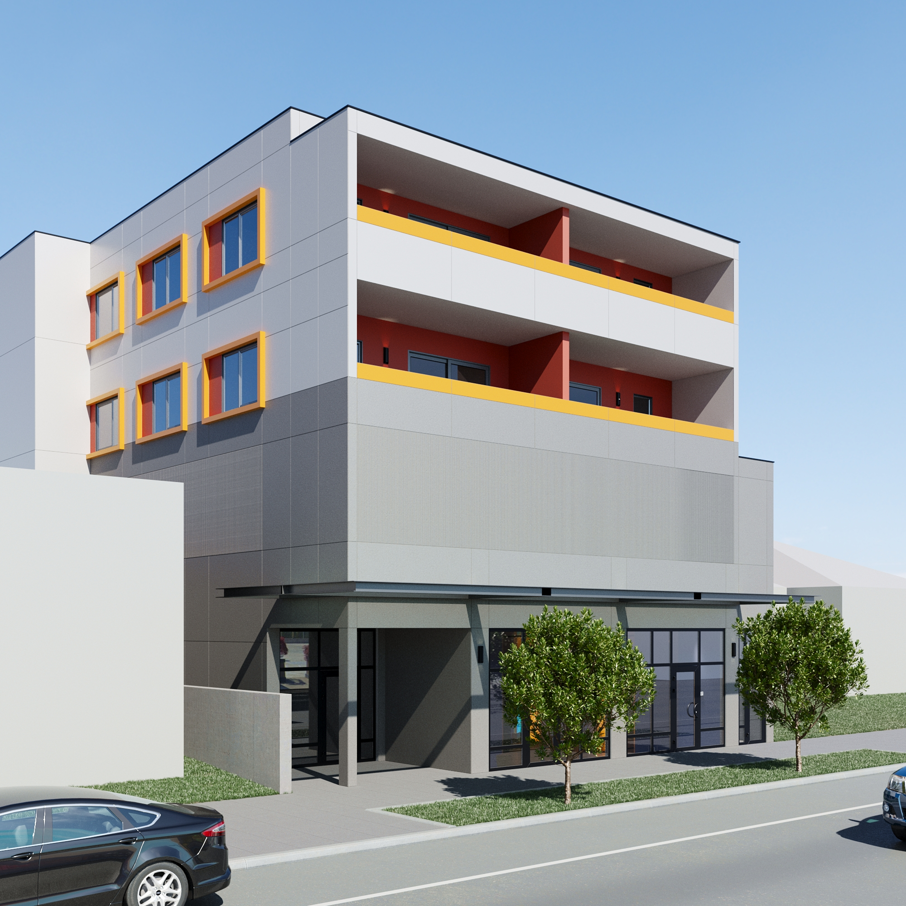
Approved Development — Front Elevation
Steps from Angel of the Winds Arena & the Future Outdoor Event Center

EXECUTIVE SUMMARY
Ethos Northwest Realty presents an exceptional opportunity to acquire a 0.14-acre urban infill land parcel in the heart of Everett's highest-density corridor. The site is truly shovel-ready: permits are ready to be picked up, and the sale includes a complete set of approved architectural and structural plans for a 4-story, 8-unit mixed-use building — eliminating months of entitlement risk, design cost, and carrying cost for the next owner.
The approved design delivers ground-floor retail fronting Broadway, dedicated garage parking, and eight 2-Bedroom / 1-Bath residential units — a turnkey program ready to break ground upon closing. The property is further positioned to capitalize on Everett's structural housing deficit, the forthcoming Sound Transit Link Extension, and a robust local employment base — and sits within walking distance of Angel of the Winds Arena and the future Outdoor Event Center, two of the city's premier entertainment anchors.
As a bonus, the parcel has also been up-zoned to MU15 — a teaser of future upside for a developer who may want to explore a taller build down the road.
PROPERTY SNAPSHOT
Listing Price | $890,000
Parcel Size | 0.14 Acres (Approx. 6,098 SF)
Entitlement Status | Shovel-Ready — Permits Ready for Pickup
Approved Plans | Complete 4-Story Design: Retail + 8 Residential Units
Zoning | Mixed Use (MU) — Up-Zoned to MU15
Utilities | City of Everett — Water, Sewer, Electric Available

WHY THIS SITE
- Truly shovel-ready: permits ready for pickup with a complete, approved set of plans and designs — no entitlement delay
- Approved 4-story program: ground-floor Broadway retail, dedicated garage parking, and eight 2BD/1BA residential units
- Rare 0.14-acre infill parcel directly on the Broadway arterial with prime visibility and vehicular accessibility
- Walking distance to Angel of the Winds Arena, the future Outdoor Event Center, and the upcoming Sound Transit Link light rail station
- Site elevation may offer potential water, city, and mountain views from upper floors
- Bonus upside: recently up-zoned to MU15 for developers who may want to build taller down the road

APPROVED PLANS — SHOVEL-READY 4-STORY DEVELOPMENT
The site comes complete with a fully approved, permit-ready design — a single 4-story mixed-use building ready for immediate construction. Because the land slopes down from Broadway to the rear alley, the approved design cleverly uses that grade change: ground-floor retail opens directly onto Broadway, while the garage parking level sits just below, with its own at-grade entrance from the alley.
Building Program Summary
Total Building Area | 14,725 SF
Ground-Floor Retail | 1,032 SF, fronting Broadway
Residential Units | 8 Units — All 2-Bedroom / 1-Bath
Residential Floors | Levels 2 & 3 (4 units per floor)
Parking | 13 Stalls in Dedicated Garage Level
Bicycle Parking | 4 Secure Spaces
Construction Type | V-A, Wood-Frame, Fully Sprinklered
Governing Code | 2018 IBC / Washington State Energy Code

Approved Design Highlights
- Ground-Floor Retail: Street-activated retail space fronting Broadway, ready to lease or owner-occupy
- Dedicated Garage Parking: Enclosed parking level with its own at-grade entrance from the rear alley, made possible by the site's natural slope
- Eight Residential Units: All eight units are designed as spacious 2-Bedroom, 1-Bath apartments across the two upper floors
This turnkey design allows a buyer to submit for permit pickup and break ground almost immediately upon closing — a rare, de-risked path to a finished asset in one of Everett's most active corridors.
LOOKING AHEAD — MU15 UPSIDE
For developers who want more, the parcel has also been recently up zoned to MU15, permitting building heights up to 15 stories. It's a compelling long-term option worth exploring alongside the approved, ready-to-build 4-story plan.

LOCATION & TRANSIT ADVANTAGE
The property's standout locational advantage is its proximity to two of Everett's largest entertainment and event draws — Angel of the Winds Arena and the future Outdoor Event Center — placing future residents and retail tenants within a short walk of concerts, sporting events, and year-round foot traffic.
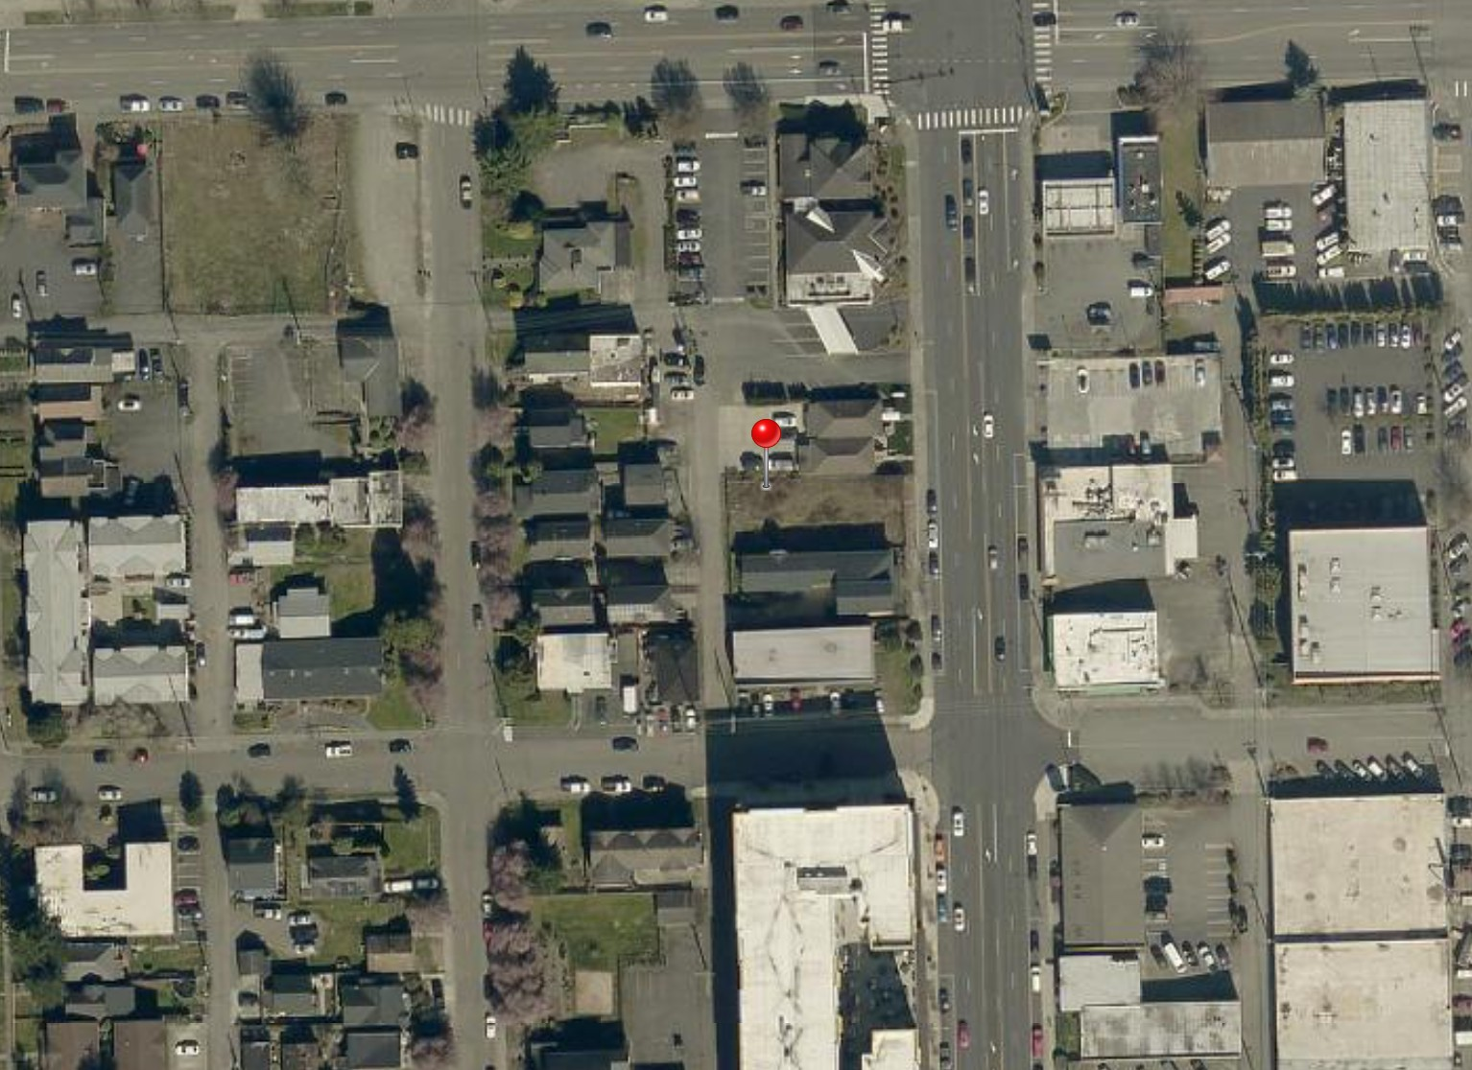
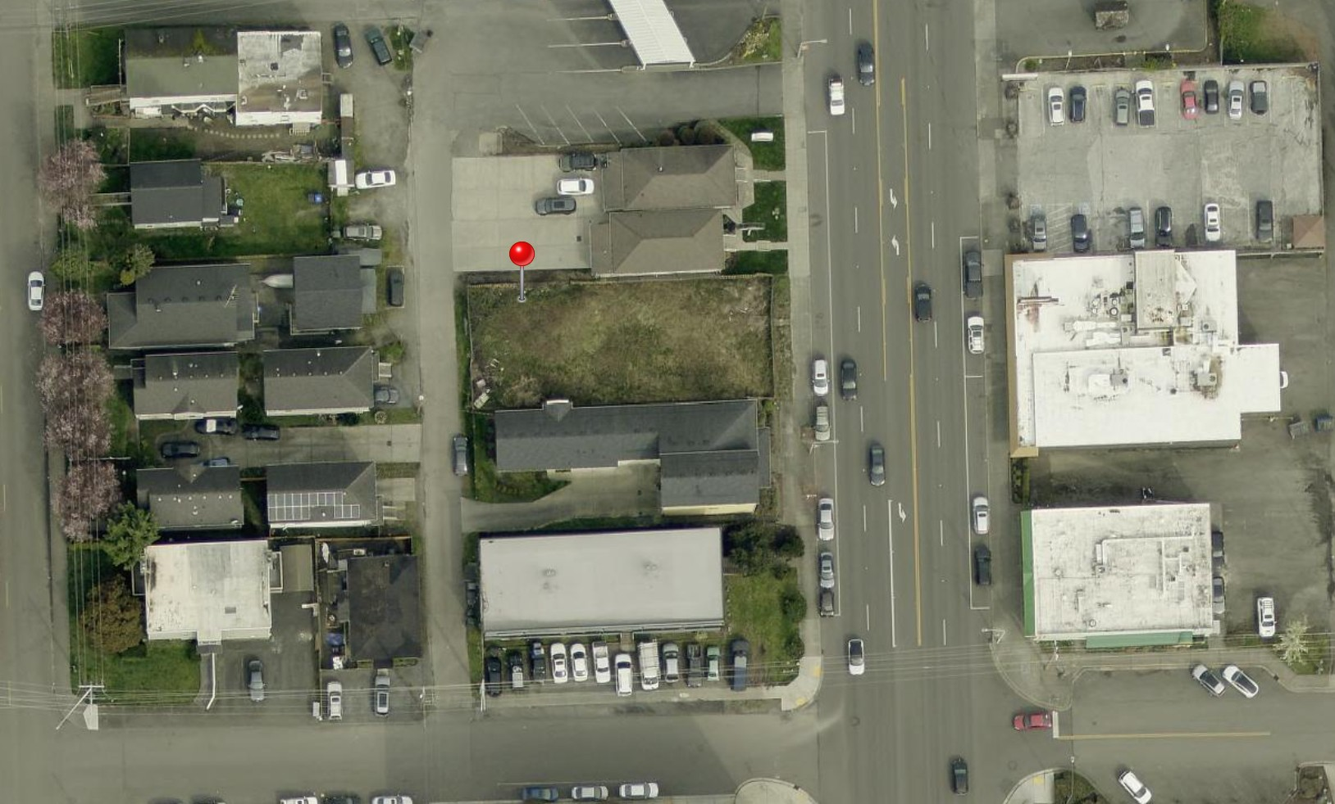
Aerial context: subject property (pin) along the Broadway corridor
- Light Rail Access: Within walking distance of the upcoming Sound Transit Link light rail extension, further boosting long-term connectivity and value
- Transit-Oriented: Located in the urban core near Community and Everett Transit networks, with the Link Extension set to enhance connectivity to Sea-Tac Airport
- Major Employment Anchors: Surrounded by recession-resistant economic drivers, including the Boeing Everett Facility, Providence Regional Medical Center, and the Port of Everett
- Entertainment & Events: A short walk to Angel of the Winds Arena and the future Outdoor Event Center
- Views: Potential water, city, and mountain views from upper-floor units
- Infill Scarcity: 0.14-acre parcels directly on the Broadway arterial are exceedingly rare

APPROVED DEVELOPMENT — REAR ELEVATION
The rear elevation illustrates the at-grade alley entrance to the garage level — the design solution that makes on-site parking possible on this sloped, narrow infill lot.
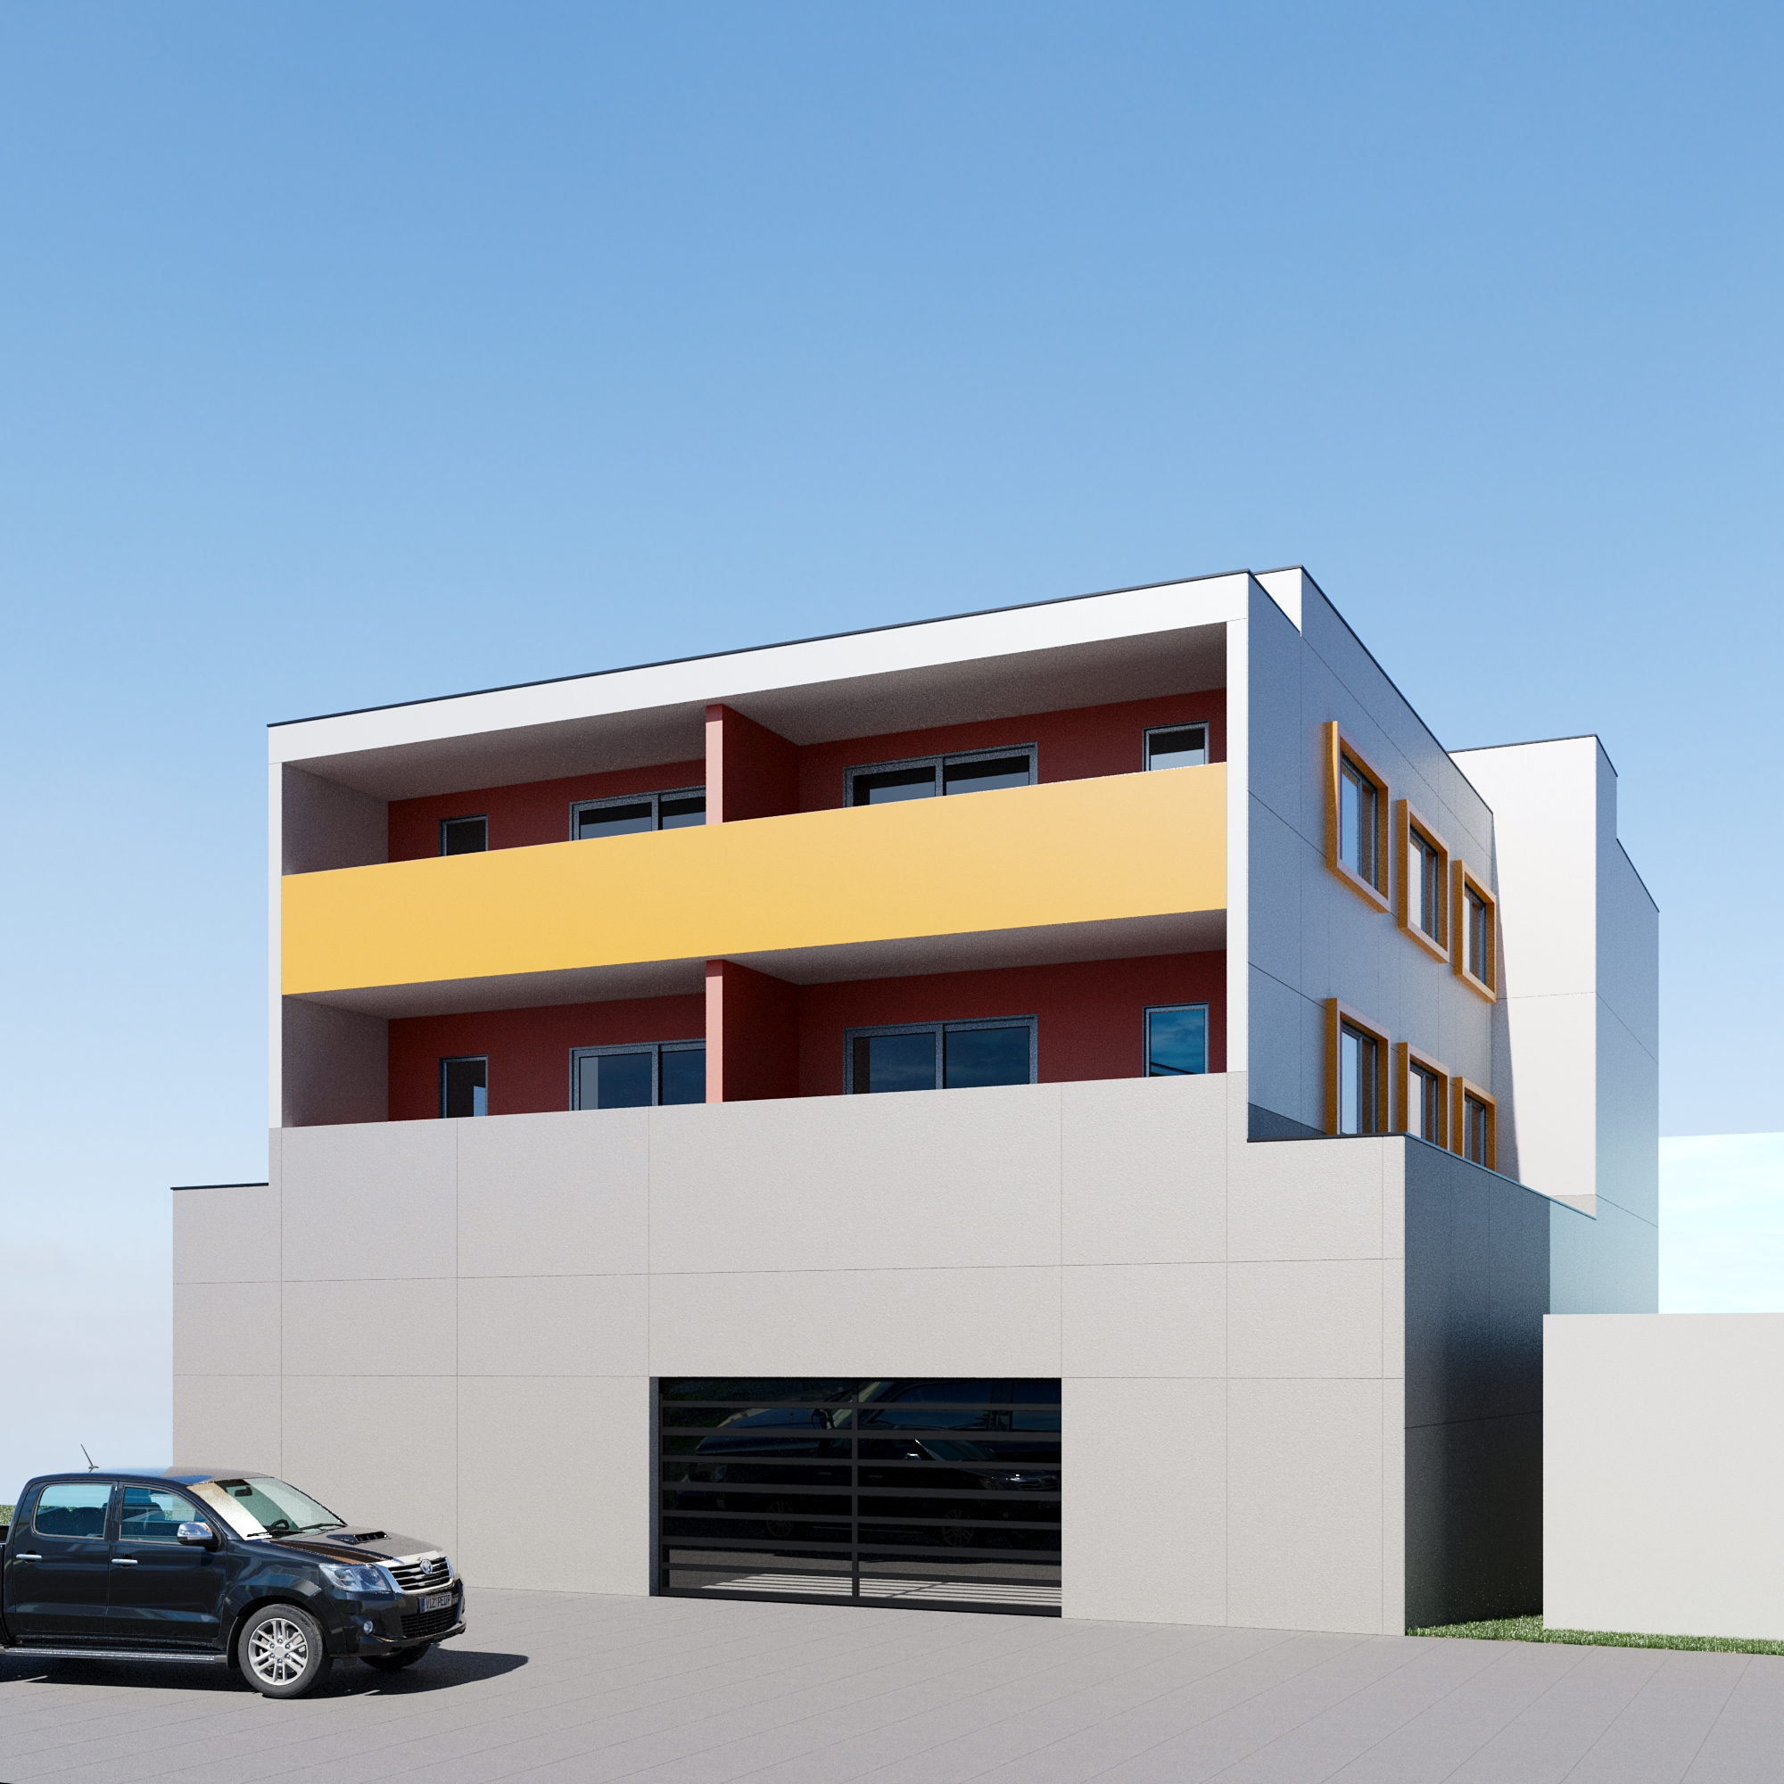
Rear Elevation / Alley-Level Garage Entrance

CONTACT YOUR ADVISOR
Qualified investors and developers are invited to submit a Letter of Intent or request the complete Due Diligence Package (including approved plans, the Phase I ESA report, and title preliminary).
Cindi Johnston
Senior Broker, Ethos Northwest Realty
Direct: 206.931.7524
Email: Cindi@ethosnwrealty.com
Website: www.ethosnorthwestrealty.com
Office: Kirkland, Washington

This Offering Memorandum has been prepared by Ethos Northwest Realty for informational purposes only and does not constitute an offer to sell. Information contained herein, including entitlement, permit, and zoning status, has been obtained from sources believed reliable but has not been independently verified. Prospective purchasers should conduct their own investigation.

