LANE GUEST RANCH
11957 Highway 7, Allenspark, CO 80510 $2,750,000
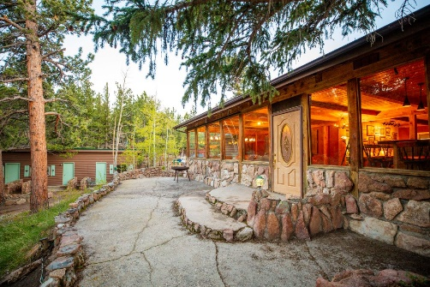
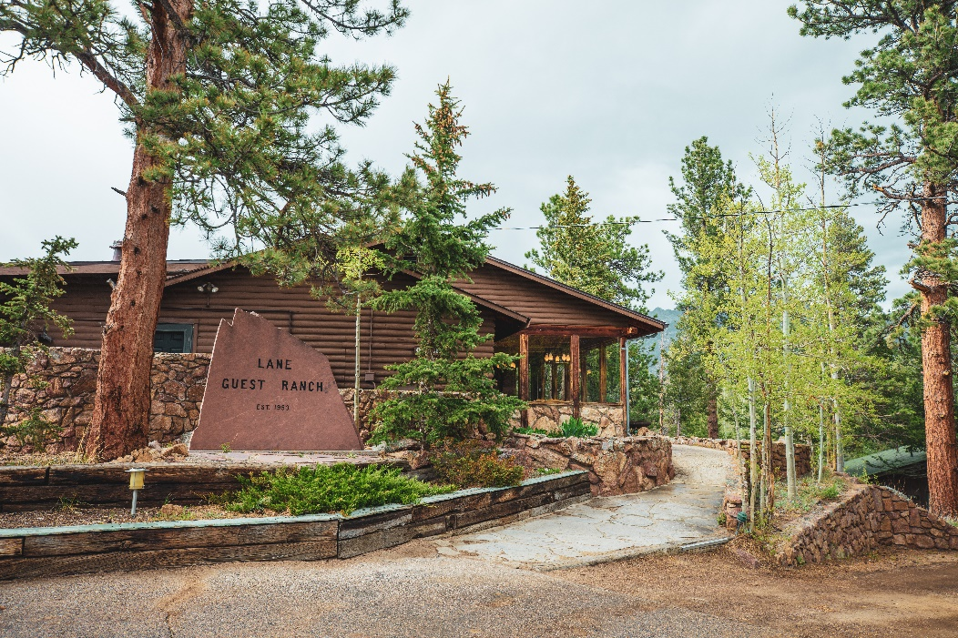

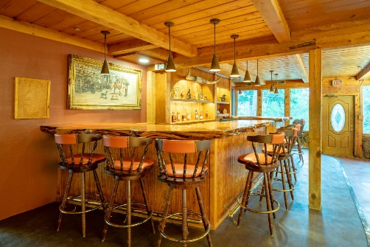

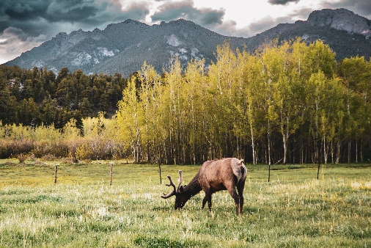
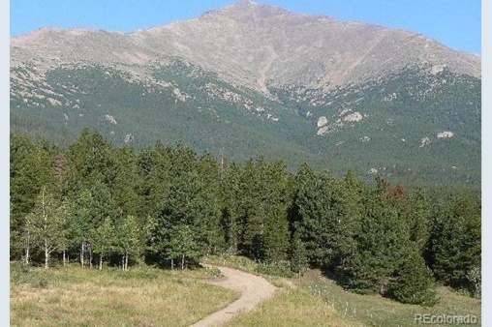
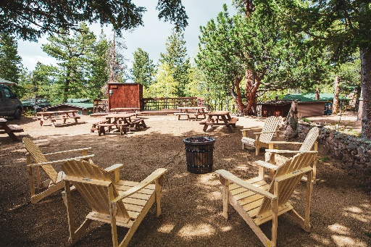
LISTING AGENT
Sandy Colohan 303-919-5993
scolohan@creekcos.com

Keller Williams Rlty DTC
303-722-1067
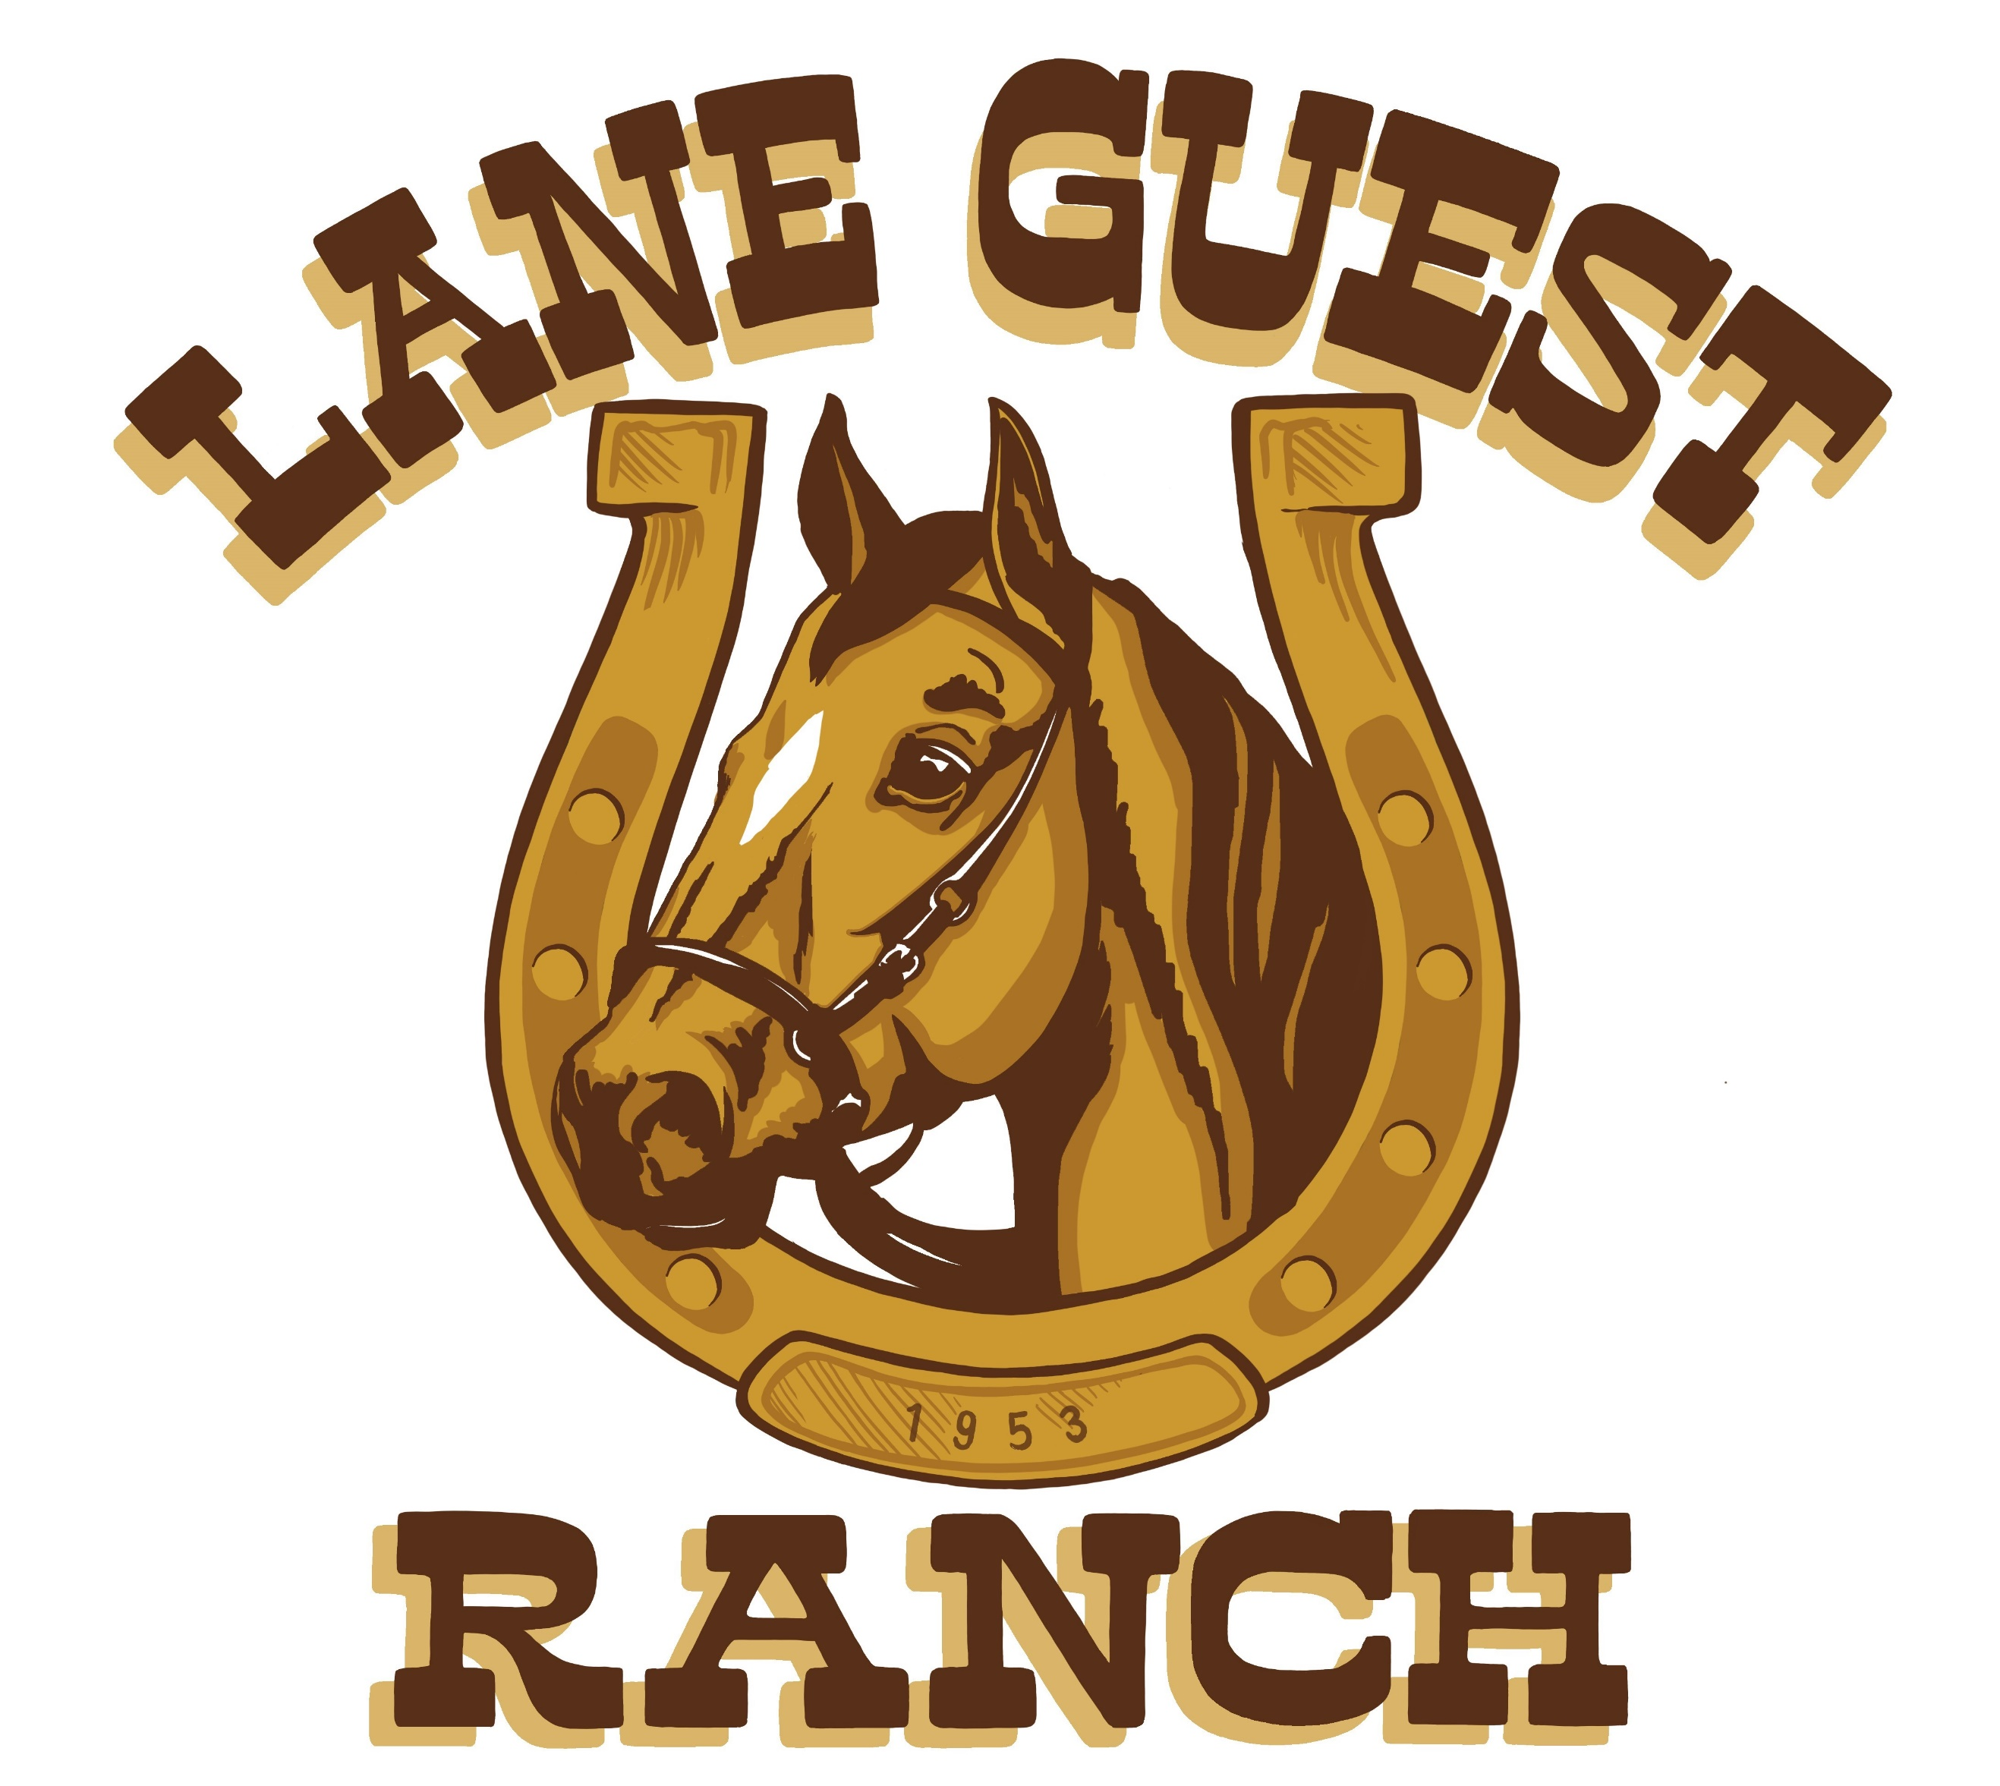
This Iconic property is just 13 miles from Estes Park and 67 miles from Denver. There are 25 1 & 2 Bedroom guest cabins plus a wonderful Bar/Deck/Restaurant. There is a tack room and a corral for horses.
Make this your private retreat or event center.
20.221 acres of Wooded Bliss.

