Prime Visibility. Turnkey Space. Reduced Move-In Costs.
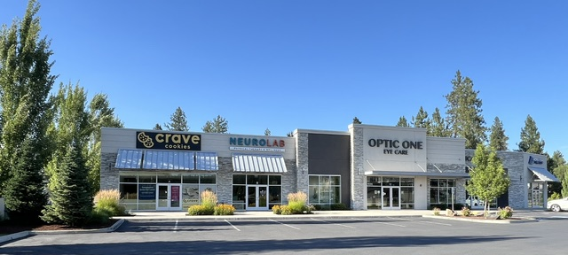

Suite A is now available for immediate occupancy offering a premier opportunity for a bakery, donut shop, café, coffee or sandwich shop, etc. This 2,006 sq. ft. move-in-ready space was previously occupied by Crave Cookies and features a dedicated food service and retail/counter buildouts.
Square Footage/Pricing: 2,006 sq ft / $24 sq ft / NNN

Property Highlights
Completed in 2019, this premium commercial property is located at 513 E. Hastings Road in North Spokane’s upscale Wandermere area. Situated on a highly visible, high-traffic thoroughfare, the building offers exceptional exposure and accessibility. It is positioned within walking distance of major anchors like Fred Meyer and a local movie theater, as well as extensive residential neighborhoods and apartment complexes.

Property Specifics
- Outdoor Space: Includes a front patio and a 1,300 sq. ft. rear patio, fully plumbed with electrical and natural gas connections.
- Utilities & Amenities: Equipped with independent utility metering, a fully compliant ADA-accessible restroom, and access to a shared 39-stall parking lot.
- Visibility: Features dedicated exterior building signage with timers facing a high-traffic thoroughfare.

Location Advantage
Situated in one of the fastest-growing sectors of Spokane County, the property is strategically positioned between Highway 2 and Highway 395. It benefits from exceptional visibility and exposure, with daily traffic counts averaging between 15,000 and 20,000 +.

