SHORT & LONG TERM COMMERCIAL SPACE AVAILABLE!

Call for Details.

210-399-3679
Full Services available.
Full Pick up and Delivery.
*Certain Restrictions May Apply



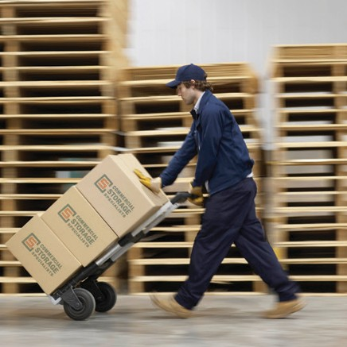
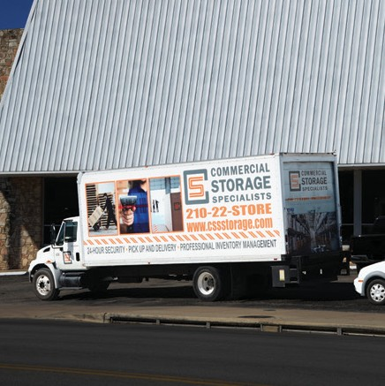

Leave Self-Storage Behind And Start Saving With CSS. We Will Pick Up And Move Your Assets Into Our Warehouse. It Is That Simple To Save.

Downsizing? Need Short Term?

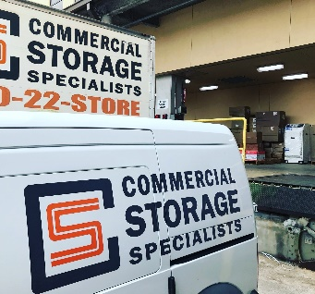
10511 Wetmore San Antonio, Texas 78205
Contact us at 210-399-3679 or email us at www.cssstorage.com

