FOR SALE

Brick Redevelopment Opportunity with Lot

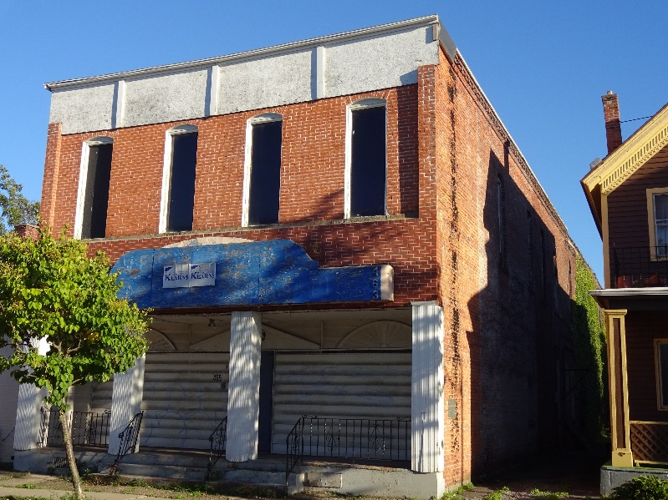
463 & 466 Connecticut Street
Buffalo New York

Building Lot Size: 30 x 116
Vacant Lot: 26 x 116 (across the street)

Building Size: 6840 sq. ft. (3420 sq. ft. per floor)

Features:
- Building is fairly gutted and ready for rehab
- High 12 ft ceilings
- Historical Tax Credit available to assist in rehab costs
- Located near D’Youville College
- Up and coming area featuring new residential, restaurants and retail
- $295,000 sale price includes building and lot

Hastings Cohn Real Estate
James (Jay) Newman
Licensed Real Estate Broker
716-886-3325
www.hastingscohn.com
alan@hastingscohn.com



ALTHOUGH ALL INFORMATION FURNISHED REGARDING PROPERTY FOR SALE, RENTAL OR FINANCING IS FROM SOURCES DEEMED RELIABLE, SUCH INFORMATION HAS NOT BEEN VERIFIED, AND NO EXPRESS REPRESENTATION IS MADE NOR IS ANY TO BE IMPLIED AS TO THE ACCURACY THEREOF AND IT IS SUBMITTED SUBJECT TO ERRORS, OMISSIONS, CHANGE OF PRICE, RENTAL OR OTHER CONDITIONS PRIOR SALE LEASE OR FINANCING OR WITHDRAWAL WITHOUT NOTICE.

